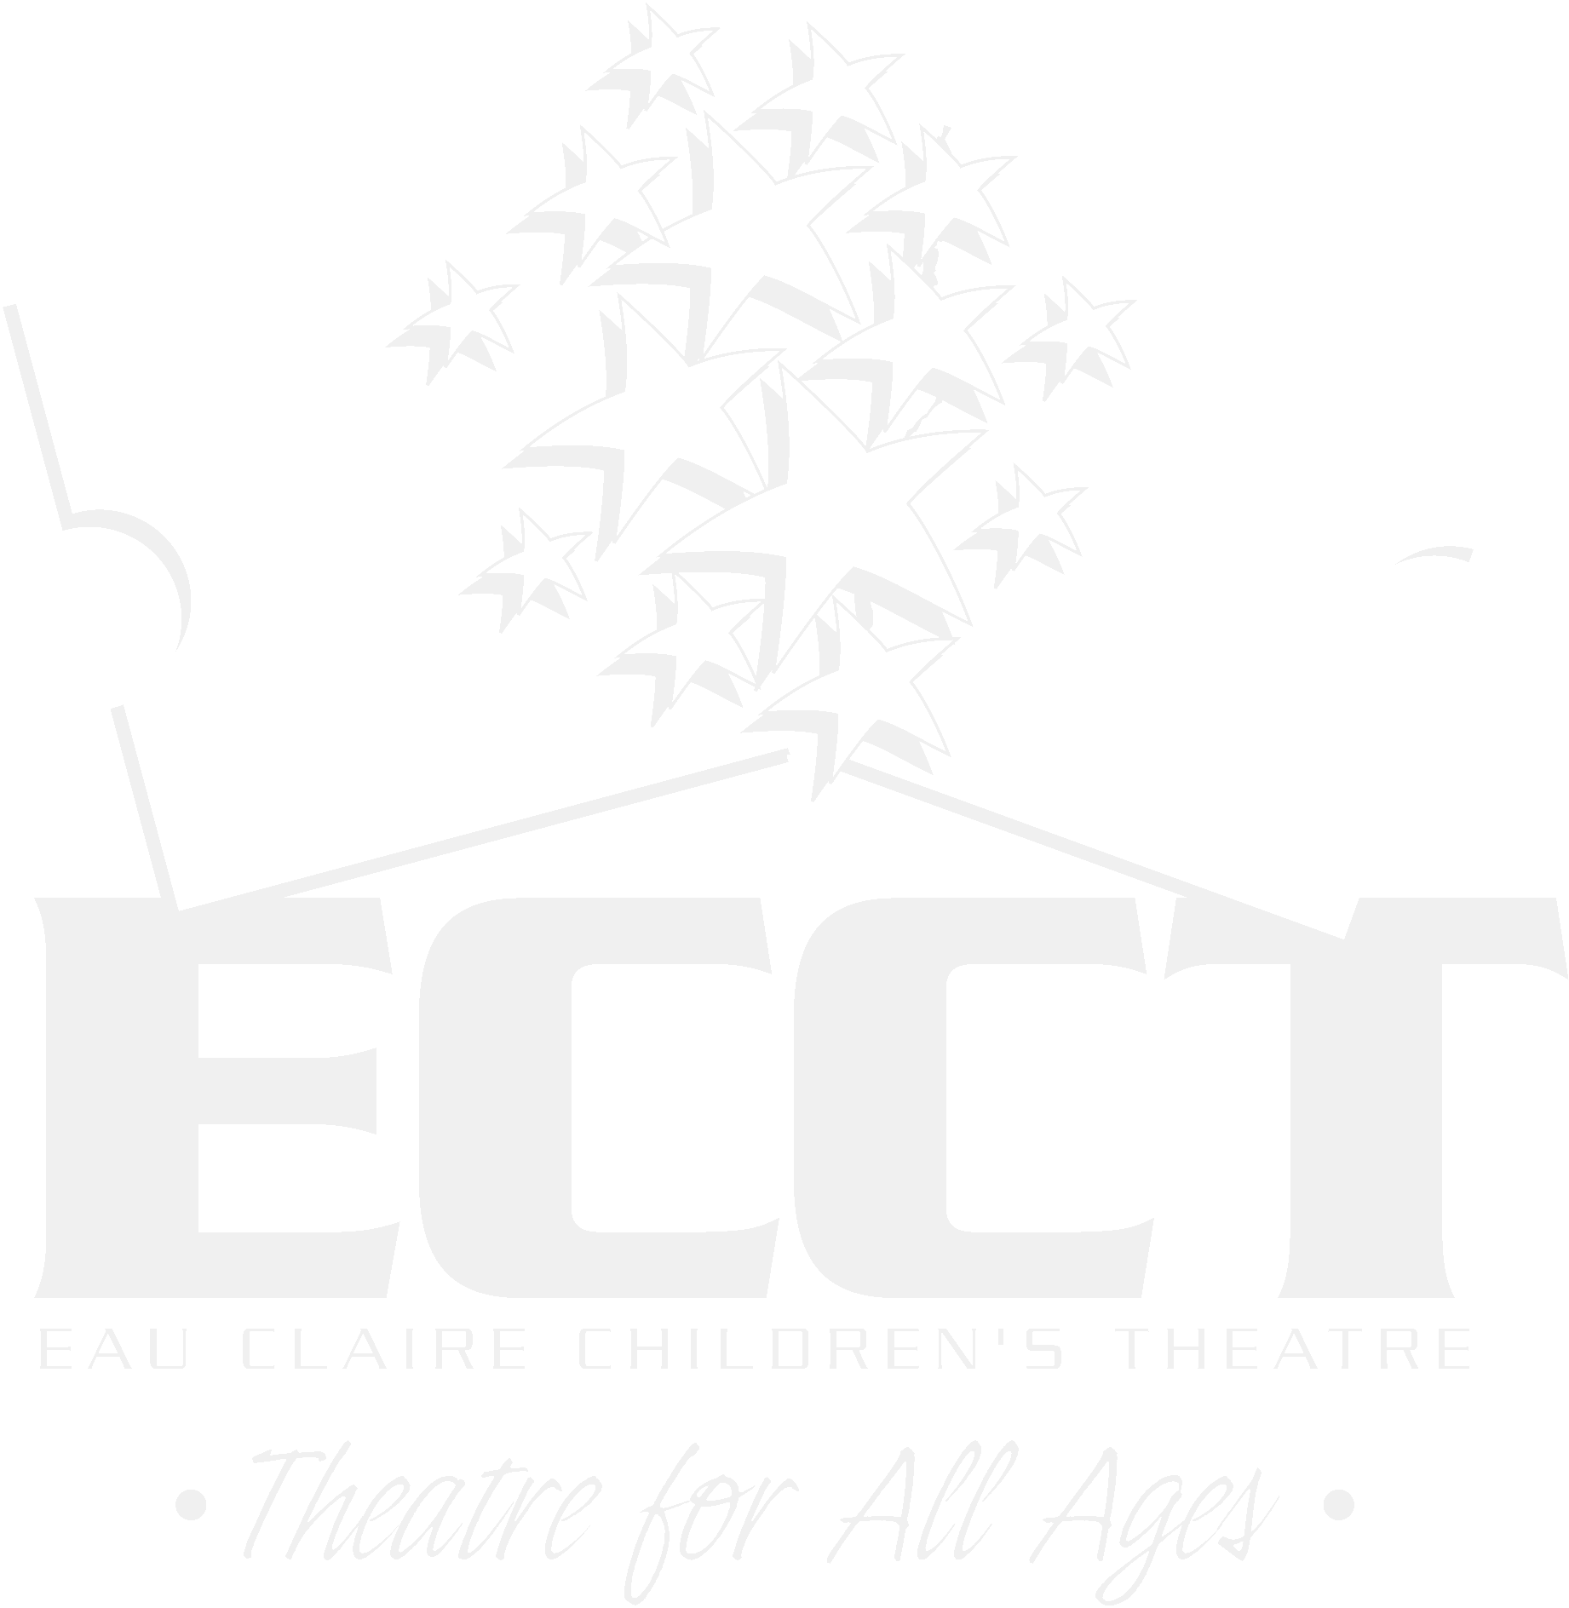
EAU CLAIRE CHILDREN’S THEATRE
YOUTH ADVISORY COUNCIL APPLICATION

NAME_______________________________________________ PHONE________________

ADDRESS___________________________________________________________________

SCHOOL_____________________________________ GRADE THIS FALL_____________

WORK_______________________________________ PHONE________________

EMAIL______________________________________________________________________

LIST YOUR PAST THEATRE EXPERIENCE- BOTH ON STAGE AND BACK STAGE

OF THESE EXPERIENCES, CHOOSE ONE THAT WAS PARTICULARLY SIGNIFICANT FOR YOU AND EXPLAIN WHAT YOU LEARNED AND HOW YOU CONTRIBUTED TO THE SUCCESS OF THE PRODUCTION.

PLEASE CHECK THOSE YAC COMMITTEES YOU MIGHT BE INTERESTED IN SERVING ON:
_____ FUNDRAISING _____ PUBLICITY _____ PARADES

_____ LOBBY DISPLAYS _____ SPECIAL EVENTS

_____ AUDITIONS _____ CONCESSIONS

ON THE BACK:
- Please list 3 goals or activities you would like to see YAC accomplish this year.
- Tell us why you would be a good candidate for the Youth Advisory Council and what skills you could offer. (Be Creative!!- We like fun people!)

Thank you for taking the time to complete this application. Please return to the ECCT by August 29.

