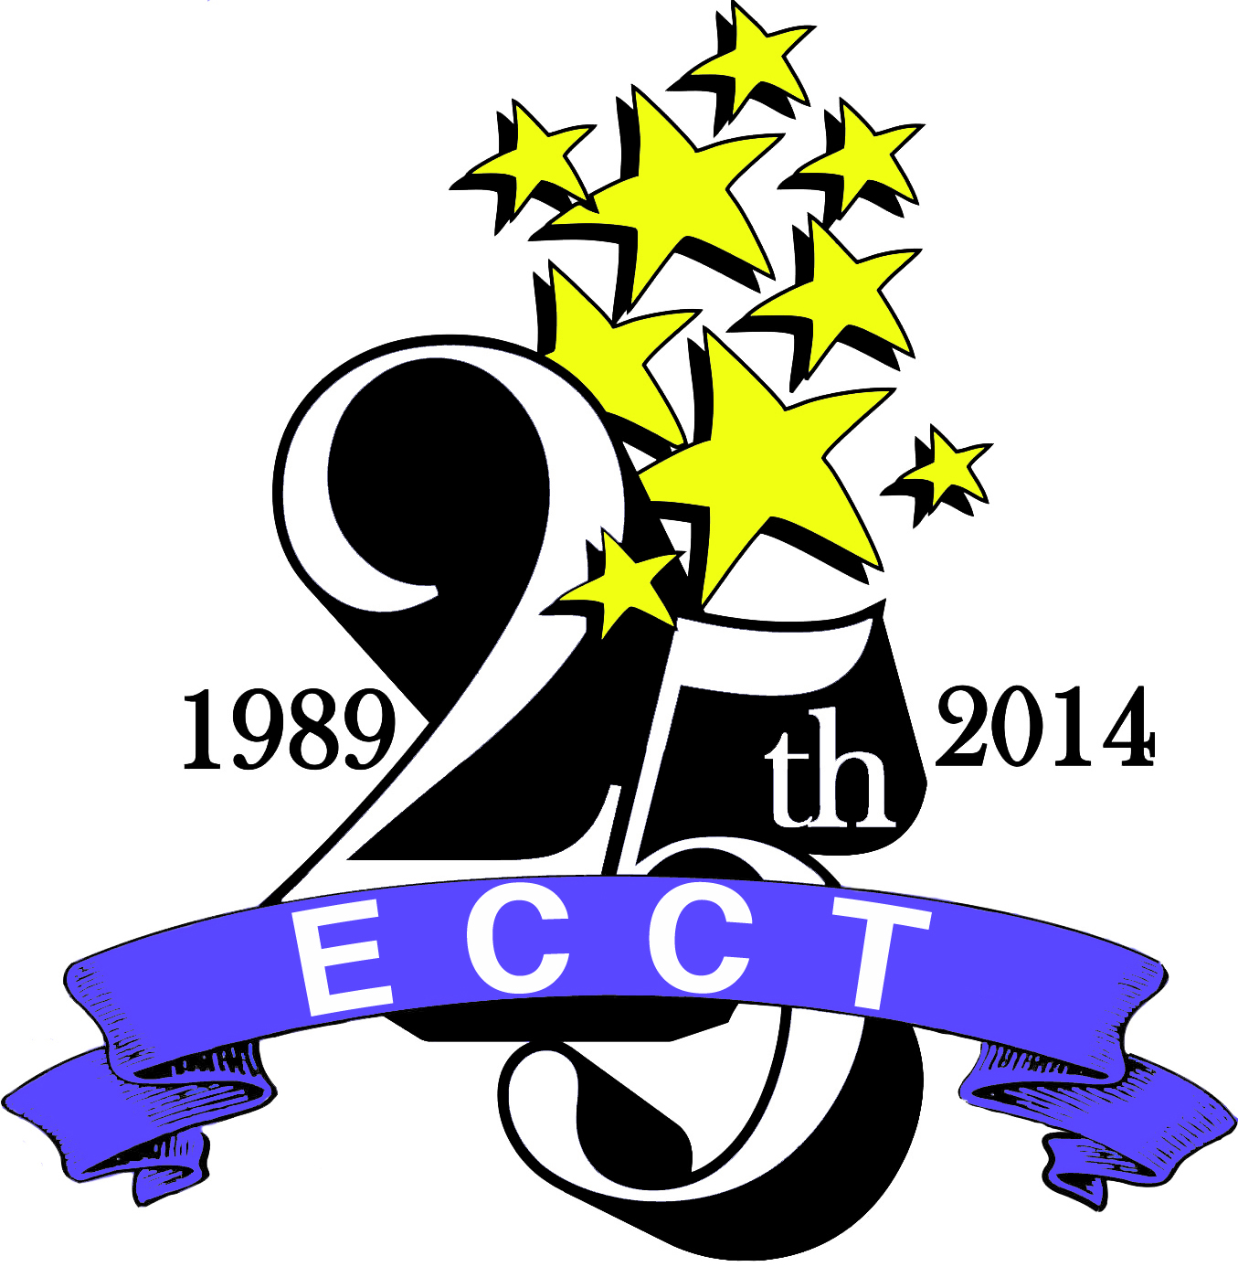

The Eau Claire Children’s Theatre is a non-profit, volunteer-driven community theatre providing quality theatrical and educational experiences for western Wisconsin residents of all ages. Founded in 1989, the Eau Claire Children’s Theatre is currently celebrating its 25th Anniversary. ECCT has four main areas of programming-

mainstage productions of major Broadway musicals

school matinees of shows based on award-winning children’s literature

touring productions

summer theatre classes

Each season ECCT produces 14-16 shows along with a variety of special events, at two main venues- the 1100 seat State Theatre and the 275 seat theatre owned by ECCT, The Oxford. With annual attendance of 32,000-35,000 patrons and an annual budget of $580,000, the Eau Claire Children’s Theatre is one of the largest community theatres in western Wisconsin.
Currently our paid staffing consists of the following positions:
- Executive Director
- Technical Director & Facilities Manager
- Costume Designer
- Outreach Coordinator
- Part-time Costume Assistant
- Part-time Special Events Coordinator
In addition there is a Production Team that consists of the technical staff above and the following positions:
- Scenic Coordinator
- Scenic Assistant
- Lead Artist
- Hair and Makeup Designer
- Properties Coordinators (2)

We are currently taking applications to fill the Technical Director & Facilities Manager position currently held by M. Lloyd Pena, who will be relocating to San Diego in early June. More information about ECCT can be found at www.ecct.org and on our Facebook pages- “ECCT” and “ECCT Tech Productions”. We look forward to receiving your application materials.

EAU CLAIRE CHILDREN’S THEATRE, INC.

TECHNICAL DIRECTOR & FACILITIES MANAGER

I. POSITION OBJECTIVES: To provide superior technical expertise in the areas of Lighting, Sound and Special Effects for ECCT productions, rentals and special events. To oversee day to day facilities operations and maintenance for ECCT and The Oxford. To be an active member of the Production Staff, assisting in the areas of scenic construction, painting and/or properties as capable.

II. POSITION CHARACTERISTICS:

Recruited by: Executive Director

Salary/Benefits: Annual salary negotiable depending on experience
Monthly health insurance stipend provided
Monthly cell phone allowance provided
Paid vacations, holidays and sick days

Schedule: Full time salaried position; schedule will flex between daytime, evening and

weekend hours depending on ECCT production schedule

III. POSITION RELATIONSHIPS:

Reports to: Executive Director

Supervises: Community volunteers, Technical Assistant, Interns

Coordinates with: Scenic Coordinator, Lead Artist, Properties Coordinator

IV. POSITION QUALIFICATIONS:
- BA/BS in Technical Theatre, Lighting or Sound Design, Tech Ed or related field desired or comparable experience in the field
- Demonstrated lighting and sound design ability
- Knowledge of theatrical lighting and sound reproduction
- Knowledge of theatrical style, conventions and terminology
- Strong oral communication skills
- Background in or appreciation of theatre
- Demonstrated ability to recruit and work with volunteers
- Ability to manage several projects simultaneously
- Strong organizational skills and highly motivated with strong work ethic
- Ability to work with minimal supervision

V. PERFORMANCE RESPONSIBILITIES AND SAMPLE TASKS
- Design and implement lighting, sound and special effects elements for productions, rentals and special events at The Oxford & offsite locations ie: State Theatre, Zorn Arena, Convention Center
- Train and work with volunteers as part of the running crew for productions
- Oversee maintenance of facilities and equipment at ECCT and in The Oxford
- Assist with the completion of all scenic requirements for ECCT shows as able
- Assist with IT and related tasks as experience allows
- Other duties as assigned

VI. HOW TO APPLY
Submit application form from website (www.ecct.org), cover letter and current resume to ECCT by email to info@ecct.org or by mail or in person at 1814 Oxford Avenue Eau Claire WI 54703. Application deadline is Friday, May 16. Questions regarding this position may be directed to Executive Director Wayne Marek at info@ecct.org or 715-839-8877.

