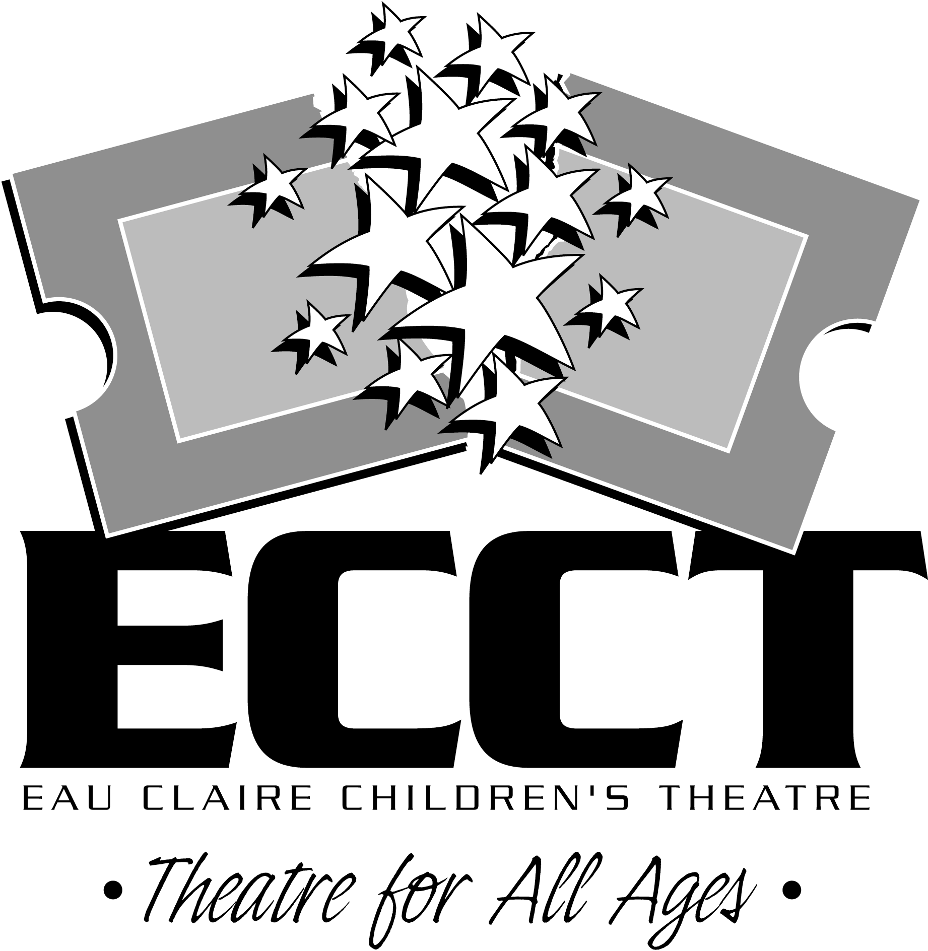
SUMMER 2017 INTERNSHIP PROGRAM

ABOUT ECCT
ECCT will be wrapping up its 28th season of providing quality family entertainment this summer. Located in Eau Claire, Wisconsin, ECCT annually presents over 16 productions (Broadway musicals and shows based on children’s literature) using a combination of youth and adult performers in two area venues. School matinee performances, classes and touring productions are offered in addition to many annual special events including a Murder Mystery Dinner Theatre, Starquest and Dancing with the Eau Claire Stars. With a budget of over $640,000 and annual attendance of over 32,000 patrons, ECCT is one of the largest community theatres in western Wisconsin. In the summer of 2007 ECCT purchased and renovated their current home and in the spring of 2010 opened a new multi-purpose performance space, The Oxford.

REQUIREMENTS
All applicants must be 18 years of age and must complete required paperwork to be considered for an internship. Applicants must be US citizens and have a valid driver’s license. Applicants need not be currently enrolled in a university theatre program.

POSITIONS OFFERED
We are offering opportunities for six interns- one Technical Theatre Intern, one Costume Intern, one Education Intern, one Marketing Intern, one House Management Intern and one Graphic Design Intern. Throughout the summer interns will have the opportunity to teach a variety of theatre and arts related classes, work in their specialty area on summer and upcoming touring productions and participate in promotional events on weekends. Hours will vary based on class schedules and the needs of the organization throughout the summer- 36-40 hours per week. Depending on their skills and interests interns will also have the opportunity to do design work and/or perform on stage. Interns will earn $3000 for the summer. While dates may be flexible, internships basically run 3 months, from May 30-August 18.

SCHOOL CREDIT
Applicants who wish to receive class credit for their internship will need to coordinate the details with their school advisor and ECCT. The applicant is responsible to communicate needs of the institution to ECCT. We will complete any necessary paper work and make adjustments to the schedule and work load to fulfill university requirements.

IMPORTANT DATES
Application deadline is April 14. Materials may be sent by mail or email.

APPLICATION MATERIALS
A completed application includes the following items:
A completed and signed Application Form
A resume of theatre-related experience
A brief, personal statement which discusses the following:
Your long-term professional goals
How you feel an internship will help you achieve those goals
Your expectations regarding the internship
What makes you tick and what you can bring to ECCT
Submit the Application to: Questions? Contact:
Internship Program Wayne Marek
Eau Claire Children’s Theatre Executive Director
1814 Oxford Avenue Phone: 715.839.8877
Eau Claire, WI 54703 OR Email: info@ecct.org
Email to: info@ecct.org Web: www.ecct.org

EAU CLAIRE CHILDREN’S THEATRE
SUMMER INTERNSHIP PROGRAM APPLICATION

NAME_______________________________________________________________
First Middle Initial Last

Permanent contact information:

ADDRESS___________________________________________________________
Number/Street/Apt. # City/State Zip Code

PHONE( )__________________EMAIL________________________________

Current contact information (if different from above):

ADDRESS___________________________________________________________
Number/Street/Apt. # City/State Zip Code

PHONE( )_________________ EMAIL________________________________

Current contact information effective until what date? _______/_______/________
Month Day Year
Academic Information:

College/University_______________________________________________________

Year in School_________Degree___________ Major___________________________

Which internship(s) are you interested in? Technical Theatre Intern Marketing Intern
Costume Intern Education Intern House Management Intern Graphic Design Intern

Will you be completing this internship for credit? YES NO

Internships run May 30-August 18. Do you have any issues with the start or end date?

YES NO If Yes, please explain__________________________________________

Any other potential schedule conflicts this summer?____________________________

Will you need assistance locating housing? YES NO

Will you have reliable transportation while in Eau Claire? YES NO

How did you hear about the internship program?_______________________________

Signature________________________________________________

EAU CLAIRE CHILDREN’S THEATRE, INC.

POSITION TITLE: SUMMER SCENIC INTERNSHIP

I. POSITION OBJECTIVES: To provide scenic assistance to the Technical Director for ECCT summer productions

II. POSITION CHARACTERISTICS:

Recruited by: Executive Director

Stipend: $1000/month ($3000 for the summer)

Schedule: Flexible schedule- days, nights and weekends

36-40 hours per week for 12 weeks
May 30- August 18, 2017

III. POSITION RELATIONSHIPS:

Reports to: Technical Director

Supervises: Community volunteers

Coordinates with: Assistant Technical Director

IV. PREFERRED POSITION QUALIFICATIONS:
- Working towards or holding BA/BS in Theatre Arts, Construction Management, Technical Theatre, Scenic Design, Education, or related field
- Intermediate to advanced scenic construction ability
- Beginning to intermediate painting ability
- Some design experience appreciated
- Knowledge of theatrical style, conventions and terminology
- Strong oral communication skills
- Background in or appreciation of theatre
- Demonstrated ability to work with volunteers
- Strong organizational skills
- Ability to work with minimal supervision

PERFORMANCE RESPONSIBILITIES AND SAMPLE TASKS
- Master carpenter responsibilities for the completion of scenic requirements for 9 ECCT summer shows
- Prepare projects in advance for community volunteers
- Assist with scenic painting based on skill level
- Opportunities for design projects
- Running crew duties based on skills and interests
- Other duties as assigned

HOW TO APPLY
Submit application materials to ECCT by email at info@ecct.org, by mail or in person at 1814 Oxford Ave. Eau Claire WI 54703. Application deadline is April 14, 2017. Questions regarding this position may be directed to Executive Director Wayne Marek at (715) 839-8877.

EAU CLAIRE CHILDREN’S THEATRE, INC.

POSITION TITLE: SUMMER SOUND/LIGHTING INTERNSHIP

I. POSITION OBJECTIVES: To provide sound and lighting assistance to the Technical Director for ECCT summer productions

II. POSITION CHARACTERISTICS:

Recruited by: Executive Director

Stipend: $1000/month ($3000 for the summer)

Schedule: Flexible schedule- days, nights and weekends

36-40 hours per week for 12 weeks
May 30- August 18, 2017

III. POSITION RELATIONSHIPS:

Reports to: Technical Director

Supervises: Community volunteers

Coordinates with: Assistant Technical Director

IV. PREFERRED POSITION QUALIFICATIONS:
- Working towards or holding BA/BS in Theatre Arts, Technical Theatre, Lighting/Sound Design, Education, or related field
- Intermediate to advanced ability in sound design and implementation
- Intermediate to advanced ability in lighting design and implementation
- Experience in other technical theatre areas- scenic, painting, props useful
- Knowledge of theatrical style, conventions and terminology
- Strong oral communication skills
- Background in or appreciation of theatre
- Demonstrated ability to work with volunteers
- Strong organizational skills
- Ability to work with minimal supervision

PERFORMANCE RESPONSIBILITIES AND SAMPLE TASKS
- Lead responsibilities for lighting and sound design implementation for 9 ECCT summer shows
- Prepare projects in advance for community volunteers
- Opportunities for design projects based on skill level
- Running crew duties for all shows based on skills and interests
- Other duties as assigned

HOW TO APPLY
Submit application materials to ECCT by email at info@ecct.org, by mail or in person at 1814 Oxford Ave. Eau Claire WI 54703. Application deadline is April 14, 2017. Questions regarding this position may be directed to Executive Director Wayne Marek at (715) 839-8877.

