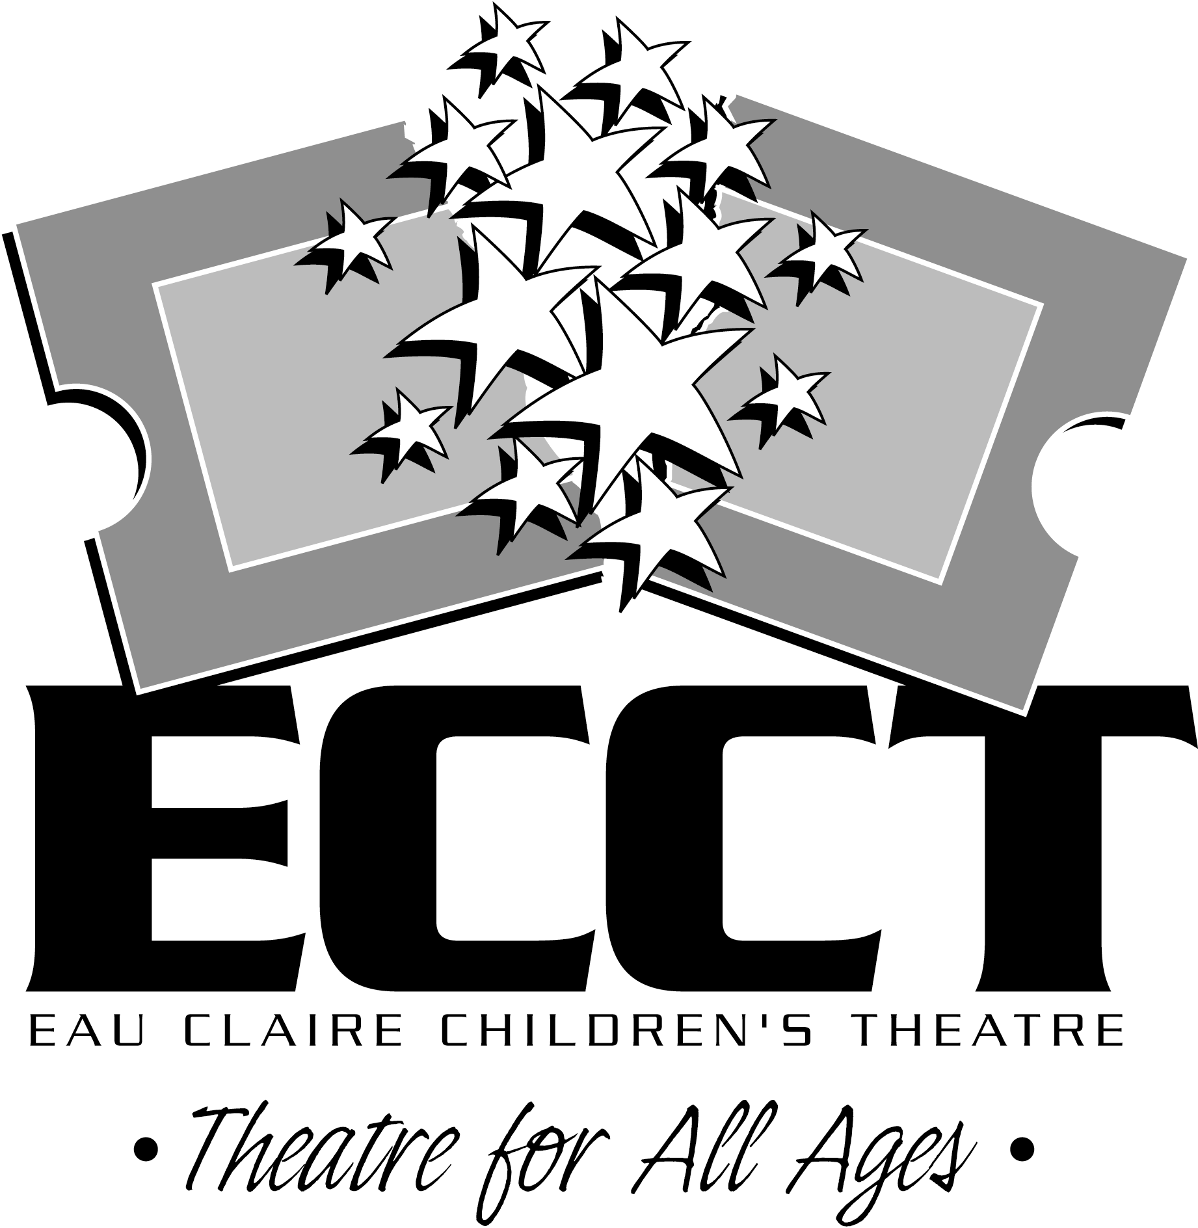
SUMMER 2016 INTERNSHIP PROGRAM

ABOUT ECCT
ECCT will be wrapping up its 27th season of providing quality family entertainment this summer. Located in Eau Claire, Wisconsin, ECCT annually presents over 16 productions (Broadway musicals and shows based on children’s literature) using a combination of youth and adult performers in two area venues. School matinee performances, classes and touring productions are offered in addition to many annual special events including a Murder Mystery Dinner Theatre, Starquest and Dancing with the Eau Claire Stars. With a budget of over $645,000 and annual attendance of over 32,000 patrons, ECCT is one of the largest community theatres in western Wisconsin. In the summer of 2007 ECCT purchased and renovated their current home and in the spring of 2010 opened a new multi-purpose performance space, The Oxford.

REQUIREMENTS
All applicants must be 18 years of age and must complete required paperwork to be considered for an internship. Applicants must be US citizens and have a valid driver’s license. Applicants need not be currently enrolled in a university theatre program.

POSITIONS OFFERED
We are offering opportunities for six interns- one Technical Production Intern, one Costume Intern, one Education Intern, one Marketing Intern, one House Management Intern and one Graphic Design Intern. Each intern will have the opportunity to teach a variety of theatre and arts related classes in the morning, work in their specialty area on summer and upcoming touring productions in the afternoons and evenings and participate in promotional events on some weekends. Hours will vary based on class schedules and the needs of the organization throughout the summer- 36-40 hours per week. Depending on their skills and interests interns will also have the opportunity to do design work and/or perform on stage. Interns will earn $3000 for the summer. While dates may be flexible, internships basically run 3 months, from May 31-August 19.

SCHOOL CREDIT
Applicants who wish to receive class credit for their internship will need to coordinate the details with their school advisor and ECCT. The applicant is responsible to communicate needs of the institution to ECCT. We will complete any necessary paper work and make adjustments to the schedule and work load to fulfill university requirements.

IMPORTANT DATES
Application deadline is February 26. Materials may be sent by mail or email.

APPLICATION MATERIALS
A completed application includes the following items:
A completed and signed Application Form
A resume of theatre-related experience
A brief, personal statement which discusses the following:
Your long-term professional goals
How you feel an internship will help you achieve those goals
Your expectations regarding the internship
What makes you tick and what you can bring to ECCT
Submit the Application to: Questions? Contact:
Internship Program Wayne Marek
Eau Claire Children’s Theatre Executive Director
1814 Oxford Avenue Phone: 715.839.8877
Eau Claire, WI 54703 OR Email: info@ecct.org
Email to: info@ecct.org Web: www.ecct.org

EAU CLAIRE CHILDREN’S THEATRE
SUMMER INTERNSHIP PROGRAM APPLICATION

NAME_____________________________________________________________________
First Middle Initial Last

Permanent contact information:

ADDRESS__________________________________________________________________
Number/Street/Apt. # City/State Zip Code

PHONE___ ( )__________________ EMAIL_________________________________

Current contact information (if different from above):

ADDRESS__________________________________________________________________
Number/Street/Apt. # City/State Zip Code

PHONE___ ( )__________________ EMAIL_________________________________

Current contact information effective until what date? _______/_______/________
Month Day Year

Academic Information:

College/University____________________________________________________________

Year in School_________Degree___________ Major________________________________

Which internship(s) are you interested in? Technical Production Intern Marketing Intern
Costume Intern Education Intern House Management Intern Graphic Design Intern

Will you be completing this internship for credit? YES NO

Internships run May 31-August 19. Do you have any issues with the start or end date? YES NO
If Yes, please explain____________________________________________________________

Any other potential schedule conflicts this summer? ___________________________________

Will you need assistance locating housing? YES NO

Will you have reliable transportation while in Eau Claire? YES NO

How did you hear about the internship program?________________________________________

Signature________________________________________________

EAU CLAIRE CHILDREN’S THEATRE, INC.

POSITION TITLE: COSTUME INTERN

I. POSITION OBJECTIVES: To provide creative and management assistance to the ECCT Costume Designer for ECCT Theatre productions and efficient management of the ECCT costume shop

II. POSITION CHARACTERISTICS:

Recruited by: Executive Director

Stipend: $3000 per summer

Schedule: Flexible schedule- days, nights or weekends

36-40 hours per week for 12 weeks
May 31-August 19, 2016

III. POSITION RELATIONSHIPS:

Reports to: Costume Designer

Supervises: Community volunteers

Coordinates with: Technical crew heads, Associate Director

IV. PREFERRED POSITION QUALIFICATIONS:

Working towards or holding BA/BS in Theatre Arts, Education or related field
- Demonstrated costume design or construction ability
- Basic sewing skills
- Some knowledge of theatrical style, fabrics and historical periods
- Strong oral communication skills
- Background in or appreciation of theatre
- Demonstrated ability to work with volunteers
- Demonstrated organizational skills

PERFORMANCE RESPONSIBILITIES AND SAMPLE TASKS
- Assist with costume designs for ECCT productions
- Coordinate the costume running crew for productions
- Help supervise community volunteers involved in construction of costumes
- Assist with promotional events and fundraisers requiring costuming
- Assist with the checking in and out of rental costumes
- Other duties as assigned

HOW TO APPLY
Submit application materials to ECCT by email at info@ecct.org, by mail or in person at 1814 Oxford Ave. Eau Claire WI 54703. Application deadline is February 26, 2016. Questions regarding this position may be directed to Executive Director Wayne Marek at (715) 839-8877.

EAU CLAIRE CHILDREN’S THEATRE, INC.

POSITION TITLE: TECHNICAL ASSISTANT INTERN

I. POSITION OBJECTIVES: To provide technical assistance to the Scenic Coordinator, Scenic Artist and/or Lighting and Sound Designer for ECCT productions

II. POSITION CHARACTERISTICS:

Recruited by: Executive Director

Stipend: $3000 per summer

Schedule: Flexible schedule- days, nights or weekends

36-40 hours per week for 12 weeks
May 31- August 19, 2016

III. POSITION RELATIONSHIPS:

Reports to: Technical Director

Supervises: Community volunteers

Coordinates with: Lead Artist, Scenic Coordinator, Lighting and Sound Designer

IV. PREFERRED POSITION QUALIFICATIONS:
- Working towards or holding BA/BS in Theatre Arts, Education or related field
- Demonstrated scenic construction or artistic ability
- Knowledge of theatrical style, conventions and terminology
- Knowledge of stage lighting and sound
- Strong oral communication skills
- Background in or appreciation of theatre
- Demonstrated ability to work with volunteers
- Strong organizational skills
- Ability to work with minimal supervision

PERFORMANCE RESPONSIBILITIES AND SAMPLE TASKS
- Prepare projects in advance for community volunteers per written instructions from Scenic Coordinator and/or Lead Artist
- Assist with lighting and sound projects based on skill level
- Assist with the completion of scenic requirements for ECCT shows
- Opportunities for design projects based on skill level
- Design and implement scenic elements for assigned projects
- Other duties as assigned

HOW TO APPLY
Submit application materials to ECCT by email at info@ecct.org, by mail or in person at 1814 Oxford Ave. Eau Claire WI 54703. Application deadline is February 26, 2016. Questions regarding this position may be directed to Executive Director Wayne Marek at (715) 839-8877.

EAU CLAIRE CHILDREN’S THEATRE, INC.

POSITION TITLE: MARKETING INTERN

I. POSITION OBJECTIVES: To provide creative marketing assistance to the ECCT staff for all ECCT Theatre productions

II. POSITION CHARACTERISTICS:

Recruited by: Executive Director

Stipend: $3000 per summer

Schedule: Flexible schedule- days, nights or weekends

36-40 hours per week for 12 weeks
May 31- August 19, 2016

III. POSITION RELATIONSHIPS:

Reports to: Executive Director

Supervises: Community volunteers

Coordinates with: Technical crew heads, Associate Director

IV. PREFERRED POSITION QUALIFICATIONS:

Working towards or holding BA/BS in Theatre Arts, Marketing, Public Relations or related field
- Demonstrated marketing ability
- Basic graphic design skills and knowledge or design programs
- Strong oral communication skills
- Background in or appreciation of theatre
- Demonstrated ability to work with volunteers
- Demonstrated organizational skills

PERFORMANCE RESPONSIBILITIES AND SAMPLE TASKS
- Assist with marketing plan for ECCT productions
- Coordinate marketing volunteers for productions
- Help supervise community volunteers involved in marketing projects
- Assist with promotional events and fundraisers
- Produce flyers and promotional materials
- Assist with social media
- Other duties as assigned

HOW TO APPLY
Submit application materials to ECCT by email at info@ecct.org, by mail or in person at 1814 Oxford Ave. Eau Claire WI 54703. Application deadline is February 26, 2016. Questions regarding this position may be directed to Executive Director Wayne Marek at (715) 839-8877.

EAU CLAIRE CHILDREN’S THEATRE, INC.

POSITION TITLE: HOUSE MANAGEMENT INTERN

I. POSITION OBJECTIVES: To provide quality house management services during ECCT productions

II. POSITION CHARACTERISTICS:

Recruited by: Executive Director

Stipend: $3000 per summer

Schedule: Flexible schedule- days, nights or weekends

36-40 hours per week for 12 weeks
May 31- August 19, 2016

III. POSITION RELATIONSHIPS:

Reports to: Associate Director

Supervises: Community volunteers

Coordinates with: Administrative Assistant

IV. PREFERRED POSITION QUALIFICATIONS:
- Pursuing a degree in Theatre, Marketing, Event Planning, Non-Profit Management, Sales, Public Relations or related degree

Working towards or holding BA/BS in Theatre Arts, Public Relation, Sales, Education or related field
- Demonstrated customer service skills
- Strong oral communication skills
- Background in or appreciation of theatre
- Demonstrated ability to work with volunteers
- Demonstrated organizational skills
- Ability to work with minimal supervision

PERFORMANCE RESPONSIBILITIES AND SAMPLE TASKS
- Manage box office volunteers
- Coordinate and train volunteer ushers
- Manage beverage sales and concessions and those volunteers
- Represent ECCT to the public
- Maintain the safety and integrity of the patrons and facility during performances
- Respond to emergencies as the person in charge during performances
- Maintain inventory of concessions, beverages and souvenirs
- Assist with pre-show events and value added activities
- Create lobby displays, picture boards and other promotional pieces for the lobby as needed
- Other duties as assigned

HOW TO APPLY
Submit cover letter and current resume to ECCT by email at info@ecct.org or by mail or in person at 1814 Oxford Ave. Eau Claire WI 54703. Application deadline is Friday, February 26, 2016. Questions regarding this position may be directed to Executive Director Wayne Marek at (715) 839-8877.

EAU CLAIRE CHILDREN’S THEATRE, INC.

POSITION TITLE: EDUCATION INTERN

I. POSITION OBJECTIVES: To provide classroom instruction for a wide variety of theatre and arts-related summer classes

II. POSITION CHARACTERISTICS:

Recruited by: Executive Director

Stipend: $3000 per summer

Schedule: Flexible schedule- days, nights or weekends

36-40 hours per week for 12 weeks
May 31- August 19, 2016

III. POSITION RELATIONSHIPS:

Reports to: Associate Director

Supervises: Pre-school, elementary and middle school students

Coordinates with: Teen volunteers, ECCT production staff

IV. PREFERRED POSITION QUALIFICATIONS:

Working towards or holding BA/BS in Theatre Arts, Education or related field
- Demonstrated ability to work with children
- Background in creative drama, theatre direction and/or tech theatre areas (costumes or sets/props)
- Strong oral communication skills
- Background in or appreciation of theatre
- Demonstrated ability to work with volunteers
- Demonstrated organizational skills

PERFORMANCE RESPONSIBILITIES AND SAMPLE TASKS
- Curriculum development and execution for a wide variety of theatre and arts-related classes
- Work with teen volunteers involved with program
- Assist with promotional activities as needed
- Other duties as assigned

HOW TO APPLY
Submit application materials to ECCT by email at info@ecct.org or by mail or in person at 1814 Oxford Avenue Eau Claire WI 54703. Application deadline is February 26, 2016. Questions regarding this position may be directed to Executive Director Wayne Marek at (715) 839-8877.

EAU CLAIRE CHILDREN’S THEATRE, INC.

POSITION TITLE: GRAPHIC DESIGN INTERN

I. POSITION OBJECTIVES: To provide high quality graphic design support for ECCT promotional efforts

II. POSITION CHARACTERISTICS:

Recruited by: Executive Director

Stipend: $3000 per summer

Schedule: Flexible schedule- days, nights or weekends

36-40 hours per week for 12 weeks
May 31- August 19, 2016

III. POSITION RELATIONSHIPS:

Reports to: Executive Director

Supervises: None

Coordinates with: Associate Director

IV. PREFERRED POSITION QUALIFICATIONS:

Working towards or holding BA/BS in Graphic Design, Art, Multi-Media Design, Theatre Arts or related field
- Demonstrated ability to work with children
- Proficiency with current design programs
- Strong creative skills and ability to work collaboratively with others
- Strong oral communication skills
- Background in or appreciation of theatre
- Demonstrated organizational skills

PERFORMANCE RESPONSIBILITIES AND SAMPLE TASKS
- Complete responsibility for the design of 2016-17 season brochure including show logos, web and Facebook graphics
- Design work on posters, flyers, brochures for summer productions and fall 2017 programs
- Assist with promotional activities as needed
- Creation and painting of signage as needed
- Other duties as assigned

HOW TO APPLY
Submit application materials to ECCT by email at info@ecct.org or by mail or in person at 1814 Oxford Avenue Eau Claire WI 54703. Application deadline is February 26, 2016. Questions regarding this position may be directed to Executive Director Wayne Marek at (715) 839-8877.

