Eau Claire

Children’s Theatre

Summer Classes

2016

NEW- Kids in the Eau Claire & Chippewa Falls School Districts can take more than one class FREE! Details inside!

NEW Classes and returning favorites for ages 3-18!

With over 40 Classes, there’s something for everyone!

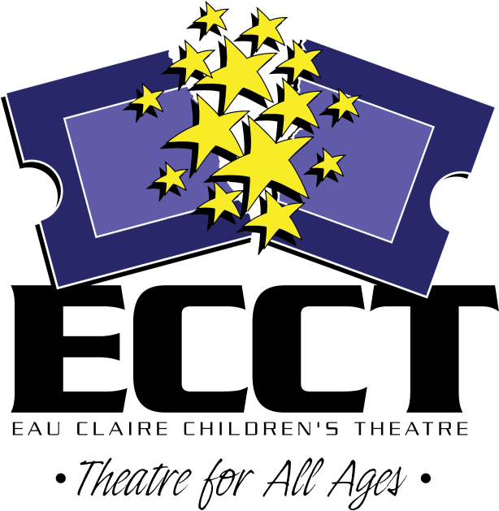

715-839-8877 * 1814 Oxford Avenue * ecct.org

**1814 Oxford Avenue**

**Eau Claire, WI 54703**

**715.839.8877**

The Eau Claire Area School District will pay the registration fee for ECASD students to take select ECCT classes indicated in the brochure by this icon:



until filled. All other classes are the responsibility of the student’s family.

Ages 3-4

**FAIRY TALE THEATRE**

**June 13-June 29 Mon/Wed**

**9am-9:45am $24**

**July 18-22 9am-9:45am $24**

Fairytales introduce our youngest actors to theatre with playacting, storytelling, and arts & crafts.

**LITTLE PIRATES**

**July 11-15 11am-11:45am $24**

Have a swashbuckling good time! Play pirate games, make flags, and hunt for hidden treasure!

**FROZEN SUMMER**

**July 25-29 9am-9:45 $24**

Find out what Frozen kids do in summer! Play games and make crafts inspired by *Frozen!*



**Ages 5-7**

**PLUNDERING PIRATES**

**June 13-17 9am-Noon $40**

Ahoy Mateys! We’ll be sailing the high seas and looking for adventure while learning pirate lingo and hunting treasure!



**PLAYACTING**

**June 13-17 1pm-3pm $28**

We’ll work together to create stage versions of our favorite fairytales, including dialogue, masks, and simple set pieces.

**ELEPHANT AND PIGGIE: WE ARE IN A CAMP!**

**June 20-24 9am-Noon $40**

Elephant Gerald and Piggie have so many fun adventures! We’ll make new friends while playing theatre games and making Elephant and Piggie crafts!

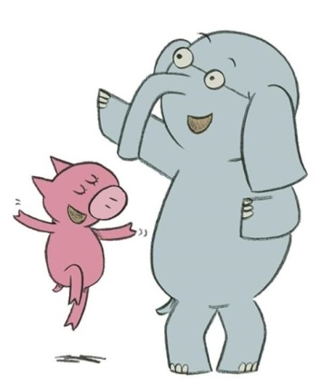

**MUNCHKINLAND**

**June 20-24 1pm-4pm $40**

**July 25-29 9am-Noon $40**

We’ll explore the theatre and the world of Oz in this wonderful class! Find the courage, the brain, and the heart to join us in Munchkinland!

**IT’S A ZOO!**

**June 27-July 1 9am-Noon $40**

So many animals, so little time! Let’s learn to act as some of our favorite animals while learning theatre games and making animal crafts!



**FAIRY PRINCESSES**

**June 27-July 1 1pm-4pm $40**

**July 11-15 9am-Noon $40**

Become a Princess for the week! Design costumes, get a princess make-over, make tiaras and have a royal tea party! Learn about real and storybook princesses.



**DRAGON TRAINING**

**July 18-22 9am-Noon $40**

Let’s play Knights, Vikings and Dragons! We’ll be playing games from our favorite dragon stories like *How to Train Your Dragon!*

**WORLD OF SEUSS**

**August 1-5 9am-Noon $40**

Oh, the thinks we will think, and the acts we will act! Using the works of Dr. Seuss, every day will feature new games and crafts as we learn to use our imaginations!

**Ages 7-10**

**MUSIC IN ME**

**June 13-17 9am-Noon $40**

Combo class! Take “Junkyard Symphony,” “Broadway Dance,” and “Sing Out!” and save!

**JUNKYARD SYMPHONY**

**June 13-17 9am-10am $20**

We’ll use coffee cans, soda bottles and other found objects to create our own “STOMP” show.

**BROADWAY DANCE**

**June 13-17 10am-11am $20**

Pick up a variety of dance moves – tap, jazz, modern – with the help of fun Broadway songs.

**SING OUT!**

**June 13-17 11am-Noon $20**

Learn the proper way to sing and pick out Broadway songs to use for future auditions.

**THEATRE GAMES**

**June 27-July 1 1pm-4pm $40**

**July 18-22 1pm-4pm $40**

Easy theatre and improv games are used to explore creating characters, getting comfortable on stage and making people laugh.

**WITCHES & WIZARDS**

**July 11-15 1pm-4pm $40**

We’ll explore the Magic of Theatre using some of our favorite magical characters and stories, like *Harry Potter,* and *The Wizard of Oz!*

**GLEE FOR BEGINNERS**

**July 25-29 9am-Noon $40**

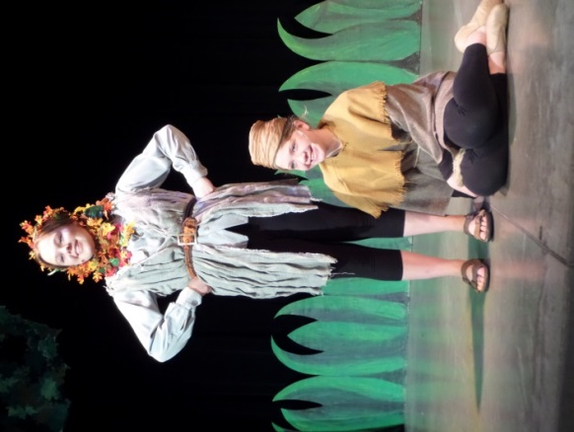Learn show choir basics and put together a routine to present on the last day of class!

**DRAMA CAMP I**

**July 25-29 1pm-4pm $50**

Not sure what the theatre has to offer? Each day covers two new topics. Includes a snack break and a ticket to see *THE WIZARD OF OZ.*

**Ages 8-12**

**ACTING FOR GIRLS ONLY**

**June 13-17 1pm-4pm $40**

**July 11-15 1pm-4pm $40**

Class focuses on theatre games, modeling, and acting skills using scenes, monologues and audition pieces for girls only.

**ACT IT OUT!**

**June 20-24 1pm-4pm $40**

Combo class! Take “Stage Combat,” “Relaxation for Actors,” and “Clowning Around” and save!

**STAGE COMBAT**

**June 20-24 1pm-2pm $20**

Have fun learning the proper and safe way to fight and use weapons on stage.

**RELAXATION FOR ACTORS**

**June 20-24 2pm-3pm $20**

Learn ways to conquer stage fright and mentally prepare yourself for the stage.

**CLOWNING AROUND**

**June 20-24 3pm-4pm $20**

Find out how to make people laugh with magic, pantomime & juggling.

**TRIPLE THREAT**

**July 25-29 1pm-4pm $40**

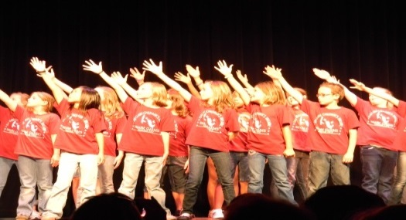You’ll be what every performer dreams of being- a Triple Threat- by learning acting, singing and dancing skills in one week.

**Ages 8-14**

**SUMMER KIDS CABARET**

**June 13-17 1pm-3pm $28**

Create a musical revue with group numbers, vocal solos and duets and dance numbers presented on the last day of class

**CELEBRATE SUMMER WITH A SHOW I**

**June 20-24 & 27-July 1 9am-Noon $60**

Join the cast of the musical *Disney’s 101 Dalmatians*

Rehearse 2 weeks & present 5 shows June 30 10am, 1:30pm, 6:30pm/July 1 10am & 1:30pm

**CELEBRATE SUMMER WITH A SHOW II**

**July 11-15 & 18-22 9am-Noon $60**

Be in the cast of the *Emperor’s New Clothes.* Rehearse 2 weeks & present 5 shows July 21 10am, 1:30pm, 6:30pm/July 22 10am & 1:30pm

**AUDITIONING WORKSHOP**

**August 1 & 3 5pm-6pm $10**

Learn what to expect and how to prepare to audition for shows coming up next season!  
 **Ages 8-16**

**PRIVATE VOICE LESSONS**

**June 14-July 27**

**Tues 9am-1pm or Wed 9am-5pm**

**30 min lesson each week $70**

Improve your skills! Get private voice training through the study of musical theatre literature.

**Ages 8-16**

**(Continued)**

**SO YOU WANNA DO A SHOW?**

**August 1-6 9am-5pm $90**

Think you’ve got what it takes to put on a show in a week? Rehearse all week to present the musical *Disney’s My SON PINOCCHIO (based on the movie with music by Stephen Scwartz (“Wicked”, “Pippin”)* Sat. Aug. 6 at 2pm. Includes all snack breaks.

MC900021360[1]

. **Ages 10-16**

**STREET ART**

**July 18-22 & August 1 9am-Noon $30**

Let’s turn Downtown Eau Claire into Oz! Let’s make the roads yellow brick! Use your creative skills to help promote this summer’s production of *The Wizard of Oz*. Includes tickets to the show!

**SHOW CHOIR PREP**

**July 18-22 1pm-4pm $30**

Learn show choir basics or hone your skills over the week. We will be learning and choreographing a routine in a week! Are you up to the challenge?

**Ages 12-18**

**TECHIE TRAINING**

**July 11-15 1pm-4pm $40**

Learn what happens backstage to bring shows to life. Work on upcoming shows in the areas of stagecraft, costuming, lighting and backstage crew to become the ultimate techie!

**Heyde Center Classes**(The Chippewa Falls Area Unified School District will pay the registration fee for CFAUSD students to take any of the classes offered at the Heyde Center for free until filled!)

**LET’S DO A SHOW!  
June 13-17 Ages 10-16**

**9am-3pm $70**  
Join the cast of the musical *Disney’s THE ARISTOCATS.* Rehearse for one week and present the show at 1:30pm on June 17.

**SO YOU THINK YOU CAN ACT?**

**August 8-12 Ages 8-14**

**9am-3pm $70**

Think you’ve got what it takes to put on a show in a week? Present *Trial of the Big Bad Wolf* Friday August 12 at 1:30pm. Includes snack breaks.

**IT’S A ZOO!**

**August 8-12 Ages 4-7   
9am-Noon $40**

So many animals, so little time! Let’s learn to act as some of our favorite animals while learning theatre games and making animal crafts!

**DRAGON TRAINING**

**August 8-12 Ages 4-7   
1pm-3pm $40**

Let’s play Knights, Vikings and Dragons! We’ll be playing games from our favorite dragon stories like *How to Train Your Dragon!*

**T-Shirts**

Everyone taking a class gets a t-shirt as a reward for a job well-done and a souvenir of their summer fun!

Please indicate the t-shirt size you would like on the registration form. One

t-shirt is given to each child. (Not one t-shirt per class)

Registrations received after July 6th will not be guaranteed a shirt, but will receive one pending availability.

Free Classes!

The Eau Claire and Chippewa Falls School Districts offer select ECCT classes FREE to their students! See registration form for complete details.

Time

Unless otherwise specified, classes run Monday through Friday of the week(s) indicated.

Location

Unless otherwise specified, all classes are located at the Eau Claire Children’s Theatre, 1814 Oxford Avenue in Eau Claire.

Heyde Center Classes will take place at the Heyde Center, 3 S. High Street in Chippewa Falls.

REGISTRATION POLICIES

**ECCT SUMMER 2016 DRAMA CLASS REGISTRATION FORM**

CHILD’S NAME_____________________________________________________

AGE______ CURRENT GRADE SPRING 2016________ GENDER M F

SCHOOL______________________________________________________________

PARENT/GUARDIAN NAME(S)____________________________________________

ADDRESS_____________________________________________________________

CITY/ST/ZIP___________________________________________________________

PARENT EMAIL ________________________________________________________

(Registration confirmations will only be sent by email- please print neatly!)

DAYTIME PHONE__________________ EMERGENCY PHONE________________

**\*PARTICIPANT’S T-SHIRT SIZE:**  **YOUTH**  10-12 14-16 **ADULT** S M L XL

CLASS DATE(S) TIME FEE

______________________________ _____________ ___________ _____

______________________________ _____________ ___________ _____

______________________________ _____________ ___________ _____

______________________________ _____________ ___________ _____

______________________________ _____________ ___________ _____

**GRAND TOTAL $_____**

_____ Cash (in person only) _____ Check to “ECCT” enclosed

_____ Charge my: ___ Mastercard ___ Visa Exp. Date________ CVV________ (3 digit code on back)

Card Number___________________________________________________________

Signature______________________________________________________________

I agree to hold ECCT, its Board of Directors and employees free and harmless from any and all claims, costs, losses, damages and expenses of any nature or kind which may be incurred by participation in ECCT summer activities.

Parent/Guardian___________________________________ Date_________________

**MAIL COMPLETED FORM WITH PAYMENT BY MAY 27 TO:**

**ECCT 1814 Oxford Avenue Eau Claire, WI 54703.**

FOR OFFICE USE:

Rec’d________ Confirmed_______ Payment: Cash Check #_______ CC- _______

**REFUNDS**

* All classes have enrollment limits. Early registration is encouraged. Should you enroll in a class that is already filled you will be issued a refund.
* A full refund will be made if a class is cancelled by ECCT.
* **No refunds will be given if a student drops out of a class or cancels their registration. No exceptions.**

**CLASS CANCELLATIONS**

A minimum number of students are required before a class can be offered. ECCT reserves the right to cancel a class if enrollment numbers are not met.

**INSURANCE**

ECCT does not provide accident insurance for students participating in sponsored activities. All participants should review their personal insurance policies.

**CLASSROOM BEHAVIOR**

Disruptive or disrespectful behavior is not tolerated and will result in expulsion from class with no refund.

**WE LOVE PARENTS, BUT…**

With your child’s best interests in mind, parents are invited to attend their child’s first class session and perhaps the last session, particularly if it ends in a performance for family and friends. The quality of instruction is affected by parent and/or sibling distractions and interruptions. Instructors welcome the opportunity to discuss participants’ progress with parents- give them a call at 715-839-8877.

**REGISTRATION DEADLINE**

Registration deadline is **MAY 27, 2016.** After this date classes with low enrollment may be cancelled. After May 27, call 715-839-8877 for class availability before registering.

**ATTENTION STUDENTS IN THESE SCHOOL DISTRICTS:**

**EAU CLAIRE AREA SCHOOL DISTRICT (ECASD)**

**CHIPPEWA FALLS AREA UNIFIED SCHOOL DISTRICT (CFAUSD)**

****For students currently attending these districts- public, parochial, homeschool- the Registration Fee will be covered by your school district for **select** ECCT classes as indicated in the brochure: by an icon for ECASD students and all the classes at the Heyde Center for CFAUSD students. Put your school district code- ECASD or CFAUSD- under FEE for the select classes on your registration form being paid for by the District. All fees for additional classes are the responsibility of the student. **PLEASE NOTE:**

* District residency is based on where you live- ie: where you pay taxes. A student who lives in Eau Claire that attends school in Altoona would qualify for select free classes. A student who lives in Altoona but attends school in Eau Claire wouldn’t.
* To qualify for select free classes, the student must currently be attending school in grades K-12, not entering school this fall.
* Due to administrative changes, three and four year olds that are in pre-school or 4K programs no longer qualify for this offer.

**PHOTOGRAPHY**

ECCT may take photos and/or video during workshops, workshop presentations and classes for our archives and for use in future education program marketing in print, broadcasting and online (no names would be listed with photos/video).

**QUESTIONS? 715-839-8877 or** [**frontdesk@ecct.org**](mailto:frontdesk@ecct.org)