Eau Claire

Children’s Theatre

Summer Classes

2015

Kids in the Eau Claire and Chippewa Falls School District can take one class FREE! Details inside!

NEW Classes and returning favorites for ages 3-18!

With over 50 Classes, there’s something for everyone!

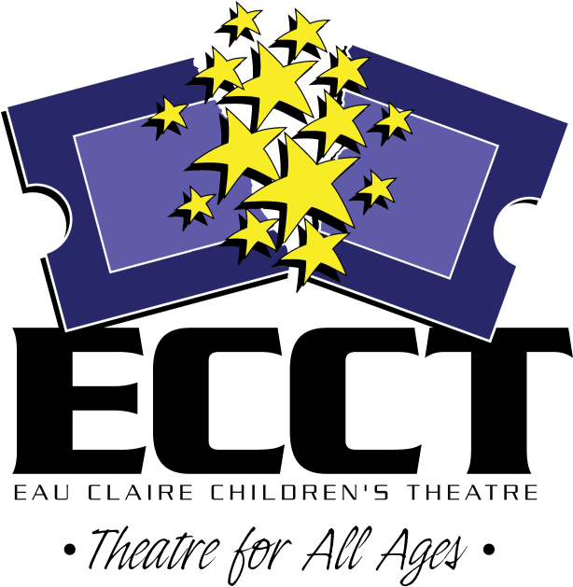

715-839-8877 * 1814 Oxford Avenue * ecct.org

**1814 Oxford Avenue**

**Eau Claire, WI 54703**

**715.839.8877**

Ages 3-4

**FAIRY TALE THEATRE**

**June 15-July 1 Mon/Wed**

**9am-9:45am $24**

**July 13-17 9am-9:45am $24**

Fairytales introduce our youngest actors to theatre with playacting, storytelling & arts & crafts.

**LITTLE PRINCESSES**

**July 6-10 9am-9:45am $24**

Discover famous storybook princesses through games, acting, arts & crafts, and stories!

**HAPPY FEET**

**July 6-10 10am-10:45am $24**

Our youngest dancers show us their Happy Feet to popular Disney songs.

**LITTLE PIRATES**

**July 6-10 11am-11:45am $24**

Have a swashbuckling good time! Play pirate games, make flags, and hunt for hidden treasure!

**FROZEN SUMMER**

**July 20-24 9am-9:45 $24**

Find out what Frozen kids do in summer! Play games and make crafts inspired by *Frozen!*



**Ages 5-6**

**MOVE YOUR FEET**

**June 15-July 1 Mon/Wed**

**11am-Noon $24**

Move Your Feet and learn some cool dance moves to popular Disney songs.

**FAIRY TALE THEATRE**

**June 15-July 1 Mon/Wed**

**10:00-10:45am $24**

**July 13-17 10am-10:45am $24**

Fairytales are used to bring theatre to life with playacting, storytelling, movement & arts & crafts.

**FROZEN SUMMER**

**July 20-24 10am-10:45am $24**

Find out what Frozen kids do in summer! Play games and make crafts inspired by *Frozen!*

**Ages 5-7**

**PLUNDERING PIRATES**

**June 15-19 9am-Noon $40**

Ahoy Mateys! We’ll be sailing the high seas and looking for adventure while learning pirate lingo and hunting treasure!

**PLAYACTING**

**June 15-19 1pm-3pm $28**

We’ll work together to create stage versions of our favorite fairytales, including dialogue, masks, and simple set pieces.

**SUPERHERO ACADEMY**

**June 22-26 9am-Noon $40**

Everyone has a superhero inside them! Make masks and capes, draw your own comics, & have fun acting out stories with your new super-friends!



**MINION MADNESS**

**June 22-26 1pm-4pm $40**

**July 20-24 9am-Noon $40**

The Minions have taken over ECCT! Join us for a week of minion games, crafts and fun!

**FAIRY PRINCESSES**

**July 6-10 9am-Noon $40**

**July 27-31 1pm-4pm $40**

Become a Princess for the week! Design costumes, get a princess make-over, make tiaras and have a royal tea party! Learn about real and storybook princesses.

**DRAGON TRAINING**

**July 13-17 9am-Noon $40**

Let’s play Knights, Vikings and Dragons! We’ll be playing games from our favorite dragon stories like *How to Train Your Dragon!*

**WILD THINGS**

**July 27-31 9am-Noon $40**

Are you a friendly monster? Or a scary one? Make monster masks, play monster games and act out your favorite monster stories like *Where the Wild Things Are.*

**WORLD OF SEUSS**

**August 3-7 9am-Noon $40**

Oh, the thinks we will think, and the acts we will act! Using the works of Dr. Seuss, every day will feature new games and crafts as we learn to use our imaginations!

**Ages 7-10**

**DAYS WITH DAHL**

**July 6-10 1pm-4pm $40**

We’ll be having a supersillious time with skits, games, and crafts based on our favorite works by Roald Dahl, like *Charlie and the Chocolate Factory, James and the Giant Peach,* and *Matilda*.

**THEATRE GAMES**

**July 13-17 1pm-4pm $40**

**July 27-31 1pm-4pm $40**

Easy theatre and improv games are used to explore creating characters, getting comfortable on stage and making people laugh.

**GLEE FOR BEGINNERS**

**July 20-24 9am-Noon $40**

Learn show choir basics and put together a routine to present on the last day of class!

**DRAMA CAMP I**

**July 20-24 1pm-4pm $50**

Not sure what the theatre has to offer? Each day covers two new topics. Includes a snack break and tickets to see *A PIRATES LIFE FOR ME.*

**MUSIC IN ME**

**July 27-31 9am-Noon $40**

Combo class! Take “Junkyard Symphony,” “Broadway Dance,” and “Sing Out!” and save!

**JUNKYARD SYMPHONY**

**July 27-31 9am-10am $20**

We’ll use coffee cans, soda bottles and other found objects to create our own “STOMP” show.

**BROADWAY DANCE**

**July 27-31 10am-11am $20**

Pick up a variety of dance moves – tap, jazz, modern – with the help of fun Broadway songs.

**SING OUT!**

**July 27-31 11am-Noon $20**

Learn the proper way to sing and pick out Broadway songs to use for future auditions.

**Ages 8-12**

**ACTING FOR GIRLS ONLY**

**June 15-19 1pm-4pm $40**

**July 6-10 1pm-4pm $40**

Class focuses on theatre games, modeling, and acting skills using scenes, monologues and audition pieces for girls only.

**ACT IT OUT!**

**June 22-26 1pm-4pm $40**

Combo class! Take “Stage Combat,” “Relaxation for Actors,” and “Clowning Around” and save!

**STAGE COMBAT**

**June 22-26 1pm-2pm $20**

Have fun learning the proper and safe way to fight and use weapons on stage.

**RELAXATION FOR ACTORS**

**June 22-26 2pm-3pm $20**

Learn ways to conquer stage fright and mentally prepare yourself for the stage.

**CLOWNING AROUND**

**June 22-26 3pm-4pm $20**

Find out how to make people laugh with magic, pantomime & juggling.

**TRIPLE THREAT**

**July 20-24 1pm-4pm $40**

You’ll be what every performer dreams of being- a Triple Threat- by learning acting, singing and dancing skills in one week.

**Ages 8-14**

**CELEBRATE SUMMER WITH A SHOW I**

**June 15-19 & 22-26 9am-Noon *Class is full*  $60**

***\*Afternoon session added\****

**June 15-19 & 22-26 1-4pm $60**

Join the cast of the musical *Magic Tree House: The Knight at Dawn!* Rehearse 2 weeks & present 3 shows. Morning session: June 25 10am, & 6:30pm June 26 10am. Afternoon session: June 24 at 6:30pm, June 25 & 26 at 1:30pm.

**CELEBRATE SUMMER WITH A SHOW II**

**July 6-10 & 13-17 9am-Noon $60**

Be in the cast of the *Tales from the Brothers Grimm.* Rehearse 2 weeks & present 5 shows July 16 10am, 1:30pm, 6:30pm/July 17 10am & 1:30pm

**AUDITIONING WORKSHOP**

**July 28 & 30 5pm-6pm $10**

Learn what to expect and how to prepare to audition for show in ECCT’s upcoming season.

**SUMMER KIDS CABARET**

**July 27-31 1pm-3pm $28**

Create a musical revue with group numbers, vocal solos and duets and dance numbers presented on the last day of class

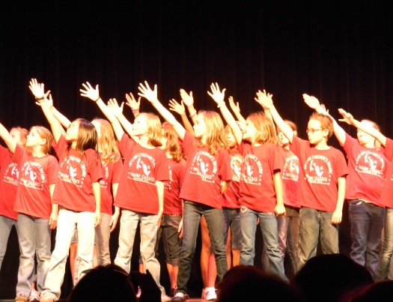**Ages 8-16**

**PRIVATE VOICE LESSONS**

**June 16-July 29**

**Tues 9am-1pm or Wed 9am-5pm**

**30min lesson each week $70**

Improve your skills! Get private voice training through the study of musical theatre literature.

**Ages 8-16**

**SO YOU WANNA DO A SHOW?**

**August 3-8 9am-5pm $90**

Think you’ve got what it takes to put on a show in a week? Rehearse all week to present the musical *A Pirate’s Life for Me* Sat. Aug. 8 at 2pm. Includes all snack breaks.

. **Ages 10-16**

**STREET ART**

**July 13-17 & July 27 9am-Noon $30**

Use your creative skills on downtown windows and sidewalks to promote WEST SIDE STORY. Includes tickets to the show!

**SHOW CHOIR PREP**

**July 13-17 1pm-4pm $30**

Learn show choir basics or hone your skills over the week. We will be learning and choreographing a routine in a week! Are you up to the challenge?

**Ages 12-18**

**TECHIE TRAINING**

**July 6-10 1pm-4pm $40**

Combo class! Take “Costuming,” “Stagecraft,” and “Stage Crew Boot Camp” together to save and become the ultimate techie!

**COSTUMING**

**July 6-10 1pm-2pm $20**

Learn about costuming from design to building a functional piece. Learn sewing skills and tour the costume warehouse!

**STAGECRAFT**

**July 6-10 2pm-3pm $20**

Find out what goes into building and painting all the sets we use in ECCT shows! Work to help construct and paint scenery pieces to be used in an upcoming ECCT production!

**STAGE CREW BOOT CAMP**

**July 6-10 3pm-4pm $20**

From lighting & sound to stage managing, there’s a lot a member of the stage crew needs to know! Learn the basics so you can start helping behind the scenes!

MC900021360[1]**Heyde Center Classes**

**Aug. 10-14**

**SO YOU THINK YOU CAN ACT?**

**9am-3pm Ages 8-14 $70**

Think you’ve got what it takes to put on a show in a week? Present *The Pied Piper* Friday August 14 at 1:30pm. Includes snack breaks.

**LITTLE PRINCESSES**

**9am-9:45am Ages 3-5 $24**

Discover famous storybook princesses through games, acting, arts & crafts, and stories!

**HAPPY FEET**

**10am-10:45am Ages 3-5 $24**

Our youngest dancers show us their Happy Feet to popular Disney songs.

**LITTLE PIRATES**

**11am-11:45am Ages 3-5 $24**

Have a swashbuckling good time! Play pirate games, make flags, and hunt for hidden treasure!

**MINION MADNESS**

**9am-Noon Ages 5-7 $40**

The Minions have taken over The Heyde Center! Join us for a week of minion games, crafts and fun!



**T-Shirts**

Everyone taking a class gets a t-shirt as a reward for a job well-done and a souvenir of their summer fun!

Please indicate the t-shirt size you would like on the registration form. One

t-shirt is given to each child. (Not one t-shirt per class)

Registrations received after July 6th will not be guaranteed a shirt, but will receive one pending availability.

Free Class!

The Eau Claire and Chippewa Falls School Districts offer one FREE ECCT class to their students! See registration form for complete details

Time

Unless otherwise specified, classes run Monday through Friday of the week(s) indicated.

Location

Unless otherwise specified, all classes are located at the Eau Claire Children’s Theatre, 1814 Oxford Avenue in Eau Claire.

Heyde Center Classes will take place at the Heyde Center, 3 S. High Street in Chippewa Falls.

REGISTRATION POLICIES

**ECCT SUMMER 2015 DRAMA CLASS REGISTRATION FORM**

CHILD’S NAME_____________________________________________________

AGE______ CURRENT GRADE SPRING 2015________ GENDER M F

SCHOOL______________________________________________________________

PARENT/GUARDIAN NAME(S)____________________________________________

ADDRESS_____________________________________________________________

CITY/ST/ZIP___________________________________________________________

PARENT EMAIL ________________________________________________________

(Registration confirmations will only be sent by email- please print neatly!)

DAYTIME PHONE__________________ EMERGENCY PHONE________________

**\*PARTICIPANT’S T-SHIRT SIZE:**  **YOUTH**  10-12 14-16 **ADULT** S M L XL

CLASS DATE(S) TIME FEE

______________________________ _____________ ___________ _____

______________________________ _____________ ___________ _____

______________________________ _____________ ___________ _____

______________________________ _____________ ___________ _____

______________________________ _____________ ___________ _____

**GRAND TOTAL $_____**

_____ Cash (in person only) _____ Check to “ECCT” enclosed

_____ Charge my: ___ Mastercard ___ Visa Exp. Date________ CVV________ (3 digit code on back)

Card Number___________________________________________________________

Signature______________________________________________________________

I agree to hold ECCT, its Board of Directors and employees free and harmless from any and all claims, costs, losses, damages and expenses of any nature or kind which may be incurred by participation in ECCT summer activities.

Parent/Guardian___________________________________ Date_________________

**MAIL COMPLETED FORM WITH PAYMENT BY MAY 29 TO:**

**ECCT 1814 Oxford Avenue Eau Claire, WI 54703.**

FOR OFFICE USE:

Rec’d________ Confirmed_______ Payment: Cash Check #_______ CC- _______

**REFUNDS**

* All classes have enrollment limits. Early registration is encouraged. Should you enroll in a class that is already filled you will be issued a refund.
* A full refund will be made if a class is cancelled by ECCT.
* No refunds will be given if a student drops out of a class or cancels their registration. No exceptions.

**CLASS CANCELLATIONS**

A minimum number of students are required before a class can be offered. ECCT reserves the right to cancel a class if enrollment numbers are not met.

**INSURANCE**

ECCT does not provide accident insurance for students participating in sponsored activities. All participants should review their personal insurance policies.

**CLASSROOM BEHAVIOR**

Disruptive or disrespectful behavior is not tolerated and will result in expulsion from class with no refund.

**WE LOVE PARENTS, BUT…**

With your child’s best interests in mind, parents are invited to attend their child’s first class session and perhaps the last session, particularly if it ends in a performance for family and friends. The quality of instruction is affected by parent and/or sibling distractions and interruptions. Instructors welcome the opportunity to discuss participants’ progress with parents- give them a call at 715-839-8877.

**REGISTRATION DEADLINE**

Registration deadline is **MAY 29, 2015.** After this date classes with low enrollment may be cancelled. After May 29, call 715-839-8877 for class availability before registering.

**ATTENTION STUDENTS IN THESE SCHOOL DISTRICTS:**

**EAU CLAIRE AREA SCHOOL DISTRICT (ECASD)**

**CHIPPEWA FALLS AREA SCHOOL DISTRICT (CFASD)**

For students currently attending these districts- public, parochial, homeschool- the Registration Fee will be covered by your school district for any ONE class this summer. Put your school district code- ECASD or CFASD- under FEE for the ONE class on your registration form being paid for by the District. All fees for additional classes are the responsibility of the student. **PLEASE NOTE:**

* District residency is based on where you live- ie: where you pay taxes. A student who lives in Eau Claire that attends school in Altoona would qualify for one free class. A student who lives in Altoona but attends school in Eau Claire would not.
* To qualify for a free class, the student must currently be attending school in grades K-12, not entering school this fall.
* Due to administrative changes, three and four year olds that are in pre-school or 4K programs no longer qualify for this offer.

**PHOTOGRAPHY**

ECCT may take photos and/or video during workshops, workshop presentations and classes for our archives and for use in future education program marketing in print, broadcasting and online (no names would be listed with photos/video).

**QUESTIONS? 715-839-8877 or** [**frontdesk@ecct.org**](mailto:frontdesk@ecct.org)