Eau Claire

Children’s Theatre

Spring Classes

2017

**ECCT SPRING 2017 DRAMA CLASS REGISTRATION FORM**

CHILD’S NAME_____________________________________________________

AGE______ GENDER M F

PARENT/GUARDIAN NAME(S)____________________________________________

ADDRESS_____________________________________________________________

CITY/ST/ZIP___________________________________________________________

PARENT EMAIL ________________________________________________________

(Registration confirmations will only be sent by email- please print neatly!)

DAYTIME PHONE__________________ EMERGENCY PHONE________________

CLASS DATE(S) TIME FEE

______________________________ _____________ ___________ _____

______________________________ _____________ ___________ _____

**GRAND TOTAL $_____**

_____ Cash (in person only) _____ Check to “ECCT” enclosed

_____ Charge my: ___ Mastercard ___ Visa Exp. Date________ CVV________ (3 digit code on back)

Card Number___________________________________________________________

Signature______________________________________________________________

I agree to hold ECCT, its Board of Directors and employees free and harmless from any and all claims, costs, losses, damages and expenses of any nature or kind which may be incurred by participation in ECCT spring activities.

Parent/Guardian___________________________________ Date_________________

**MAIL COMPLETED FORM WITH PAYMENT BY FEB 20 TO:**

**ECCT 1814 Oxford Avenue Eau Claire, WI 54703.**

FOR OFFICE USE:

Rec’d________ Confirmed_______ Payment: Cash Check #_______ CC- _______

March 4, 11, & 18

Ages 5-7 9:00am-10:20am

Theatre Games

For the young performer who wants to start exploring the

world of theatre! Easy theatre and improvisational games are

used to explore creating characters, getting comfortable on

stage, and making people laugh! $30

**REFUNDS**

* All classes have enrollment limits. Should you enroll in a class that is already filled you will be issued a refund.
* A full refund will be made if a class is cancelled by ECCT.
* No refunds will be given if a student drops out of a class or cancels their registration. No exceptions.

**CLASS CANCELLATIONS**

A minimum number of students are required before a class can be offered. ECCT reserves the right to cancel a class if enrollment numbers are not met.

**INSURANCE**

ECCT does not provide accident insurance for students participating in sponsored activities. All participants should review their personal insurance policies.

**CLASSROOM BEHAVIOR**

Disruptive or disrespectful behavior is not tolerated and will result in expulsion from class with no

refund.

Ages 8-10 10:30am-12:00pm

Theatre Training

Students will play theatre games with a focus on learning to create characters, build ensemble, and use their voice to project and articulate while having a lot of fun! Students will also participate in an audition workshop to prepare them to audition for ECCT productions $30

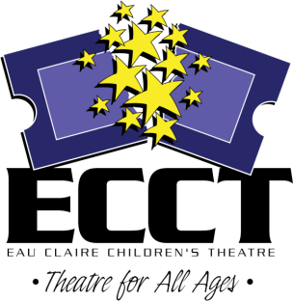

715-839-8877 | 1814 Oxford Avenue | ecct.org