Eau Claire

Children’s Theatre

Summer Classes

2017

Kids in the Eau Claire School District can take classes FREE! Details inside!

NEW Classes and returning favorites for ages 3-18!

With over 40 Classes, there’s something for everyone!

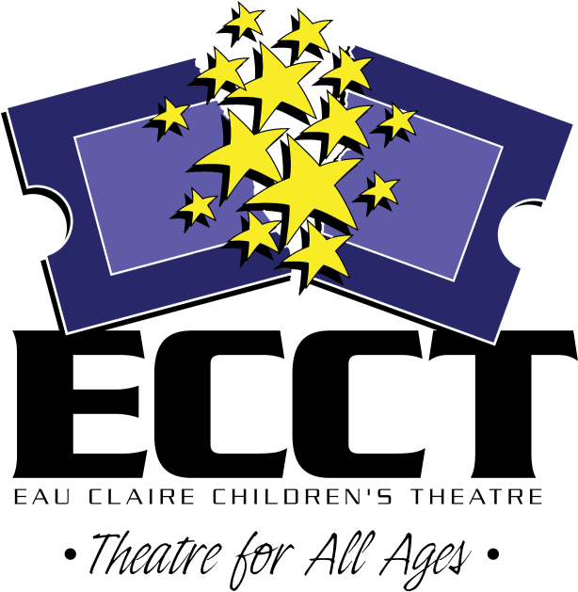

715-839-8877 * 1814 Oxford Avenue * ecct.org

**1814 Oxford Avenue**

**Eau Claire, WI 54703**

**715.839.8877**

The Eau Claire Area School District will pay the registration fee for ECASD 5-18 to take classes listed in this brochure for FREE until filled!



Ages 3-4

**FAIRY TALE THEATRE**

***(Not eligible for school district credit)***

**June 19-23 9am-9:45am $24**

Fairytales introduce our youngest actors to theatre with playacting, storytelling & arts & crafts.

**LITTLE HEROES**

***(Not eligible for school district credit)***

**June 26-30 9am-9:45am $24**

**July 24-28 9am-9:45am $24**

It’s never to early to start being a hero! Discover what it means to be super, while learning about the world of theatre through stories, games and crafts!

**Ages 5-7**

**PLUNDERING PIRATES**

**June 12-16 1pm-4pm $40**

Ahoy Mateys! We’ll be sailing the high seas and looking for adventure while learning pirate lingo and hunting treasure!



**MAD FOR MADAGASCAR!**

**June 19-23 1pm-4pm $40**

**July 24-28 9am-Noon $40**

Break out of the zoo and come down to ECCT, where we’ll be making animal masks, playing games and learning to MOVE IT, MOVE IT!

**ROCKIN’ ROBOTS**

**June 26-30 1pm-4pm $40**

Join us for a week of science, drama, and terrible dance moves! We’ll act out android stories and make cyborg crafts. It’s a blast for any automaton!

**FAIRY PRINCESSES**

**July 24-28 1pm-4pm $40**

Become a Princess for the week! Design costumes, get a princess make-over, make tiaras and have a royal tea party! Learn about real and storybook princesses.



**DINO DRAMA!**

**July 17-21 9am-Noon $40**

Find out what happens when the world of theatre and the world of dinosaurs combine! Theatre games, crafts and activities perfect for any dino lover!

**SUPERHERO ACADEMY**

**July 17-21 1pm-4pm $40**

Everyone has a superhero inside them! Make masks and capes, draw your own comics, & have fun acting out stories with your new super-friends!



**WORLD OF SEUSS**

**July 31-Aug 4 9am-Noon $40**

Oh, the thinks we will think, and the acts we will act! Using the works of Dr. Seuss, every day will feature new games and crafts as we learn to use our imaginations!

**Ages 7-10**

**GLEE FOR BEGINNERS**

**July 10-14 9am-Noon $40**

Learn show choir basics and put together a routine to present on the last day of class!

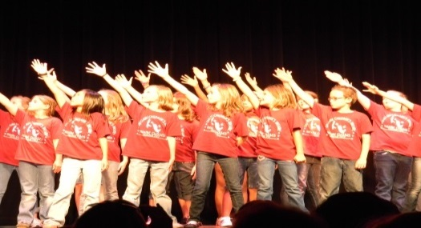

**MUSIC IN ME**

**July 17-21 9am-Noon $40**

Combo class! Take “Junkyard Symphony,” “Broadway Dance,” and “Sing Out!” and save!

**Ages 7-10**

**(Continued)**

**JUNKYARD SYMPHONY**

**July 17-21 9am-10am $20**

We’ll use coffee cans, soda bottles and other found objects to create our own “STOMP” show.

**BROADWAY DANCE**

**July 17-21 10am-11am $20**

Pick up a variety of dance moves – tap, jazz, modern – with the help of fun Broadway songs.

**Ages 8-12**

**ACTING FOR GIRLS ONLY**

**June 12-16 1pm-4pm $40**

**July 10-14 1pm-4pm $40**

Class focuses on theatre games, modeling, and acting skills using scenes, monologues and audition pieces for girls only.

**ACT IT OUT!**

**June 19-23 1pm-4pm $40**

Combo class! Take “Stage Combat,” “Improv Games,” and “Clowning Around” and save!

**Ages 8-14**

**SUMMER KIDS CABARET**

**June 12-16 1pm-3pm $30**

Perfect for a new performer! Create a revue with music, sketches and dance numbers presented on the last day of class

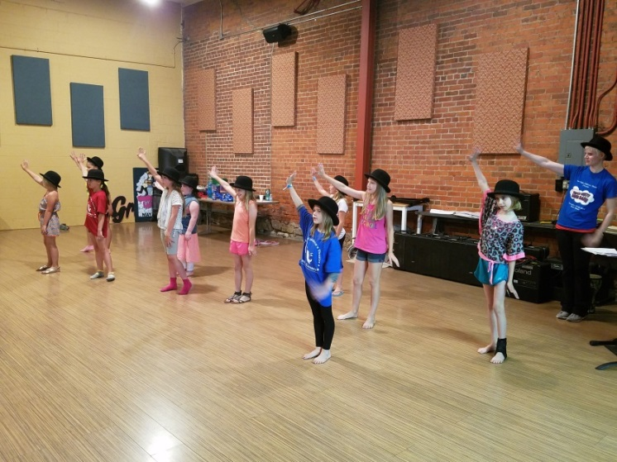

**CELEBRATE SUMMER WITH A SHOW I (afternoon)**

***(Not eligible for school district credit)***

**June 19-23 & 26-30 1pm-4pm $60**

Join the cast of the musical *Magic Treehouse: Pirates Past Noon* Rehearse 2 weeks & present 3 shows June 28 at 6:30pm, June 29 at 1:30pm, June 30 at 1:30pm

**AUDITIONING WORKSHOP**

**July 31 & Aug 2 5pm-6pm $10**

Learn what to expect and how to prepare to audition for show in ECCT’s upcoming season.

**Ages 8-16**

**PRIVATE VOICE LESSONS**

***(Not eligible for school district credit)***

**June 12-July 26**

**Mon OR Wed 1:30-4:30pm**

**30min lesson each week $70**

Improve your skills! Get private voice training through the study of musical theatre literature.

*Please list top 3 preferences for voice lesson time*

. **Ages 10-16**

**SHOW CHOIR PREP**

**June 12-16 9am-12pm $30**

Learn show choir basics or hone your skills over the week. We will be learning and choreographing a routine in a week! Are you up to the challenge?

**T-Shirts**

T-shirts are available as a souvenir of your week at ECCT. T-shirts are $7 and may be ordered on the registration form.

Please indicate the t-shirt size you would like on the registration form, and add $7 to your fee. Shirts are not covered by the school district and must be paid for at time of order.

T-shirt orders must be received by July 7th to ensure correct size order. Orders received after this date may still receive a shirt based on availability.

Free Classes!

The Eau Claire and Chippewa Falls School Districts offer ECCT classes for FREE to their students! See registration form for complete details.

Time

Unless otherwise specified, classes run Monday through Friday of the week(s) indicated.

Class Limits

All classes have enrollment limits, and many of our classes fill very quickly! Early registration is encouraged. Please read the reservation policies for more information.

REGISTRATION POLICIES

**ECCT SUMMER 2017 DRAMA CLASS REGISTRATION FORM**

CHILD’S NAME_____________________________________________________

AGE______ CURRENT GRADE SPRING 2017________ GENDER M F

SCHOOL______________________________________________________________

PARENT/GUARDIAN NAME(S)____________________________________________

ADDRESS_____________________________________________________________

CITY/ST/ZIP___________________________________________________________

PARENT EMAIL ________________________________________________________

(Registration confirmations will only be sent by email- please print neatly!)

DAYTIME PHONE__________________ EMERGENCY PHONE________________

CLASS DATE(S) TIME FEE

______________________________ _____________ ___________ _____

______________________________ _____________ ___________ _____

______________________________ _____________ ___________ _____

______________________________ _____________ ___________ _____

T-SHIRT (optional)

**SIZE (circle one):**  **YOUTH**  10-12 14-16 **ADULT** S M L XL $7

**GRAND TOTAL $_____**

_____ Cash (in person only) _____ Check to “ECCT” enclosed

_____ Charge my: ___ Mastercard ___ Visa Exp. Date________ CVV________ (3 digit code on back)

Card Number___________________________________________________________

Signature______________________________________________________________

I agree to hold ECCT, its Board of Directors and employees free and harmless from any and all claims, costs, losses, damages and expenses of any nature or kind which may be incurred by participation in ECCT summer activities. I have read and will abide by ECCT’s registration policies.

Parent/Guardian___________________________________ Date_________________

**MAIL COMPLETED FORM WITH PAYMENT TO:**

**ECCT 1814 Oxford Avenue Eau Claire, WI 54703.**

FOR OFFICE USE:

Rec’d________ Confirmed_______ Payment: Cash Check #_______ CC- _______

**REFUNDS**

* All classes have enrollment limits. Early registration is encouraged. Should you enroll in a class that is already filled you will be issued a refund.
* A full refund will be made if a class is cancelled by ECCT.
* No refunds will be given if a student drops out of a class or cancels their registration. No exceptions.

**CLASS CANCELLATIONS**

A minimum number of students are required before a class can be offered. ECCT reserves the right to cancel a class if enrollment numbers are not met.

**INSURANCE**

ECCT does not provide accident insurance for students participating in sponsored activities. All participants should review their personal insurance policies.

**CLASSROOM BEHAVIOR**

Disruptive or disrespectful behavior is not tolerated and will result in expulsion from class with no refund.

**WE LOVE PARENTS, BUT…**

With your child’s best interests in mind, parents are invited to attend their child’s first class session and perhaps the last session, particularly if it ends in a performance for family and friends. The quality of instruction is affected by parent and/or sibling distractions and interruptions. Instructors welcome the opportunity to discuss participants’ progress with parents- give them a call at 715-839-8877.

**REGISTRATION DEADLINES**

Registration deadline for June Classes is **MAY 26, 2017.** Registration deadline for July and August classes is **JUNE 26, 2017.** After these dates classes with low enrollment may be cancelled Registrations will be accepted after the deadline for any classes with room but please call 715-839-8877 for class availability before registering.

**PHOTOGRAPHY**

ECCT may take photos and/or video during workshops, workshop presentations and classes for our archives and for use in future education program marketing in print, broadcasting and online (no names would be listed with photos/video).

**ATTENTION STUDENTS IN EAU CLAIRE AREA SCHOOL DISTRICT (ECASD):**

For students currently attending these districts- public, parochial, homeschool- the Registration Fee will be covered by your school district for any classes this summer. Put your school district code- ECASD under FEE for the class(es) on your registration form being paid for by the District.

**PLEASE NOTE:**

* District residency is based on where you live- ie: where you pay taxes. A student who lives in Eau Claire that attends school in Altoona would qualify for free classes. A student who lives in Altoona but attends school in Eau Claire would not.
* To qualify for free classes, the student must currently be attending school in grades K-12, not entering school this fall.
* Students that are currently in pre-school or 4K programs do not qualify for this offer.

**QUESTIONS? 715-839-8877 or** [**frontdesk@ecct.org**](mailto:frontdesk@ecct.org)