SPOTLIGHT ACT AUDITIONS

Tuesday, January 22nd at 5:30pm
ECCT - 1814 Oxford Avenue

Kidz Kabaret
“Movie Night”

This year's theme is MOVIE NIGHT and will feature the South and Altoona Middle School Show Choirs, Spotlight Acts and performances by the Starquest 2012 Winners.
What to Know:
Auditions: Prepare a song of your choosing, in keeping with the theme. You may use piano, guitar or CD accompaniment. You may not sing a cappella. You may perform as a solo, duet or small group act. If selected the song you audition with will be the song you perform at KIDZ KABARET.
Performers in these acts must be ages 14 and younger.

Number of Openings: Up to 10 acts will be selected.
Rehearsals: Dress rehearsal will be held Feb. 7 at 5:30pm at The Oxford.
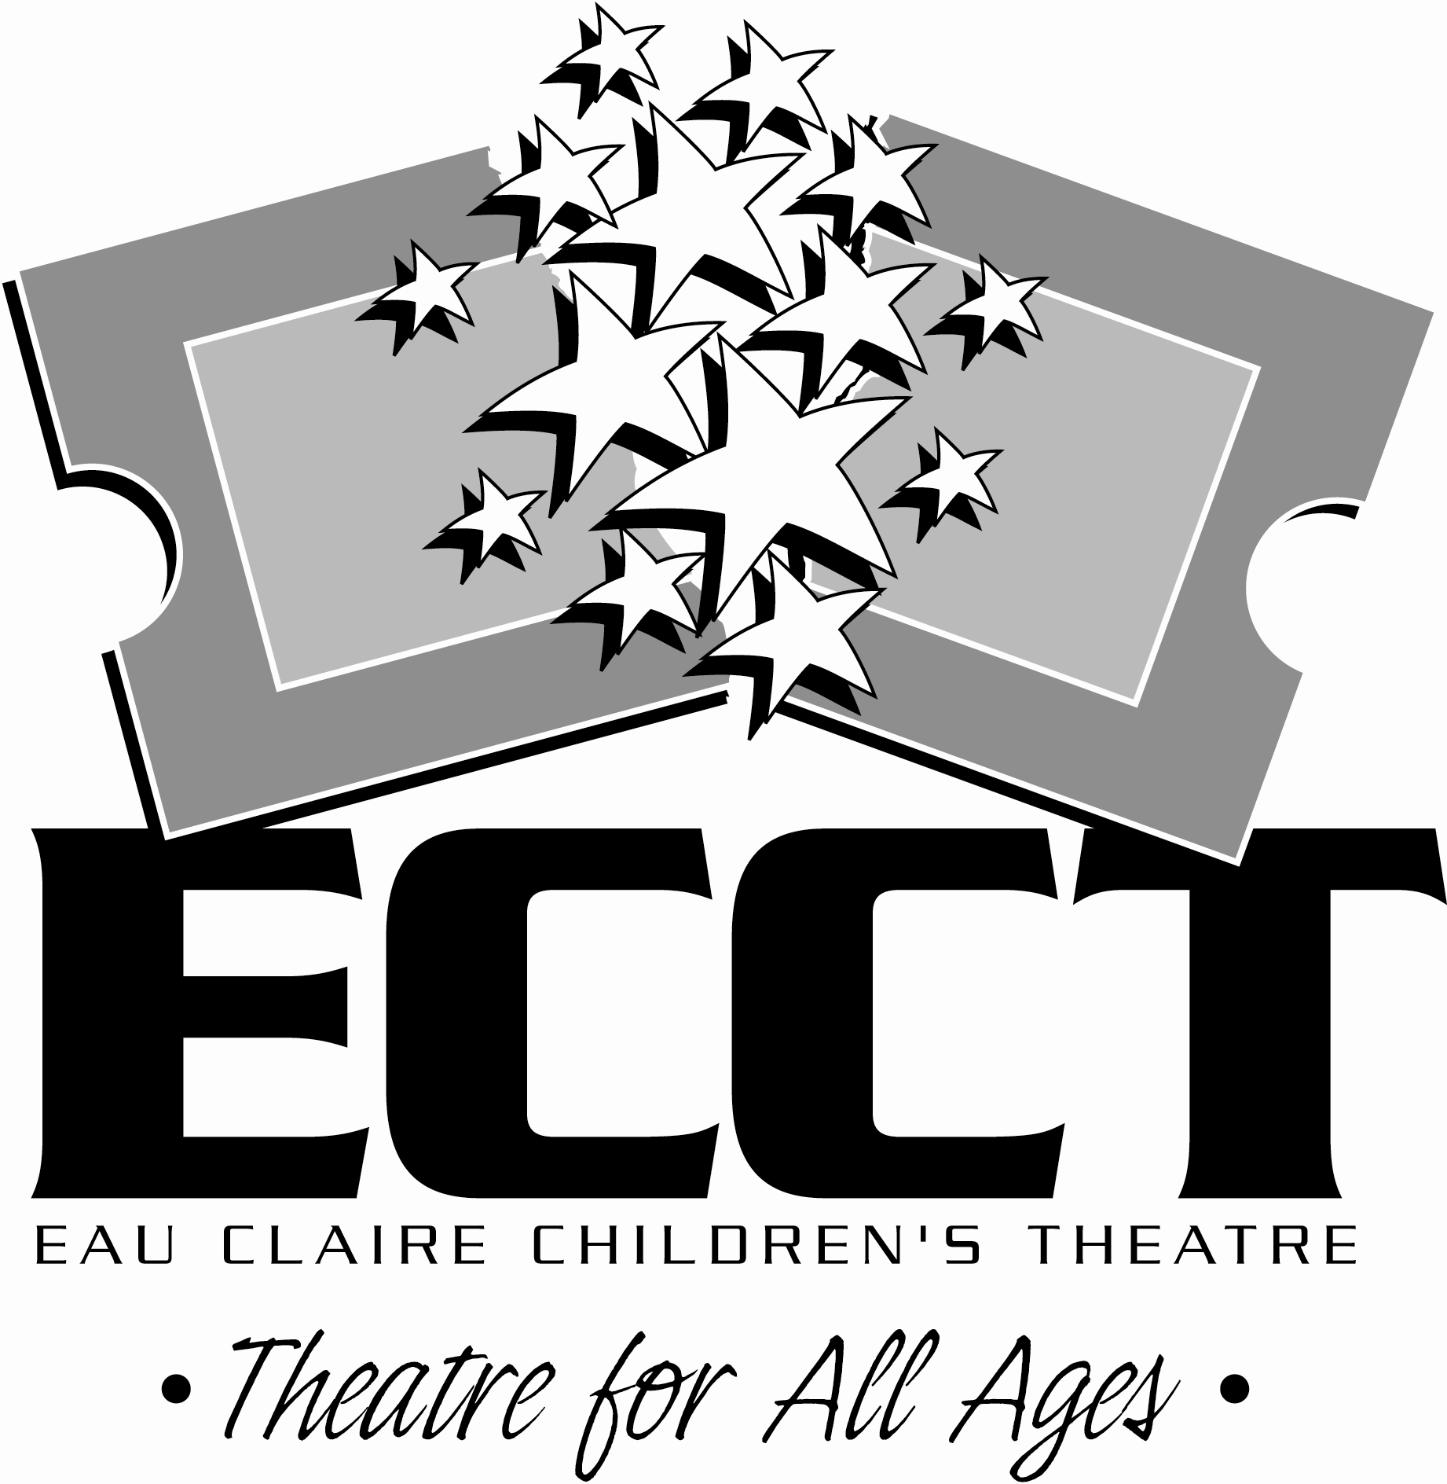
Performance: One performance will be given at The Oxford on Friday, Feb. 8 at 7pm.

For more info call 715-839-8877 or email frontdesk@ecct.org

