
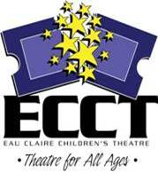
Winter Break Workshops
ECCT presents…
Three workshops to choose from:
Arctic Acting
Tuesday, December 28 9am-5pm
Come to play acting and improv games and put on a show!

Sounds of the Season
Wednesday, December 29 9am-5pm
Explore the world of sound effects and voice acting!

Polar Playwrights
Thursday, December 30 9am-5pm
Learn the basics of writing a play and help to make an
original show!

Other Info:
Program is open to 2-6th grade students.
Students must bring their own lunch. Snacks provided.
A short performance will be held each day at 5 pm.

Come to one, two, or all three!
For more information, call 715-839-8877 or email frontdesk@ecct.org
Cost: $25 per student
per session
Eau Claire Children’s Theatre, 1814 Oxford Avenue, Eau Claire
s
Registration forms available at: www.ecct.org

