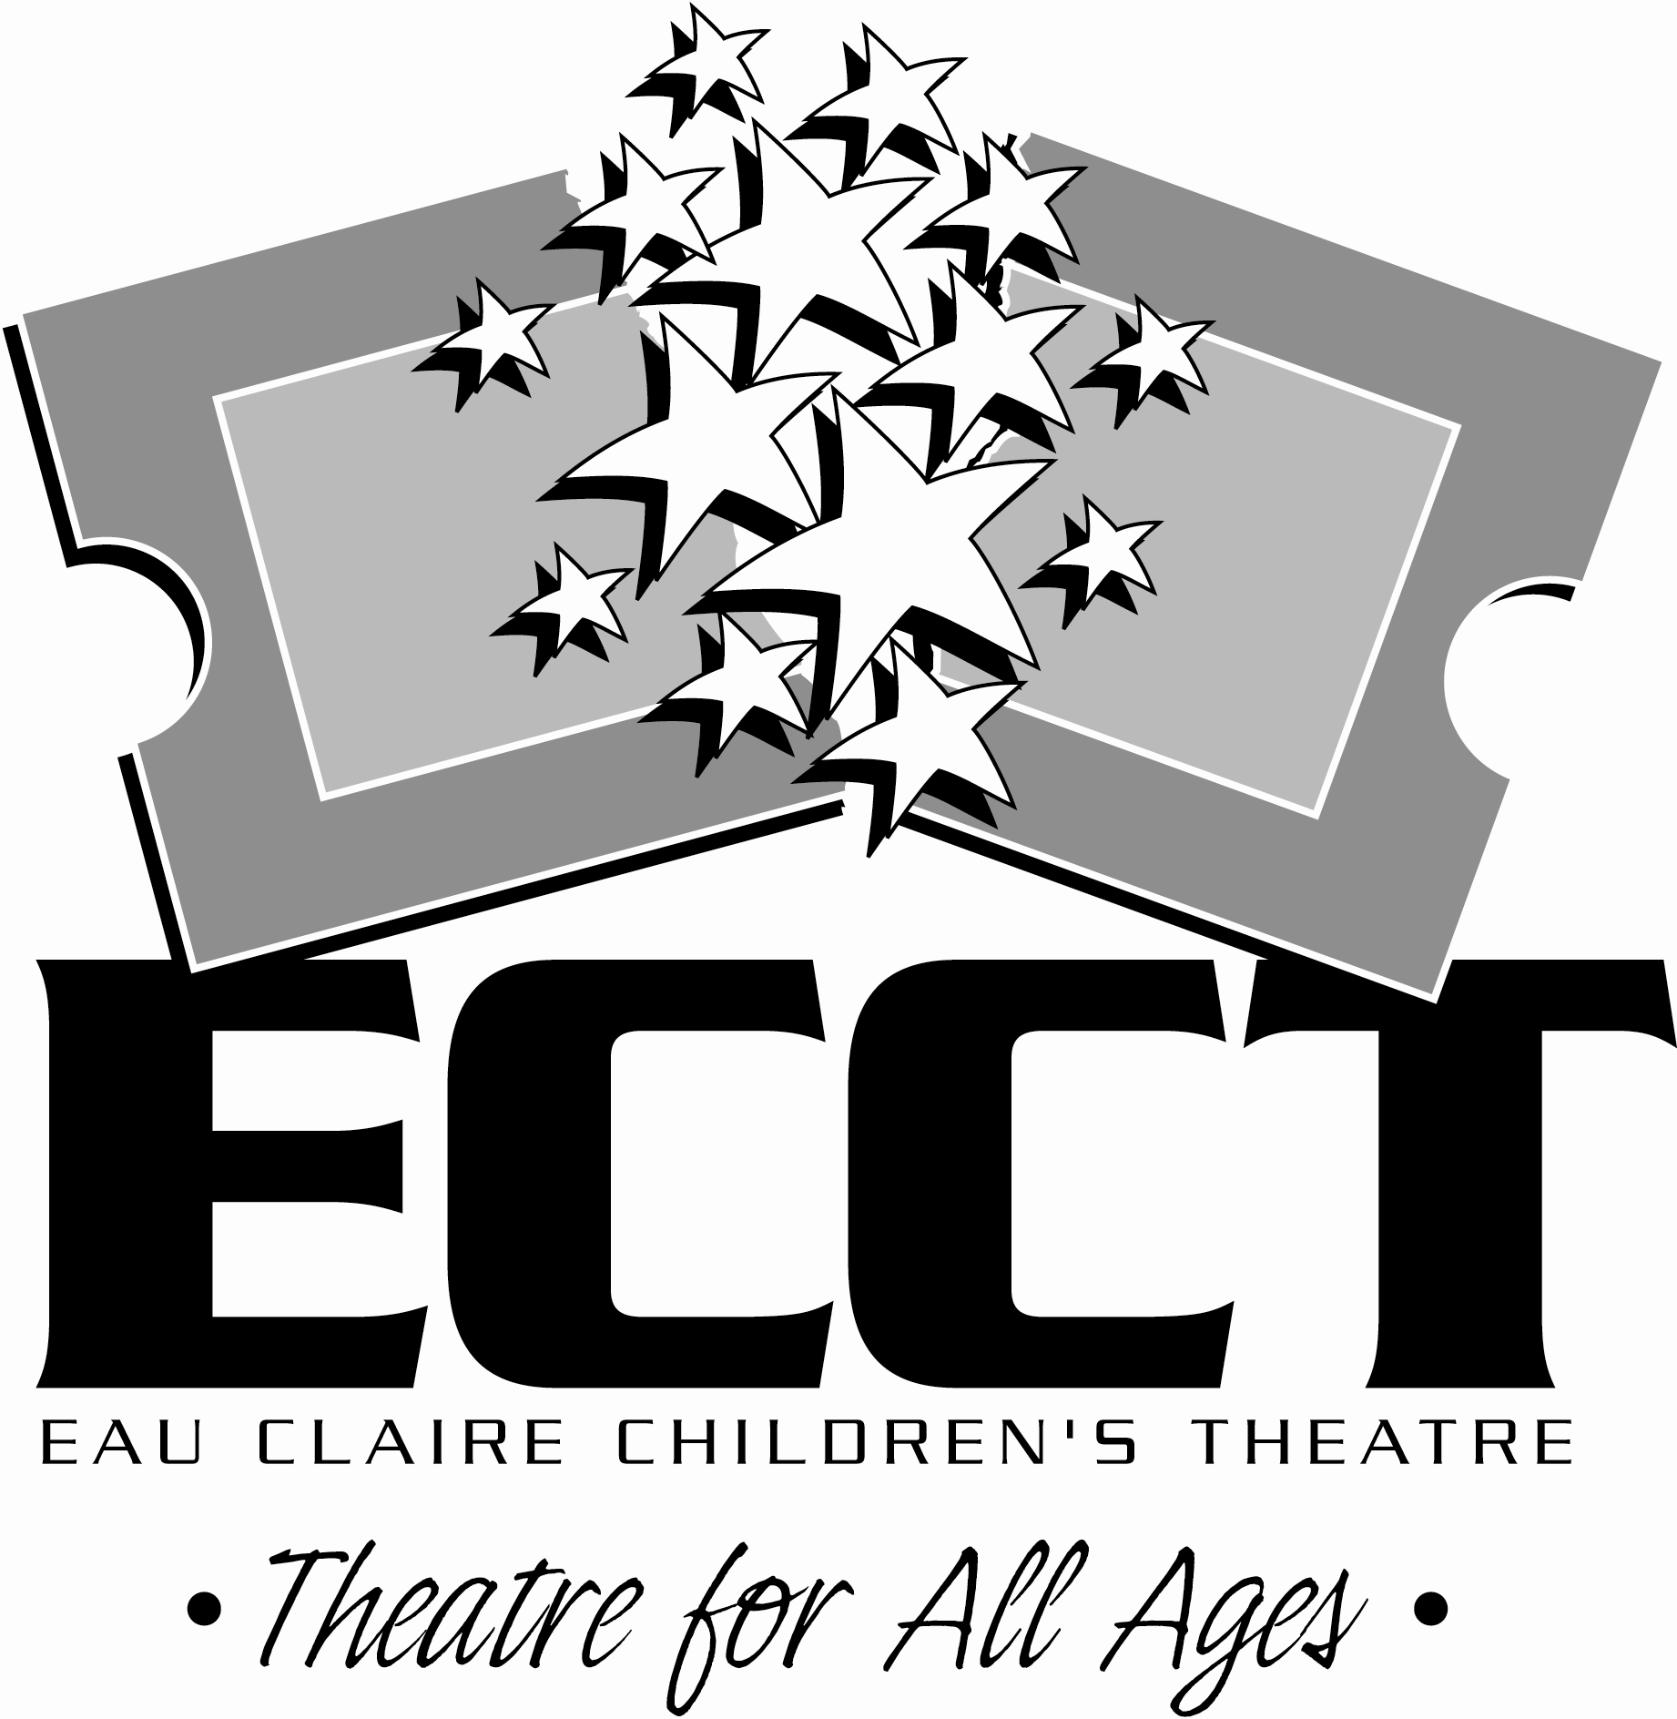
CALL FOR ENTRIES

The Eau Claire Children’s Theatre is western Wisconsin’s premier producer of live theatre for all ages. ECCT will be celebrating its 25th Anniversary during the 2013-2014 Season starting in September 2013. As part of the celebration, we are looking for a logo that can be used on items like tote bags and t-shirts to commemorate this achievement. The logo may also be used on the cover of 12,000 Season Brochures.

Things to know about ECCT:
- A great deal of information about ECCT can be found at www.ecct.org.
- ECCT presents Broadway musicals, school matinees, touring shows, and special events and offers summer classes.
- ECCT is Theatre for All Ages - children and adults are both onstage as performers and in the audience.
- ECCT was established in 1989 and presents an average of 15 shows each season at The Oxford and the State Theatre.

Things to know about submitting:
- Design specifications: We are looking for a creative logo that has a theatrical flair or sense to it. The design may be a variation on our current logo. The logo will be printed in color and in black and white and may be used in a variety of ways – on print pieces, souvenirs, website, etc. The design should be clean and versatile to use in these different formats. Because the logo may be used as stand alone branding in some instances, “Eau Claire Children’s Theatre” or “ECCT” must be worked into the logo. Also, as it’s for the 25th Anniversary, wording such as “25th Anniversary” or “Established 1989” should be worked into the design.

- Submitting: Creators may submit more than one design. Designs can be submitted as a JPG or PDF via email at info@ecct.org or mailed/delivered to ECCT, 1814 Oxford Avenue, Eau Claire, WI, 54703. Please include your name, address, phone number, and email address with your submission. All designs become the property of the Eau Claire Children’s Theatre, Inc. The creator must also be avaialble to work with ECCT staff to provide high and low res versions of the logo and any shape or size adjustments needed for various printing uses.

- Winning: The creator of the design that’s selected will receive two (2) season tickets to the 25th Anniversary Season (a $128 value), a tote bag featuring their design, and recognition in the ECCT newsletter and E-News (a combined circulation of over 11,000).

- Deadline: Submission deadline is April 30, 2013.

Questions? Contact ECCT at info@ecct.org or 715-839-8877.

WE WANT TO HEAR
FROM YOU!

The Eau Claire Children’s Theatre will be celebrating its 25th Anniversary during the 2013-2014 Season starting in September, 2013 and we want to hear from YOU! Do you have a funny backstage story? Memories of being in a show? Thoughts on how involvement with ECCT influenced your life? The 25th Anniversary Committee is looking for these anecdotes, thoughts, experiences, funny stories and the like to include in lobby displays, newsletters and playbills throughout the next season.

Over the next 3 months committee member and performer/actress/juggler Kobi Shaw will be collecting, editing and compiling these memories to be used throughout the season. You can submit your stories and thoughts to HappyAnniversaryECCT@gmail.com. In addition to your stories, thoughts and memories, please include your full name, a contact phone number, the approximate year(s) that you were involved with ECCT and a little about what you’re up to now- people love hearing where life has taken those who have been involved. Kobi may also contact you for more info or to see if you have pictures of your ECCT involvement that you could share.

Our deadline for collecting these stories is May 15 as we may use some in the next season brochure as well. With 25 years of experiences we hope to hear from many of you over the next three months and invite you to check out all the great shows and events coming up later this year for the 25th Anniversary.

CONTACT US
Send your stories and thoughts to Kobi at HappyAnniversaryECCT@gmail.com. Send questions about the anniversary season and events to Wayne at info@ecct.org.
Check out what’s going on at ECCT at www.ecct.org.

