ECCT SUMMER 2010 THEATRE CLASSES

EAU CLAIRE AREA SCHOOL DISTRICT STUDENTS
For students currently attending the ECASD- public, parochial, homeschool- Registration Fees will be covered by the school district for any ONE class this summer and Materials Fees will be covered by the student. ECASD students should put "ECASD" under Registration Fee for the ONE class on their registration form being paid for by the District. All fees for additional classes are the responsibility of the student.

CHIPPEWA FALLS AREA UNIFIED SCHOOL DISTRICT STUDENTS
For students currently attending the CFAUSD- public schools- Registration Fees will be covered by the school district for any ONE class this summer and Materials Fees will be covered by the student. CFAUSD students should put "CFAUSD" under Registration Fee for the ONE class on their registration form being paid for by the District. All fees for additional classes are the responsibility of the student.

ALL OTHERS
Students residing outside the ECASD and CFAUSD, all adult students, and young children not yet attending school will be responsible for both registration and materials fees for their classes.

The following classes will be held at ECCT,
1814 Oxford Avenue Eau Claire, WI.

PRIVATE VOICE LESSONS DATES: June 7-July 29, 2010
INSTRUCTOR: Annelies Slack
AGE DAY TIME Regist. Fee Materials Fee
10 years-Adult MON 9am-1pm; ½ hr./wk. $64 NA
10 years-Adult TUE 9am-7pm; ½ hr./wk. $64 NA
10 years-Adult WED 9am-1pm; ½ hr./wk. $64 NA
10 years-Adult THU 9am-7pm; ½ hr./wk. $64 NA
Private voice instruction emphasizing proper breathing, diction and projection through the study of musical theatre literature.

ACTING FOR THE CAMERA DATES: June 7—June 30, 2010
INSTRUCTOR: Taylor Price
AGE DAY TIME Regist. Fee Materials Fee
10-14 years MON & WED5pm-6pm $20 NA
15-Adult MON & WED 6pm-7pm $20 NA
Interested in commercials and film work? Learn acting basics and auditioning tips for the camera.

THEATRE GAMES DATES: June 7-July 1, 2010
INSTRUCTOR: Siri Brobst
AGE DAY TIME Regist. Fee Materials Fee
5-7 years TUES & THURS 12pm-1pm $20 NA
8-10 years MON & WED 12pm-1pm $20 NA
Easy theatre games for the young performer to explore creating a character and being comfortable on stage.

JUNKYARD SYMPHONY DATES: June 8- July 1, 2010
INSTRUCTOR: Annelies Slack
AGE DAY TIME Regist. Fee Materials Fee
7-10 years TUES & THUR 12pm-1pm $24 NA
Students will explore the use of coffee cans, 2-liter soda bottles & other found objects as instruments. Students will create their own “STOMP” show.

ACTING FOR GIRLS ONLY
DATES: Session 1-June 14- June 18, 2010
Session 2-June 28-July 2, 2010
INSTRUCTOR: Sara Shellenberger
AGE DAY TIME Regist. Fee Materials Fee
8-12 years MON-FRI 1pm-4pm $30 NA
This class for girls only will focus on theatre games, modeling and acting skills through the use of scenes, monologues and auditions pieces for girls only.
IMPROV FOR BEGINNERS DATES: June 8—July 1, 2010
INSTRUCTOR: Sara Shellenberger
AGE DAY TIME Regist. Fee Materials Fee
8-12 years TUES & THUR 5pm-7pm $40 NA
Learn acting basics without a script through the use of improve games, fairytales and kid’s stories.

CELEBRATE SUMMER WITH A SHOW
DATES: June 14-June 25, 2010
INSTRUCTOR: Wayne Marek
AGE DAY TIME Regist. Fee Materials Fee
8-14 years MON-FRI 9am-Noon $50 $12
Be a part of the cast for “TALES FROM THE BROTHERS GRIMM”. Actors rehearse for 2 weeks & present 5 shows June 24 and 25. Fees include show T-shirt.

ACTING FOR BOYS ONLY DATES: June 14-June 18, 2010
INSTRUCTOR: Chasten Glezman
AGE DAY TIME Regist. Fee Materials Fee
8-12 years MON-FRI 1pm-4pm $30 $NA
This class for boys only will focus on theatre games and acting skills developed through the use of scenes, monologues and auditions pieces for boys only.

ACTING FOR GIRLS ONLY II DATES: June 21-June 25, 2010
INSTRUCTOR: Sara Shellenberger
AGE DAY TIME Regist. Fee Materials Fee
10-15 years MON-FRI 1pm-4pm $30 NA
This class is for the intermediate to advanced performer. Develop acting skills through more advanced scenes, monologues and theatre games.

CREATIVE ACTING DATES: June 21-June 25, 2010
INSTRUCTOR: Siri Brobst
AGE DAY TIME Regist. Fee Materials Fee
7-11 years MON-FRI 1pm-3pm $20 NA
Young actors will use popular books to write stage scenes to perform on the last day of class.

SUMMER YOUTH CHOIR DATES: June 22-July 15 2010
INSTRUCTOR: Cathy Reitz
AGE DAY TIME Regist. Fee Materials Fee
8-14 years TUES & THUR 10am-11:30am $30 $10
Join local music teacher Cathy Reitz for a fun-filled summer choir experience! Learn new music, make new friends and spend two days performing at places all over Eau Claire. Fees include performance t-shirt!

DRAMA CAMP DATES: June 28-July 2, 2010
INSTRUCTORS: Various area performers & teachers
AGE DAY TIME Regist. Fee Materials Fee
7-10 years MON-FRI 9am-Noon $50 $10
Not sure what the theatre has to offer? Past camp topics have included stage makeup, auditioning, prop making, dance, improv games, juggling, costuming, tech theatre and more. Fees include all materials, a mid-morning snack break, souvenir T-shirt and ticket to see THE PIED PIPER OF HAMELIN!

INTRO TO STAGE MAKEUP DATES: June 28-July 1, 2010
INSTRUCTOR: Siri Brobst
AGE DAY TIME Regist. Fee Materials Fee
10 years-Adult MON-THUR 10am-12pm $20 $18
Learn the techniques of stage makeup, including animals, scars and fantasy.

PUPPETRY DATES: June 28-July 1, 2010
INSTRUCTOR: Siri Brobst
AGE DAY TIME Regist. Fee Materials Fee
8-12 years MON-THUR 10am-12pm $20 $5
Make a variety of puppets, write short scripts and perform a puppet show on the last day of class.

INSTRUMENT MAKING DATES: July 5- July9, 2010
INSTRUCTOR: Brynn Boyd
AGE DAY TIME Regist. Fee Materials Fee
6-9 years MON-FRI 12pm-2pm $20 $8
Make a variety of musical instruments including a shaker, a bell, a triangle, a drum and a harp.

FAIRY TALE THEATRE DATES: July 5-July 28, 2010
INSTRUCTORS: Amy Behrens & Siri Brobst
AGE DAY TIME Regist. Fee Materials Fee
3-4 years MON & WED 9am-9:45am $20 NA
3-4 years MON & WED 10am-10:45am $20 NA
5-6 years MON & WED 11am-11:45am $20 NA
Familiar fairytales are used as the basis of this introduction to theatre through creative dramatics, arts and crafts, storytelling and playacting.

BROADWAY DANCE DATES: July 5- July 28, 2010
INSTRUCTORS: Amy Behrens & Taylor Price
AGE DAY TIME Regist. Fee Materials Fee
7-10 years MON &WED 10am-11am $24 NA
11-14 years MON &WED 5pm-6pm $24 NA
15 years-Adult MON & WED 6pm-7pm $24 NA
Learn dance numbers from some of ECCT’s most popular shows like “High School Musical”, “Grease”, “Footloose” and Disney’s “Beauty and the Beast.”

MASK MAKING DATES: July 6- July 15, 2010
INSTRUCTOR: Siri Brobst
AGE DAY TIME Regist. Fee Materials Fee
10-14 years TUES & THURS 12pm-2pm $20 $10
Explore different types of mask making using items like paper plates, tag board and papier mache. Will also be making rat masks to use in THE PIED PIPER later in July.

MIME DATES: July 6- July 29, 2010
INSTRUCTOR: Siri Brobst
AGE DAY TIME Regist. Fee Materials Fee
8-13 years TUES & THUR 2pm-3pm $20 NA
Learn about the world of mime.

INTRO TO SHOW CHOIR DATES: July 12-July 28, 2010
INSTRUCTORS: Taylor Price & Annelies Slack
AGE DAY TIME Regist. Fee Materials Fee
8-11 years MON & WED 1pm-3pm $45 $10
12-15 years MON & WED 3pm-5pm $45 $10
An intensive 2-week course on show choir basics, dancing and singing to present a show on the final day of class. Includes performance t-shirt.

SO YOU THINK YOU’RE FUNNY?DATES: July 5-Aug. 6, 2010
INSTRUCTOR: TBA
AGE DAY TIME Regist. Fee Materials Fee
16 years-Adult MON & WED 6pm-8pm $30 NA
Learn improv games similar to ComedySportz and Whose Line Is It Anyway? Class will host two public shows the evenings of August 5 & 6.

PLAYACTING DATES: July 6- July 29, 2010
INSTRUCTOR: Siri Brobst
AGE DAY TIME Regist. Fee Materials Fee
7-10 years TUES & THUR 11am-12pm $18 NA
Actors will work together to create stage versions of their favorite fairytales, including dialogue, masks and simple set pieces, to present the last day of class.

IMPROV SKILLS DATES: July 6- July 29, 2010
INSTRUCTOR: Sara Shellenberger
AGE DAY TIME Regist. Fee Materials Fee
13-18 years TUES & THURS 5pm-7pm $30 NA
Learn skills and techniques to master the art of improv acting by playing games and using props, like “Whose Line Is It Anyway?”
CELEBRATE SUMMER WITH A SHOW II
DATES: July 12-July 23, 2010
INSTRUCTOR: Wayne Marek
AGE DAY TIME Regist. Fee Materials Fee
8-14 years MON-FRI 9am-Noon $50 $12
Be a part of the cast for “THE PIED PIPER OF HAMELIN”. Actors rehearse for 2 weeks & present 5 shows July 22 & 23. Fees include show t-shirt.

MUSICAL AUDITIONS DATES: July 12-July 16, 2010
INSTURCTOR: Brynn Boyd
AGE DAY TIME Regist. Fee Materials Fee
8-12 years MON-FRI 12pm-1pm $10 NA
Learn songs that are appropriate for auditions along with helpful tips.

STREET ART DATES: July 19-July 23, 2010
INSTRUCTOR: Chasten Glezman
AGE DAY TIME Regist. Fee Materials Fee
12-18 years MON-FRI 9am-Noon $20 $10
Spend the week in downtown EC creating promotional window displays and sidewalk art for the summer musical FAME! Fees include souvenir t-shirt and ticket to see FAME.

DANCE FOR THEATRE DATES: July 19-July 30, 2010
INSTRUCTOR: Brynn Boyd
AGE DAY TIME Regist. Fee Materials Fee
4-7 years MON-FRI 12pm-1pm $20 NA
Learn short dance numbers from a variety of musicals.

DRAMA CAMP II DATES: July 26-July 30, 2010
INSTRUCTOR: Various area performers & teachers
AGE DAY TIME Regist. Fee Materials Fee
11-14 years MON-FRI 9am-Noon $50 $10
For the performer with some experience that wants to find out more about theatre. Past camp topics have included stage makeup, theatre games, mask making, modeling, choreography, improv games, stage combat, and more. Fees include all materials, a mid-morning snack break, souvenir t-shirt and ticket to see FAME!

MUSICAL STORYTELLING DATES: July 26-July 30, 2010
INSTRUCTOR: Elizabeth Rasmus
AGE DAY TIME Regist. Fee Materials Fee
5-6 years MON-FRI 10am-11am $12 NA
Learn singing games and how to use musical instruments to tell stories.

SO YOU WANNA DO A SHOW?
DATES: August 2-August 7, 2010
INSTRUCTOR: Wayne Marek & Jenny Grokowsky
AGE DAY TIME Regist. Fee Materials Fee
8-18 years MON-SAT 9am-5pm $70 $20
Think you’ve got what it takes to put on a show in one week? Then this is the class for you! Students will rehearse for five full days and then perform the musical “ROBIN HOOD on Sat., Aug. 7 at The Oxford. Includes show t-shirt and snack breaks.

MUSICAL REVUE DATES: August 9- August 14, 2010
INSTRUCTOR: Annelies Slack & Jenny Grokowsky
AGE DAY TIME Regist. Fee Materials Fee
10-13 years MON-FRI 9am-12pm $35 $10
14 years-Adult MON-FRI 1pm-4pm $35 $10
Learn a short show of hit Broadway songs to perform at Summerfest in downtown EC on Aug. 14.

AUDITIONING WORKSHOP DATES: August 9 & 11, 2010
INSTRUCTOR: Wayne Marek

AGE DAY TIME Regist. Fee Materials Fee
8-13 years MON & WED 5pm-6pm $10 NA
14 years-Adult MON & WED 6pm-7pm $10 NA
Learn what to expect at different auditions- musicals, cold readings, monologues, improv, dance- and how to prepare. Learn about the shows coming up at ECCT in 2010-2011.

THEATRE AUDITION MUSIC DATES: Aug. 3-5, 2010
INSTRUCTOR: Annelies Slack

AGE DAY TIME Regist. Fee Materials Fee
13 years-Adult MON-THUR 6pm-7pm $10 NA
Always wanted to audition for a musical? This class will help get you prepared with auditioning tips and song selection.

The following classes will be held at the
Heyde Center for the Arts in Chippewa Falls:

FAIRY TALE THEATRE DATES: July 19-July 23, 2010
INSTRUCTOR: Siri Brobst
AGE DAY TIME Regist. Fee Materials Fee
3-4 years MON-FRI 9am-9:45am $12 NA
5-6 years MON-FRI 10am-10:45am $12 NA Familiar fairytales are used as the basis of this introduction to theatre through creative dramatics, arts & crafts, storytelling and

playacting.

BROADWAY DANCE DATES: July 19-July 23, 2010
INSTRUCTOR: Siri Brobst
AGE DAY TIME Regist. Fee Materials Fee
7-12 years MON-FRI 11am-12pm $12 NA
Learn dance numbers from some of Broadway’s most popular shows.

INSTRUCTORS
AMY BEHRENS is the ECCT Youth Advisory Council advisor and a frequent ECCT performer.

BRYNN BOYD has been a vocal music teacher for 3 years, dance team coach for 2 years and been involved with community theatre for 2 years.

SIRI BROBST is a Theatre Education major at UWEC and ECCT’s Education Intern for the summer.

CHASTEN GLEZMAN is a Theatre and German Education major at UWEC and is serving as ECCT’s Marketing Intern for the summer.

JENNY GROKOWSKY is co-choreographer of the Altoona MS show choir and a frequent ECCT performer.

WAYNE MAREK has been the Exec. Director of ECCT for 21 years. He holds BA in Theatre with a music minor and an MS in Guidance and Counseling.

TAYLOR PRICE is an ECCT performer, choreographer and Outreach Coordinator. He has been a professional model and actor for 3 years with the Arquette Agency in Minneapolis.

ELIZABETH RASMUS is an elementary music teacher in Chippewa Falls and has taught for 4 years at ECCT.

CATHY REITZ is the choral teacher at DeLong Middle School. She is a frequent community theatre performer and frequently performs with area jazz bands.

SARA SHELLENBERGER serves on the ECCT Board of Directors and is a frequent ECCT instructor and performer.

ANNELIES SLACK is a private voice teacher and frequent accompanist. She is a member of the MasterSingers, an ECCT performer and long term music sub at Eleva-Strum.

ECCT SUMMER 2010 DRAMA CLASS REGISTRATION FORM

CHILD’S NAME_____________________________________________________ AGE__________ CURRENT GRADE_____________

SCHOOL_______________________________________________________________________________________________________

PARENT/GUARDIAN NAME(S)_____________________________________________________________________________________

ADDRESS______________________________________________________________________________________________________

CITY/ST/ZIP____________________________________________________________________________________________________

PARENT EMAIL (to receive confirmation)_____________________________________________________________________________

DAYTIME PHONE_______________________________________ ALTERNATE EMERGENCY PHONE__________________________

CLASS DAY(S) TIME Reg. Fee Mtls. Fee
___________________________ ___________________ ___________________ _______________ _______________

___________________________ ___________________ ___________________ _______________ _______________

___________________________ ___________________ ___________________ _______________ _______________

___________________________ ___________________ ___________________ _______________ _______________

___________________________ ___________________ ___________________ _______________ _______________

___________________________ ___________________ ___________________ _______________ _______________

___________________________ ___________________ ___________________ _______________ _______________

_____ Cash (in person only) TOTAL_________ TOTAL_________

_____ Check to “ECCT” enclosed GRAND TOTAL DUE____________

_____ Charge my: ___ Mastercard ___ Visa Card Number___________________________________________ Exp. Date________

Eau Claire Students: Put “ECASD” under Reg. Fee for any ONE course to be paid for by the District. Materials Fees and any additional class fees are the student’s responsibility.

Chippewa Falls Students: Put “CFAUSD” under Reg. Fee for any ONE course to be paid for by the District. Materials Fees and any additional class fees are the student’s responsibility.

PLEASE NOTE:
- District residency is based on where you live- ie: where you pay taxes. A student who lives in Eau Claire that attends school in Altoona would qualify for one free class. A student who lives in Altoona but attends school in Eau Claire would not.
- To qualify for a free class the student must currently be attending school. A four year old that will be starting school this fall would not qualify.
- All fees must accompany registration form. We accept cash, checks, Mastercard and Visa.
- Refunds for class fees are ONLY made in the event a class is cancelled due to low enrollment- No Exceptions.
- Registration deadline is MAY 28, 2010. After this date classes with low enrollment may be cancelled. Likewise classes which have met their minimum enrollment and are running often have openings that can be filled after the deadline- after May 28 call 839-8877 for class availability.

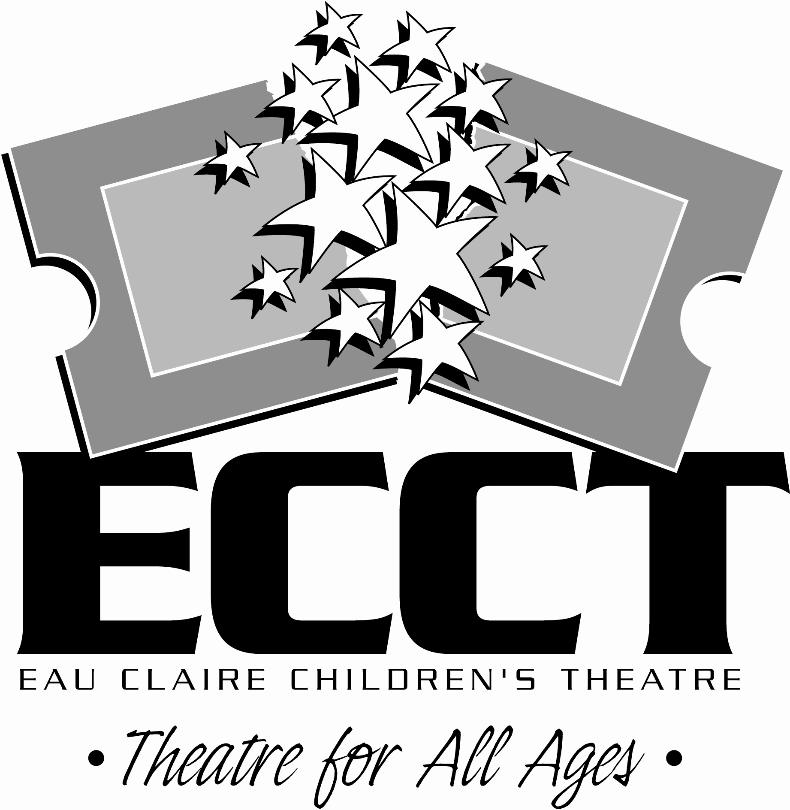
MAIL COMPLETED FORM WITH PAYMENT TO:
ECCT 1814 Oxford Ave. Eau Claire, WI 54703.

FOR OFFICE USE:

Rec’d__________ Confirmed________

Payment Type: Cash Check #___________

CC- Date processed_________

