DO THEATRE..
GET PAID!
SUMMER 2012 EVENTS:







SUMMER 2012 THEATRE CLASSES
& DRAMA CAMPS





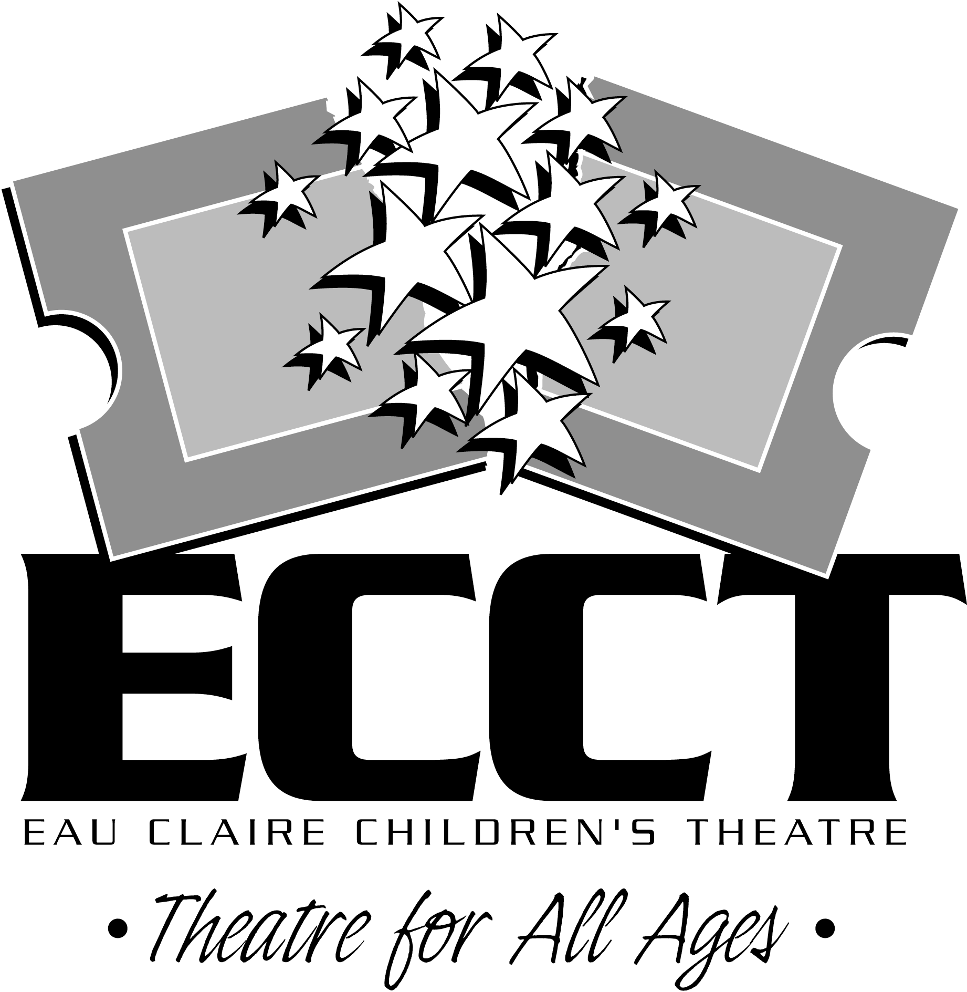
EAU CLAIRE CHILDREN’S THEATRE
SUMMER INTERNSHIP PROGRAM

ABOUT ECCT
ECCT will be wrapping up its 23rd season of providing quality family entertainment this summer. Located in Eau Claire, Wisconsin, ECCT annually presents over 16 productions (Broadway musicals and shows based on children’s literature) using a combination of youth and adult performers in three area venues. School matinee performances, classes and touring productions are offered in addition to many annual special events including a Murder Mystery Dinner Theatre, Battle of the Bands, Starquest and New Playwright’s Competition. With a budget of over $480,000 and annual attendance of almost 32,000 patrons, ECCT is one of the largest community theatres in western Wisconsin. In the spring of 2010 ECCT opened a new multi-purpose performance space.

REQUIREMENTS
All applicants must be 18 years of age and must complete required paperwork to be considered for an internship. Applicants must be US citizens and have a valid driver’s license. Applicants need not be currently enrolled in a university theatre program.

POSITIONS OFFERED
We are offering opportunities for six interns- one Technical Production Intern, one Costume Intern, one Education Intern, one Marketing Intern, one House Management Intern and one Graphic Design Intern. Each intern will teach a variety of theatre and arts related classes in the morning, work in their specialty area on summer and upcoming touring productions in the afternoons and evenings and participate in promotional events on some weekends. Hours will vary based on class schedules and the needs of the organization throughout the summer- 32-36 hours per week. Depending on their skills and interests interns will also have the opportunity to do design work and/or perform on stage. Interns are paid a weekly stipend of $200 and housing assistance may be available. While dates are somewhat flexible, internships basically run 3 months, from June 1-August 24.

SCHOOL CREDIT
Applicants who wish to receive class credit for their internship will need to coordinate the details with their school advisor and ECCT. The applicant is responsible to communicate needs of the institution to ECCT. We will complete any necessary paper work and make adjustments to the schedule and work load to fill university requirements.

IMPORTANT DATES
Application deadline is March 30. Materials may be sent by mail or email.

APPLICATION MATERIALS
A completed application includes the following items:
A completed and signed Application Form
A resume of theatre-related experience
A brief, personal statement which discusses the following:
Your long-term professional goals
How you feel an internship will help you achieve those goals
Your expectations regarding the internship
What makes you tick and what you can bring to ECCT
One recommendation form complete with letter from individual who can attest to your ability to fulfill the duties of the internship sent separately
Submit the Application to: Questions? Contact:
Internship Program Wayne Marek
Eau Claire Children’s Theatre Executive Director
1814 Oxford Avenue Phone: 715.839.8877
Eau Claire, WI 54703 OR Email: info@ecct.org
Email to: info@ecct.org Web: www.ecct.org

EAU CLAIRE CHILDREN’S THEATRE
SUMMER INTERNSHIP PROGRAM APPLICATION

NAME_____________________________________________________________________
Last First Middle Initial

DATE OF BIRTH_______/_______/_______
Month Day Year

Permanent contact information:

ADDRESS__________________________________________________________________
Number/Street/Apt. # City/State Zip Code

PHONE___ ( )__________________ EMAIL_________________________________

Current contact information (if different from above):

ADDRESS__________________________________________________________________
Number/Street/Apt. # City/State Zip Code

PHONE___ ( )__________________ EMAIL_________________________________

Current contact information effective until what date? _______/_______/________
Month Day Year

Academic Information:

College/University____________________________________________________________

Year in School_________Degree___________ Major________________________________

Which internship are you interested in? Technical Production Intern Marketing Intern
Costume Intern Education Intern House Management Intern Graphic Design Intern

Will you be completing this internship for credit? YES NO

Internships typically run June 1-August 24. Given those parameters when are you available this summer? Start date_____________________ End date____________________

Will you need assistance locating housing? YES NO

Would you have reliable transportation while in Eau Claire? YES NO

How did you hear about the internship program?________________________________________

Signature________________________________________________

EAU CLAIRE CHILDREN’S THEATRE

SUMMER INTERNSHIP PROGRAM RECOMMENDATION FORM

Applicant: Please fill in your name and give or email this form to an individual who is familiar with your work. Each applicant must include one letter of recommendation from someone familiar with their work.

NAME_____________________________________________________________________

APPLYING FOR WHICH INTERNSHIP? Technical Production Intern Marketing Intern
Costume Intern Education Intern House Management Intern Graphic Design Intern

Recommendation Sponsor: Thank you for agreeing to submit a recommendation in support of this applicant for the Eau Claire Children’s Theatre Summer Internship Program. Your comments will be available only to those involved in our decision process. Please fill out the information below and submit a statement regarding the applicant’s work and their potential for future success in their area of interest. This form and your statement of recommendation can be emailed to ECCT at info@ecct.org or mailed to us at ECCT 1814 Oxford Avenue Eau Claire, WI 54703.
Thank you again for your time and thoughtful comments.

NAME_________________________________________________________

TITLE_________________________________________________________

UNIVERSITY/COLLEGE/ORGANIZATION AFFILIATION

PHONE _____( )__________________________

EMAIL ADDRESS_______________________________________________

Signature_______________________________________________________

