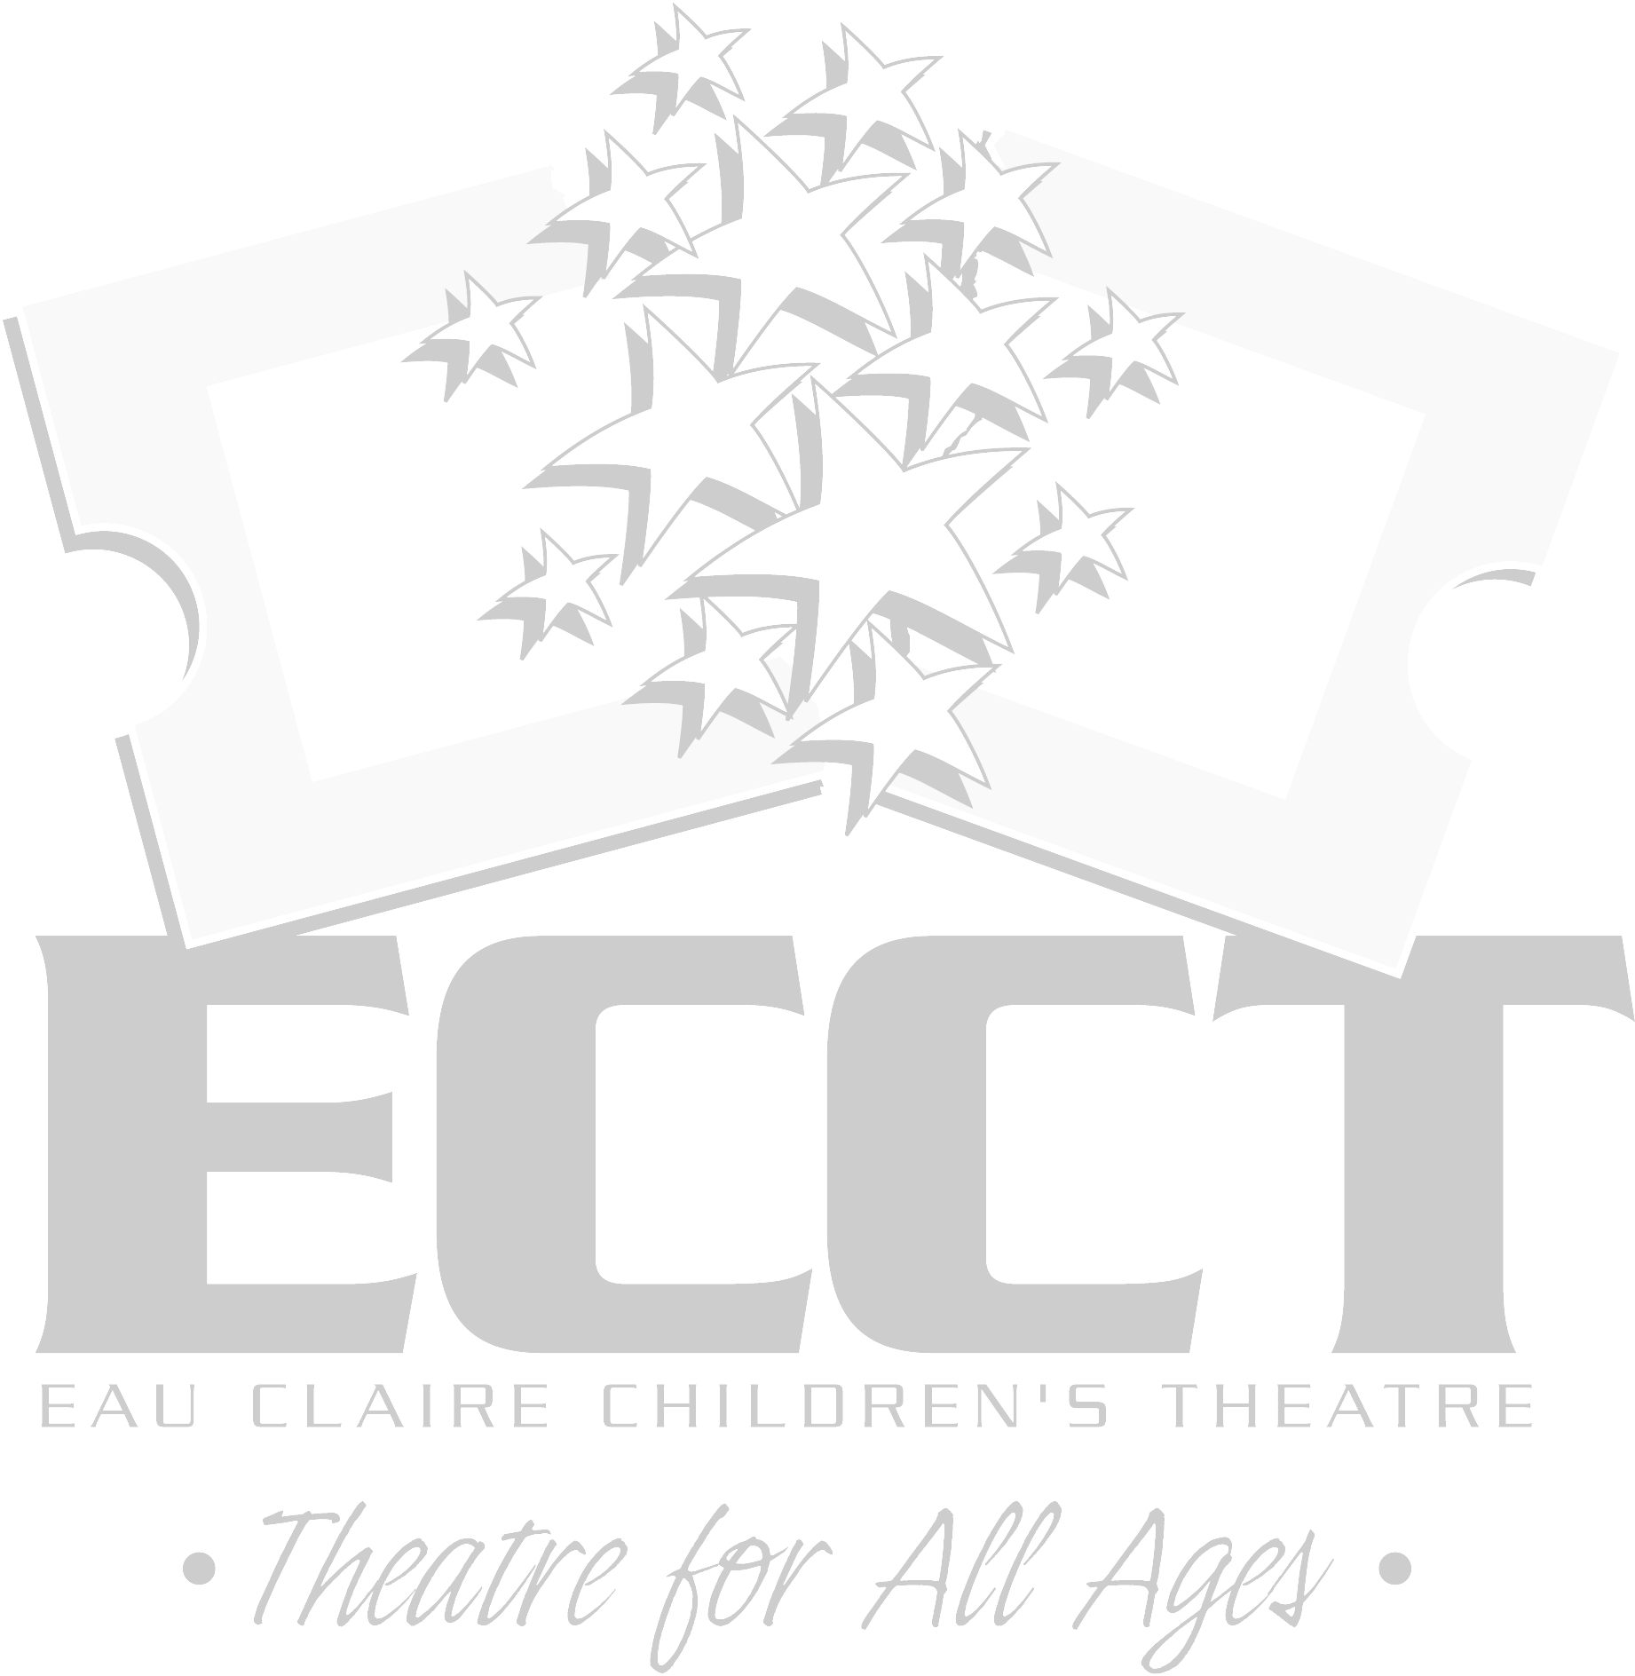
ECCT SUMMER 2011 THEATRE CLASSES
Updated June 15, 2011
The following classes will be held at
ECCT, 1814 Oxford Avenue Eau Claire, WI.

FAIRY TALE THEATRE Session 2- July 11-July 27, 2011
AGE DAY TIME Regist. Fee Materials Fee
3-4 years MON & WED 9am-9:45am $20 NA
3-4 years TUES & THUR 9am-9:45am $20 NA
5-6 years MON & WED 10am-10:45am $20 NA
Familiar fairytales are used to introduce young actors to theatre with creative dramatics, arts & crafts, storytelling and playacting

ACTING FOR GIRLS ONLY Session 2- July 11-July 15, 2011
AGE DAY TIME Regist. Fee Materials Fee
8-12 years MON-FRI 1pm-4pm $30 NA
Class focuses on theatre games, modeling & acting skills using scenes, monologues & audition pieces for girls only.
*Only 3 Spots Left!*

ACTING FOR BOYS ONLY DATES: June 27-July 1, 2011
AGE DAY TIME Regist. Fee Materials Fee
8-12 years MON-FRI 1pm-4pm $30 NA
Class focuses on theatre games, modeling & acting skills using scenes, monologues & audition pieces for boys only.

PUPPETRY DATES: June 27-July 1, 2011
AGE DAY TIME Regist. Fee Materials Fee
8-12 years MON-FRI 1pm-3pm $20 $5
Make a variety of puppets, write short scripts and perform a puppet show on the last day of class.

CLOWNING DATES: July 11-July 15, 2011
AGE DAY TIME Regist. Fee Materials Fee
7-10 years MON-FRI Noon-1pm $15 $5
11-15 years MON-FRI 1pm-2pm $15 $5
Learn to make people laugh with physical comedy, magic, juggling, slapstick, pratfalls and pantomime.

IMPROV SKILLS DATES: July 6- July 29, 2011
AGE DAY TIME Regist. Fee Materials Fee
8-12 years MON & WED 5pm-6pm $20 NA
13-Adult MON & WED 6pm-7pm $20 NA
Learn skills and techniques to master the art of improv acting by playing games and using props, like “Whose Line Is It Anyway?”

HIP HOP DANCE DATES: July 12- July 28, 2011
AGE DAY TIME Regist. Fee Materials Fee
9-12 years TUES & THUR 9am-11am $30 NA
13-Adult TUES & THUR 11am-1pm $30 NA
Have fun learning new moves and dance steps in this high energy dance class to pop music.

PLAYACTING II DATES: July 11-July 27, 2011
AGE DAY TIME Regist. Fee Materials Fee
11-15 years MON & WED Noon-1pm $18 NA
We’ll create stage versions of scenes from our favorite teen novels, including dialogue, props and simple set pieces.

MOVE YOUR FEET DATES: July 12-July28, 2011
AGE DAY TIME Regist. Fee Materials Fee
4-6 years MON & WED 11am-Noon $20 NA
For our youngest dancers, learn basic moves and routines to Disney and Broadway show tunes.
*Only 2 Spots Left!*

THEATRE GAMES DATES: July 11- July 27, 2011
AGE DAY TIME Regist. Fee Materials Fee
5-6 years MON & WED 10am- 11am $20 NA
7-9 years MON & WED 11am-Noon $20 NA
Easy theatre games for the young performer to explore creating a character and being comfortable on stage.

DANCE YOUR HEART OUT DATES: July 18-July 22, 2011
AGE DAY TIME Regist. Fee Materials Fee
8-12 years MON- FRI 11am-Noon $20 NA
Pick up a variety of ways to dance- tap, jazz, modern-with the help of fun Broadway theatre songs.

TRIPLE THREAT I DATES: July 18- July 22, 2011
AGE DAY TIME Regist. Fee Materials Fee
8-12 years MON-FRI 1pm-4pm $30 $12
You’ll be what every performer dreams of being- a Triple Threat- by learning acting, singing and dancing skills in one week!
*Only 5 Spots Left!*

TRIPLE THREAT II DATES: July 25- July 29, 2011
AGE DAY TIME Regist. Fee Materials Fee
13- 18 years MON-FRI 1pm-4pm $30 $12
You’ll be what every performer dreams of being- a Triple Threat- by learning acting, singing and dancing skills in one week!

SHOW CHOIR INTENSIVE DATES: July 18-July 22, 2011
AGE DAY TIME Regist. Fee Materials Fee
13- 18 years MON-FRI Noon-2pm $30 $12
For the intermediate and advanced performers looking to brush up their skills with a week of intense singing and dancing.

STREET ART I DATES: July 18-July 22, and August 1, 2011
AGE DAY TIME Regist. Fee Materials Fee
12-18 years MON-FRI 9am-Noon $20 $12
Use your creative skills on downtown windows to promote JOSEPH. Fees include show t-shirt & a ticket to see the show.

DRAMA CAMP DATES: July 25-July 29, 2011
AGE DAY TIME Regist. Fee Materials Fee
7-10 years MON-FRI 9am-Noon $50 $12
Not sure what the theatre has to offer? Each day covers two new topics. Fees cover snacks, T-shirt & ticket to see JOSEPH!
*Only 5 Spots Left!*

MUSICAL THEATRE- SHOW CHOIR STYLE!
DATES: July 25-July 29, 2011
AGE DAY TIME Regist. Fee Materials Fee
12- 15 years MON-FRI 9am-11am $25 $12
Sing and dance to fun musical theatre songs, show choir style!

CREATIVE ACTING DATES: July 25- July 29, 2011
AGE DAY TIME Regist. Fee Materials Fee
7-11 years MON-FRI 1pm-3pm $25 NA
Young actors will use popular books to write stage scenes to perform on the last day of class.
*Only 5 Spots Left!*

DRAMA CAMP II DATES:August 1-August 5, 2011
AGE DAY TIME Regist. Fee Materials Fee
11-15 years MON-FRI 9am-Noon $50 $12
For the intermediate performer. Each day covers two new topics. Fees cover snacks, T-shirt, & ticket to see CAMP ROCK!

RADIO DRAMA DATES: August 1- August 5, 2011
AGE DAY TIME Regist. Fee Materials Fee
7-12 years MON-FRI 1pm-3pm $25 NA
Want to perform but not memorize lines? We’ll create cool sound effects to use in a short radio play performed on Aug. 5.

STREET ART II DATES: August 1-August 5 & August 8, 2011
AGE DAY TIME Regist. Fee Materials 12-18 years MON-FRI 9am-Noon $20 $12
Use your creative skills on downtown windows to promote CAMP ROCK. Fees include show t-shirt & a ticket to see the show.

ACTING FOR GIRLS ONLY II DATES: Aug. 1-Aug. 5, 2011
AGE DAY TIME Regist. Fee Materials Fee
10-15 years MON-FRI 1pm-4pm $30 NA
For the intermediate/advanced performer. Develop acting skills with advanced scenes, monologues & games for girls only.

SCRAPBOOKING DATES: August 1-August 4, 2011
AGE DAY TIME Regist. Fee Materials Fee
8-12 years MON-THUR 5pm-6pm $15 $5
13-Adult MON-THUR 6pm-7pm $15 $5
Don’t know what to do with all your summer memories? Get started scrapbooking and get your stuff creatively organized!

SO YOU WANNA DO A SHOW? DATES: Aug. 8-Aug.13, 2011
AGE DAY TIME Regist. Fee Materials Fee
8-18 years MON-SAT 9am-5pm $70 $20
Do you have what it takes to do a show in a week? Rehearse for five full days and then perform “WONDERLAND” Aug. 13 at The Oxford. This is a musical version of Lewis Carroll’s Through the Looking Glass. Fee includes show t-shirt and snack breaks.
*7 Spots Left for this Show!*

AUDITIONING WORKSHOP DATES: August 8 & 10, 2011
AGE DAY TIME Regist. Fee Materials Fee
8-13 years MON & WED 5pm-6pm $10 NA
14 years-Adult MON & WED 6pm-7pm $10 NA
Learn what to expect & how to prepare for ECCT’s next season.

SHOW DANCE WORKSHOP DATES: June 29, 2011
AGE DAY TIME Regist. Fee Materials Fee
12-18 years WED 1pm-4pm $10 NA
Work with choreographer Frank Moran to learn dances from upcoming summer shows JOSEPH AND THE AMAZING TECHNICOLOR DREAMCOAT and CAMP ROCK!
New Class Added May 18th!

STAGE COMBAT DATES: July 12-July 21, 2011
AGE DAY TIME Regist. Fee Materials Fee
8-11 years MON & WED 10am-11am $12 NA
12-16 years TUES & THUR 10am-11am $12 NA
En Garde! Learn the essentials to having a realistic, but safe fight on stage!
New Class Added May 18th!

MAKING PROPS DATES: July 18-July 22, 2011
AGE DAY TIME Regist. Fee Materials Fee
10- 15 years MON-FRI 11am-12pm $15 NA
Learn how to make stage props like fake food to be used in JOSEPH this summer!
New Class Added May 18th!

MASK MAKING DATES: July 18- July 22, 2011
AGE DAY TIME Regist. Fee Materials Fee
7-11 years MON-FRI 1pm-3pm $25 NA
Learn how to make a variety of masks to use in short scenes.
New Class Added May 18th!

STAGE MAKEUP DATES: July 18-22, 2011
AGE DAY TIME Regist. Fee Materials Fee
10-15 years MON-FRI 3pm-5pm $25 $28
Learn a variety of stage makeup techniques and turn yourself into an animal, old person, clown, fantasy creature and give yourself bruises and scars. Fees include personal stage makeup kit to keep.
New Class Added May 18th!
The following classes will be held at the
Heyde Center for the Arts in Chippewa Falls:

SO YOU THINK YOU CAN ACT? DATES: Aug. 1-Aug. 6, 2011
AGE DAY TIME Regist. Fee Materials Fee
8-14 years MON-SAT 9am-5pm $70 $20
Do you have it takes to do a show in one week? Rehearse for 5 full days and then perform the “JACK AND THE BEANSTALK Sat., Aug. 6. Includes show t-shirt and snack breaks.
*6 Spots left for this Show!*

FAIRY TALE THEATRE DATES: August 1-August 5, 2011
AGE DAY TIME Regist. Fee Materials Fee
3-4 years MON-FRI 9am-9:45am $20 NA
5-6 years MON-FRI 10am-10:45am $20 NA
Familiar fairytales are used to introduce young actors to theatre with creative dramatics, arts & crafts, storytelling and playacting.

THEATRE GAMES DATES: August 1-August 5, 2011
AGE DAY TIME Regist. Fee Materials Fee
7-9 years MON-FRI 11am-Noon $20 NA
Easy theatre games for the young performer to explore creating a character and being comfortable on stage.

BROADWAY DANCE DATES: August 1-August 5, 2011
AGE DAY TIME Regist. Fee Materials Fee
8-12 years MON-FRI Noon-1pm $20 NA
Learn dances to popular Broadway songs.

ACTING FOR GIRLS ONLY DATES: August 1-August 5, 2011
AGE DAY TIME Regist. Fee Materials Fee
8-12 years MON-FRI 1pm-4pm $30 NA
Class focuses on theatre games, modeling & acting skills using scenes, monologues & audition pieces for girls only.

ECCT SUMMER 2011 DRAMA CLASS REGISTRATION FORM

CHILD’S NAME_____________________________________________________ AGE__________ CURRENT GRADE_____________

SCHOOL_______________________________________________________________________________________________________

PARENT/GUARDIAN NAME(S)_____________________________________________________________________________________

ADDRESS______________________________________________________________________________________________________

CITY/ST/ZIP____________________________________________________________________________________________________

PARENT EMAIL (to receive confirmation)_____________________________________________________________________________

DAYTIME PHONE_______________________________________ ALTERNATE EMERGENCY PHONE__________________________

PARTICIPANT’S T-SHIRT SIZE: YOUTH 10-12 14-16 ADULT Small Medium Large (not all classes include a shirt)

CLASS SESSION DATES DAY(S) of WEEK TIME OF DAY Reg. Fee Mtls. Fee

_______________________________ ______________ ______________ _______________ __________ __________

_______________________________ ______________ ______________ _______________ __________ __________

_______________________________ ______________ ______________ _______________ __________ __________

_______________________________ ______________ ______________ _______________ __________ __________

_______________________________ ______________ ______________ _______________ __________ __________

_____ Cash (in person only) _____ Check to “ECCT” enclosed TOTAL_________ TOTAL_______

_____ Charge my: ___ Mastercard ___ Visa Exp. Date________ CVV________ GRAND TOTAL DUE______________
(3 digit code on back)

Card Number____________________________________________

EAU CLAIRE AREA SCHOOL DISTRICT STUDENTS
For students currently attending the ECASD- public, parochial, homeschool- Registration Fees will be covered by the school district for any ONE class this summer and Materials Fees will be covered by the student. ECASD students should put "ECASD" under Registration Fee for the ONE class on their registration form being paid for by the District. All fees for additional classes are the responsibility of the student.

CHIPPEWA FALLS AREA UNIFIED SCHOOL DISTRICT STUDENTS
For students currently attending the CFAUSD- public schools- Registration Fees will be covered by the school district for any ONE class this summer and Materials Fees will be covered by the student. CFAUSD students should put "CFAUSD" under Registration Fee for the ONE class on their registration form being paid for by the District. All fees for additional classes are the responsibility of the student.

ALL OTHERS
Students residing outside the ECASD and CFAUSD, all adult students, and young children not yet attending school will be responsible for both registration and materials fees for their classes.

PLEASE NOTE:
- District residency is based on where you live- ie: where you pay taxes. A student who lives in Eau Claire that attends school in Altoona would qualify for one free class. A student who lives in Altoona but attends school in Eau Claire would not.
- To qualify for a free class the student must currently be attending school. A four year old that will be starting school this fall would not qualify.
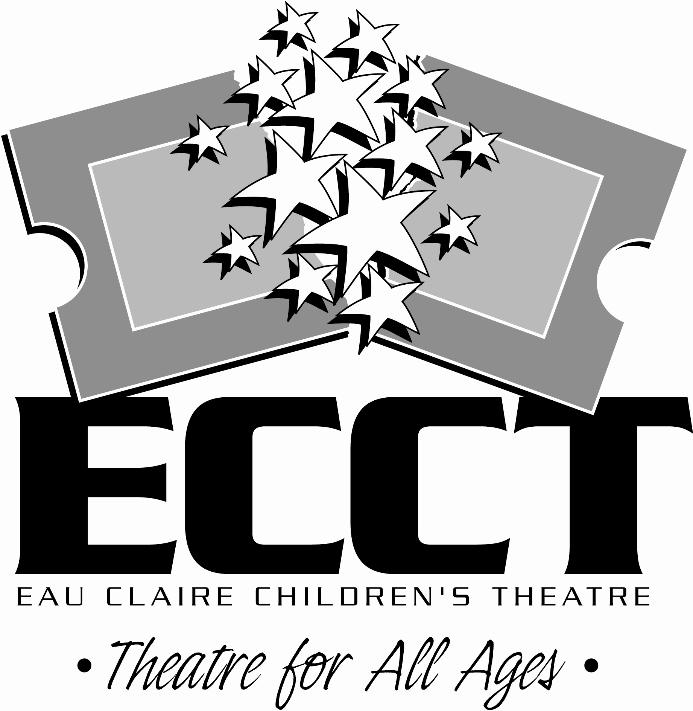
- All fees must accompany registration form. We accept cash, checks, Mastercard and Visa.
- Refunds for class fees are ONLY made in the event a class is cancelled due to low enrollment- No Exceptions.
- Registration deadline is one week before the class start date. After this date classes with low enrollment may be cancelled. Likewise classes which have met their minimum enrollment and are running often have openings that can be filled after the deadline- call 715-839-8877 for class availability.

MAIL COMPLETED FORM WITH PAYMENT TO:
ECCT 1814 Oxford Ave. Eau Claire, WI 54703.

FOR OFFICE USE:

Rec’d__________ Confirmed________ Payment Type: Cash Check #___________ CC- Date processed_________

