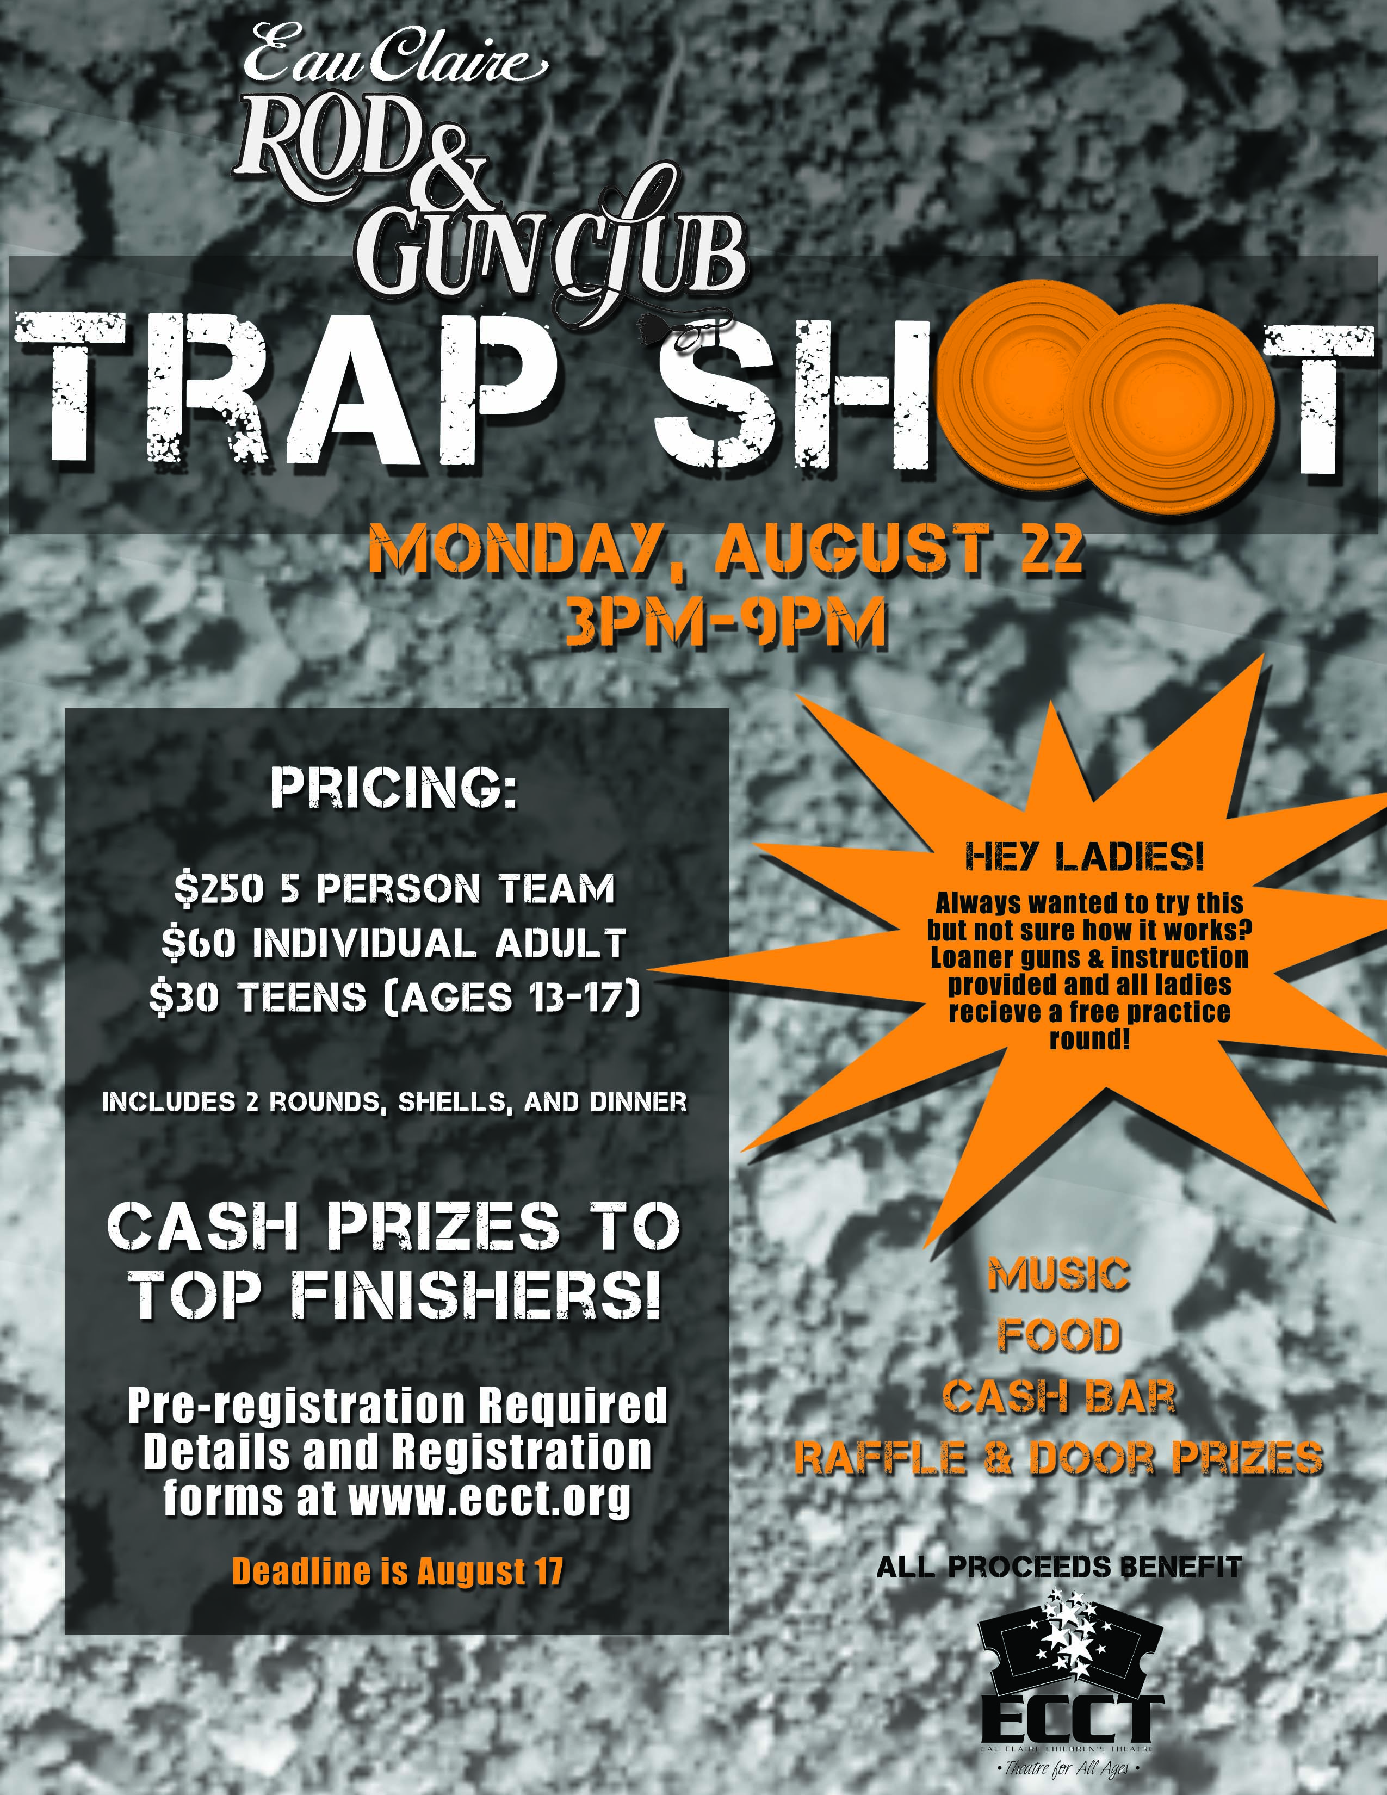

2011 REGISTRATION FORM- Deadline is August 19

NAME_______________________________________ PHONE_________________

ADDRESS/CITY/ZIP____________________________________________________

EMAIL_______________________________________________________________
(details and all confirmations will be sent via email)

NAME_______________________________________ PHONE_________________

ADDRESS/CITY/ZIP____________________________________________________

EMAIL_______________________________________________________________
(details and all confirmations will be sent via email)

NAME_______________________________________ PHONE_________________

ADDRESS/CITY/ZIP____________________________________________________

EMAIL_______________________________________________________________
(details and all confirmations will be sent via email)

NAME_______________________________________ PHONE_________________

ADDRESS/CITY/ZIP____________________________________________________

EMAIL_______________________________________________________________
(details and all confirmations will be sent via email)

NAME_______________________________________ PHONE_________________

ADDRESS/CITY/ZIP____________________________________________________

EMAIL_______________________________________________________________
(details and all confirmations will be sent via email)

5 PERSON TEAM $250
INDIVIDUAL ADULT SHOOTERS $60 X _____= $______
INDIVIDUAL TEEN SHOOTERS $30 X _____= $______
TOTAL AMOUNT ENCLOSED………………………………$________

Checks payable and send to: ECCT 1814 Oxford Avenue Eau Claire, WI 54703
(Call 715-839-8877 if you’d prefer to use a credit card.)
Questions? Michael Strubel at Visit Eau Claire 715-559-9377 or Wayne Marek at ECCT 715-839-8877

