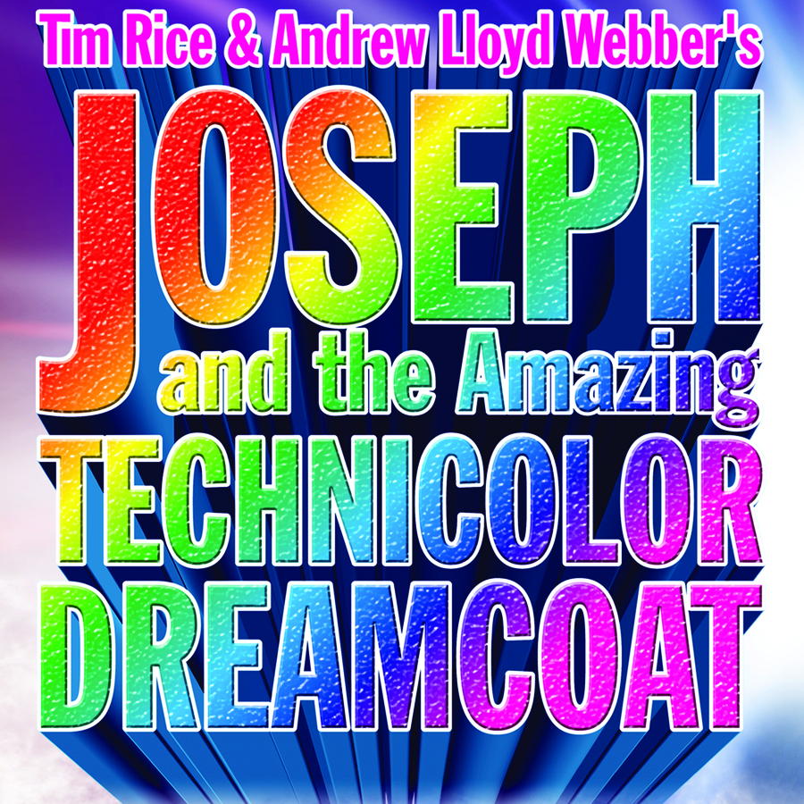

Thank you to everyone that auditioned.
Here is the JOSEPH Youth Choir.

RED GROUP GREEN GROUP
Sophia Picco Gracia Madson
Emma Weigel Anne Kaldjian
Megan Jungbluth Aaliyah Moore
Bergen Phelps Anya Nakonechna
McKaylee Johnson Ally Logan
Aura Raven Eisold Emily Surges
Grace Olson Cassandra Grant
Aidan Sanfelippo Theresa Nichols
Payton Solberg Joshua Weigel
Mikkyla Warthing Vincent Van Sleet

ORANGE GROUP BLUE GROUP
Allyson Meyer Clarissa Moore
Bernadette Rechek Kelly Coushman
Marin Jacobson Kendra Stahl
Madie Sherman Claire Steines
Katrina Mousel Kendall Rose Oman
Kira Shiffer Alexandra Meade
Shawn VanBlarcom Aiden Farnlof
Mason Sherman Tommy Peterson
Annabelle Storlie Gracie Garner
Maria Woodburn Abigail Martin

YELLOW GROUP PURPLE GROUP
Allisa Hansen Annika McClintock
Alessa Eilts Noelle Pawelski
Sara Martineau Hannah Messer
Linnea McClintock Sydney Adam
Ana Riggs Emma Knobloch
Jennifer Booth Sam Rechek
Kael Sanfelippo Caleb Moore
Mitch Tolander Eliza Weigel
Eleanor Knickerbocker Beth Berger
Emily Zimmerman Dara Madson

- The first rehearsal for the entire choir AND at least one parent will be held on Monday, June 6 from 7pm-9:30pm at ECCT. Parents should bring their calendars to complete paperwork for the summer.
- The first parade of the season is the Eleva Broiler Fest on Sun. June 5. We will be carpooling from ECCT at 12:30pm and heading to Eleva to march in the parade to promote the show. We will return to ECCT around 3:30pm. Show
T-shirts to wear in the parade can be purchased for $12 before we leave. Siblings and other family members are welcome to march in the parade as well- we have extra shirts for sale too. Please contact us at info@ecct.org if you have any questions before Sunday.

