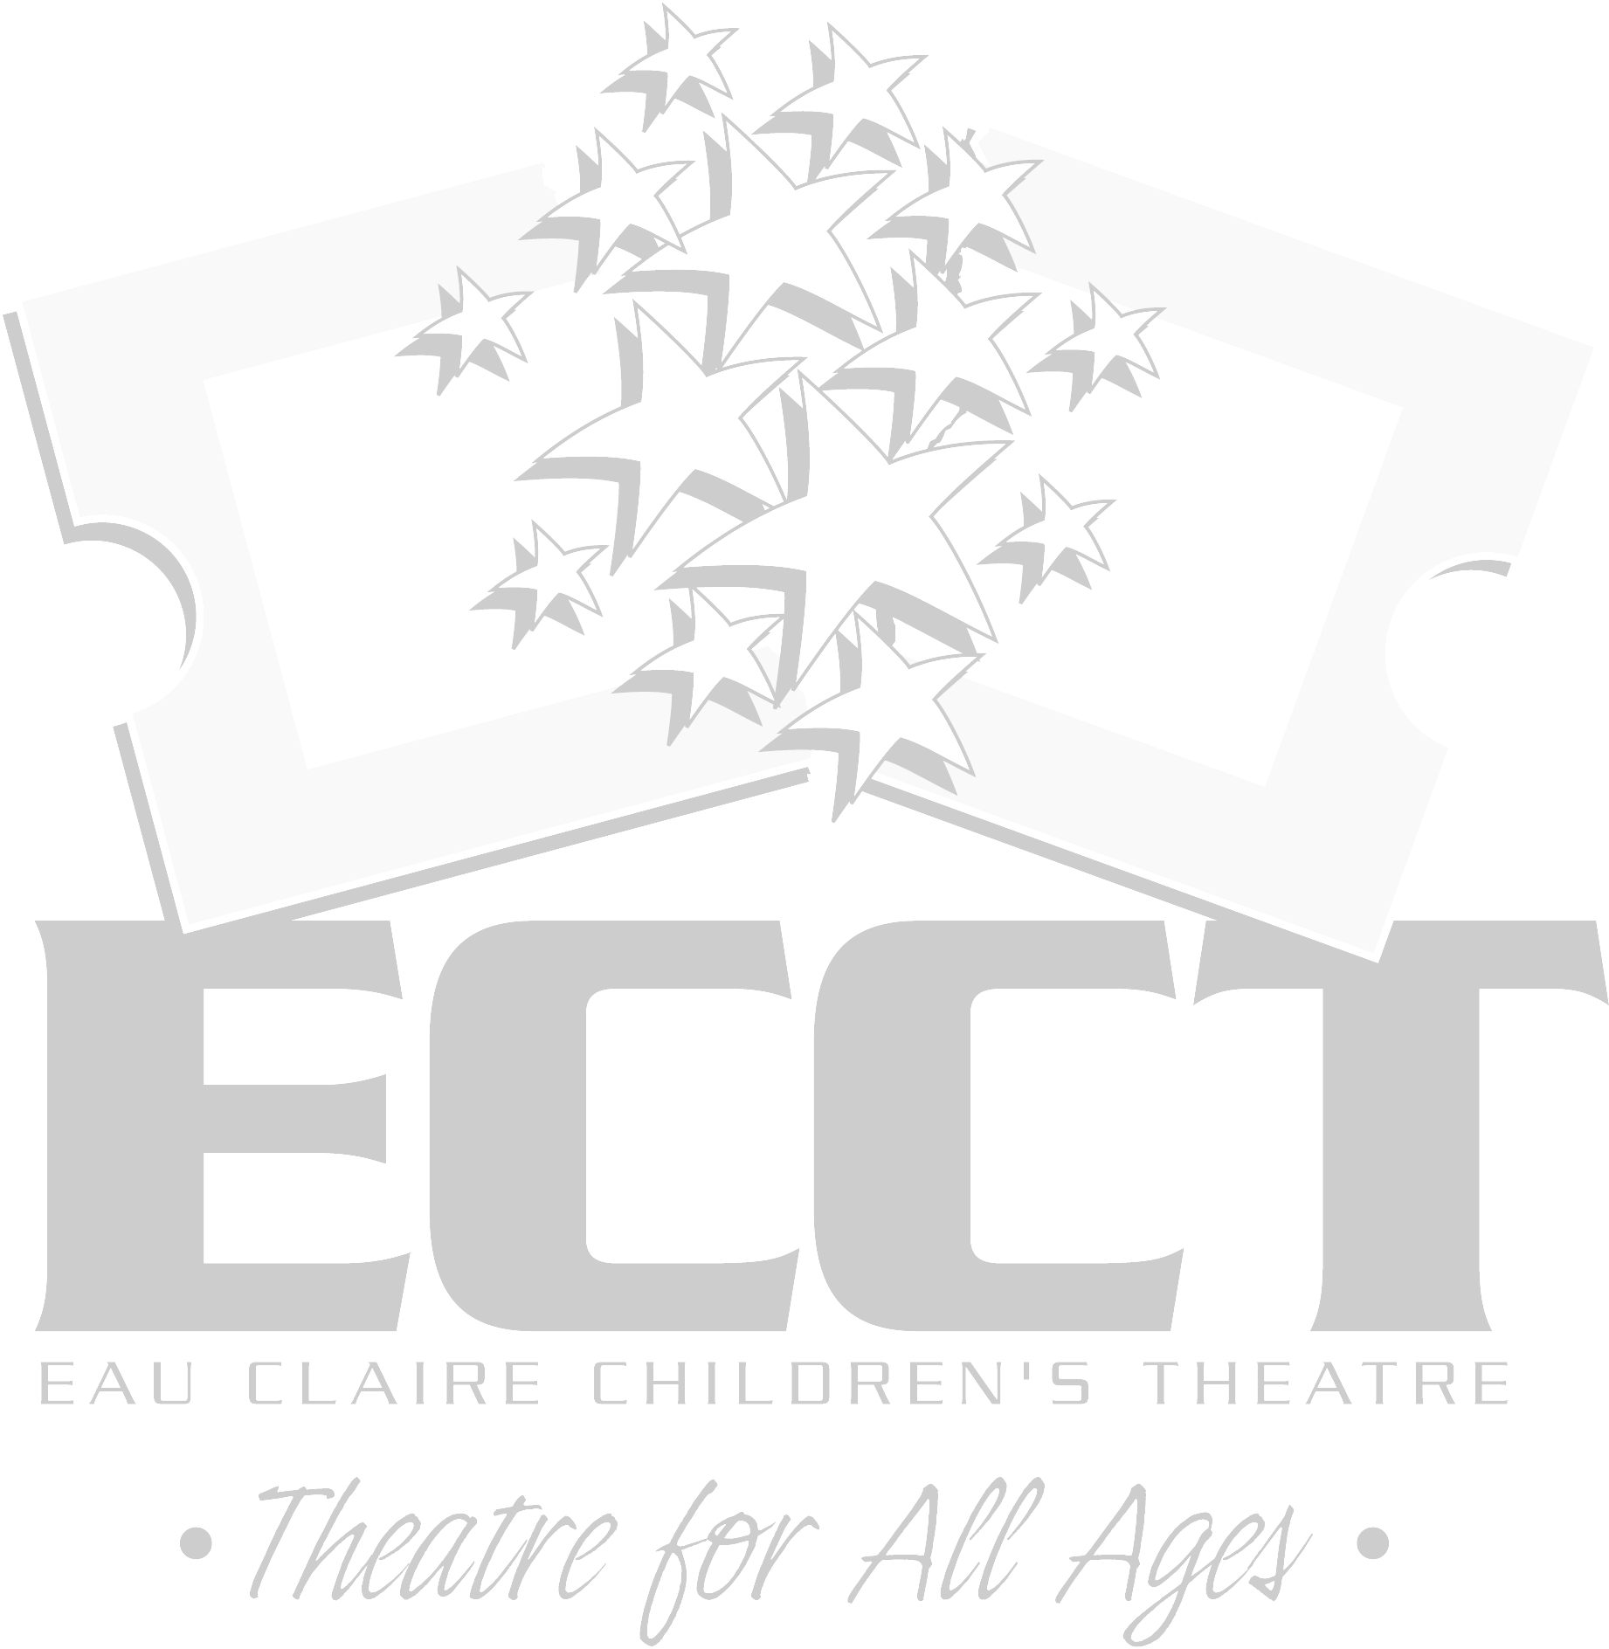
ECCT SUMMER 2011 THEATRE CLASSES
The following classes will be held at
ECCT, 1814 Oxford Avenue Eau Claire, WI.
PRIVATE VOICE LESSONS DATES:June 14-Aug. 4, 2011
AGE DAY TIME Regist. Fee Materials Fee
10 years-Adult TUE 12pm-7pm; ½ hr./wk. $63 NA
10 years-Adult WED 9am-7pm; ½ hr./wk. $63 NA
10 years-Adult THU 12pm-7pm; ½ hr./wk. $63 NA
Private voice instruction emphasizing proper breathing, diction and projection through the study of musical theatre literature.

CELEBRATE SUMMER WITH A SHOW
DATES: June 13-June 24, 2011
AGE DAY TIME Regist. Fee Materials Fee
8-14 years MON-FRI 9am-Noon $50 $12
Join the cast of Disney’s “JUNGLE BOOK”. Rehearse for 2 wks. & present 5 shows June 23 & 24. Fees include show T-shirt.

RELAXATION FOR THE ACTOR DATES: June 13-17, 2011
AGE DAY TIME Regist. Fee Materials Fee
12-Adult MON/WED/FRI 12pm-1pm $10 NA
Going on stage can be nerve-wracking! Learn techniques to calm body and mind to conquer stage fright.

ACTING FOR GIRLS ONLY Session 1-June 13- June 17, 2011
Session 2- July 11-July 15, 2011
AGE DAY TIME Regist. Fee Materials Fee
8-12 years MON-FRI 1pm-4pm $30 NA
Class focuses on theatre games, modeling & acting skills using scenes, monologues & audition pieces for girls only.

VOICE ACTING & DIALECTS Dates: June 13-June 29, 2011
AGE DAY TIME Regist. Fee Materials Fee
8-12 years MON & WED 5pm-6pm $20 NA
13-Adult MON & WED 6pm-7pm $20 NA
Be heard on stage and speak out with confidence! Create new characters by changing vocal style and learning new dialects.

DANCE FOR FUN DATES: June 13-June 29, 2011
AGE DAY TIME Regist. Fee Materials Fee
Adults MON & WED 1pm-4pm $20 NA
Pick up new dance skills to be used in upcoming Broadway musicals and have some fun getting fit.

FAIRY TALE THEATRE Session 1- June 13-June 29, 2011
Session 2- July 11-July 27, 2011
AGE DAY TIME Regist. Fee Materials Fee
3-4 years MON & WED 9am-9:45am $20 NA
3-4 years TUES & THUR 9am-9:45am $20 NA
5-6 years MON & WED 10am-10:45am $20 NA
Familiar fairytales are used to introduce young actors to theatre with creative dramatics, arts & crafts, storytelling and playacting.

BROADWAY DANCE DATES: June 13-June 29, 2011
AGE DAY TIME Regist. Fee Materials Fee
7-10 years MON & WED 11am-Noon $20 NA
Learn dance numbers from some of ECCT’s most popular shows like “High School Musical”, “Grease”, “Footloose” and “Fame.”

PLAYACTING I _______ DATES: June 13-June 29, 2011
AGE DAY TIME Regist. Fee Materials Fee
7-10 years MON & WED Noon-1pm $20 NA
We’ll work together creating stage versions of our favorite fairytales, including dialogue, masks and simple set pieces.

THEATRE GAMES DATES: June 14-June 30, 2011
AGE DAY TIME Regist. Fee Materials Fee
5-6 years TUES & THUR 10am- 11am $20 NA
7-9 years TUES & THUR 11am-Noon $20 NA
Easy theatre games for the young performer to explore creating a character and being comfortable on stage.

JUNKYARD SYMPHONY DATES: June 14- June 30, 2011
AGE DAY TIME Regist. Fee Materials Fee
7-10 years TUES & THUR 12pm-1pm $20 NA
You’ll explore the use of coffee cans, 2-liter soda bottles & other found objects as instruments to create your own “STOMP” show.

DANCE, DANCE, DANCE DATES: June 14-June 30, 2011
AGE DAY TIME Regist. Fee Materials Fee
13-18 years TUES & THUR 1pm-4pm $35 NA
Learn choreography, leaps, turns and jumps for a Broadway musical to present on the last day of class.

DANCE TEAM ROUTINES DATES: June 14-June 30, 2011
AGE DAY TIME Regist. Fee Materials Fee
8-12 years TUES & THUR 1pm-3pm $20 NA
Learn moves and routines that will make you a stand out on your school’s dance team.

CREATIVE WRITING DATES: June 14-June 23, 2011
AGE DAY TIME Regist. Fee Materials Fee
13-18 years TUES & THUR 9am-10:30am $20 NA
Learn techniques to enhance your writing and generate ideas quickly. Includes speed writing and writing challenges.

INTRO TO SHOW CHOIR DATES: June 20-June 29, 2011
AGE DAY TIME Regist. Fee Materials Fee
8-11 years MON & WED 9am-11am $35 $12
12-14 years MON & WED 12pm-2pm $35 $12
You will spend 2 weeks on show choir basics, dancing & singing to present a show on the final day of class. Includes show t-shirt.

ACTING FOR BOYS ONLY DATES: June 27-July 1, 2011
AGE DAY TIME Regist. Fee Materials Fee
8-12 years MON-FRI 1pm-4pm $30 NA
Class focuses on theatre games, modeling & acting skills using scenes, monologues & audition pieces for boys only.

PUPPETRY DATES: June 27-July 1, 2011
AGE DAY TIME Regist. Fee Materials Fee
8-12 years MON-FRI 1pm-3pm $20 $5
Make a variety of puppets, write short scripts and perform a puppet show on the last day of class.

CELEBRATE SUMMER WITH A SHOW II
DATES: July 11-July 22, 2011
AGE DAY TIME Regist. Fee Materials Fee
8-14 years MON-FRI 9am-Noon $50 $12
Be part of “THE TRIAL OF THE BIG BAD WOLF”.Rehearse for 2 wks. & present 5 shows July 21 & 22. Fees include show T-shirt.

CLOWNING DATES: July 11-July 15, 2011
AGE DAY TIME Regist. Fee Materials Fee
7-10 years MON-FRI Noon-1pm $15 $5
11-15 years MON-FRI 1pm-2pm $15 $5
Learn to make people laugh with physical comedy, magic, juggling, slapstick, pratfalls and pantomime.

IMPROV SKILLS DATES: July 6- July 29, 2011
AGE DAY TIME Regist. Fee Materials Fee
8-12 years MON & WED 5pm-6pm $20 NA
13-Adult MON & WED 6pm-7pm $20 NA
Learn skills and techniques to master the art of improv acting by playing games and using props, like “Whose Line Is It Anyway?”

HIP HOP DANCE DATES: July 12- July 28, 2011
AGE DAY TIME Regist. Fee Materials Fee
9-12 years TUES & THUR 9am-11am $30 NA
13-Adult TUES & THUR 11am-1pm $30 NA
Have fun learning new moves and dance steps in this high energy dance class to pop music.

PLAYACTING II DATES: July 11-July 27, 2011
AGE DAY TIME Regist. Fee Materials Fee
11-15 years MON & WED Noon-1pm $18 NA
We’ll create stage versions of scenes from our favorite teen novels, including dialogue, props and simple set pieces.

MOVE YOUR FEET DATES: July 12-July28, 2011
AGE DAY TIME Regist. Fee Materials Fee
4-6 years MON & WED 11am-Noon $20 NA
For our youngest dancers, learn basic moves and routines to Disney and Broadway show tunes.

THEATRE GAMES DATES: July 11- July 27, 2011
AGE DAY TIME Regist. Fee Materials Fee
5-6 years MON & WED 10am- 11am $20 NA
7-9 years MON & WED 11am-Noon $20 NA
Easy theatre games for the young performer to explore creating a character and being comfortable on stage.

DANCE YOUR HEART OUT DATES: July 18-July 22, 2011
AGE DAY TIME Regist. Fee Materials Fee
8-12 years MON- FRI 11am-Noon $20 NA
Pick up a variety of ways to dance- tap, jazz, modern-with the help of fun Broadway theatre songs.

TRIPLE THREAT I DATES: July 18- July 22, 2011
AGE DAY TIME Regist. Fee Materials Fee
8-12 years MON-FRI 1pm-4pm $30 $12
You’ll be what every performer dreams of being- a Triple Threat- by learning acting, singing and dancing skills in one week!

TRIPLE THREAT II DATES: July 25- July 29, 2011
AGE DAY TIME Regist. Fee Materials Fee
13- 18 years MON-FRI 1pm-4pm $30 $12
You’ll be what every performer dreams of being- a Triple Threat- by learning acting, singing and dancing skills in one week!

SHOW CHOIR INTENSIVE DATES: July 18-July 22, 2011
AGE DAY TIME Regist. Fee Materials Fee
13- 18 years MON-FRI Noon-2pm $30 $12
For the intermediate and advanced performers looking to brush up their skills with a week of intense singing and dancing.

STREET ART I DATES: July 18-July 22, and August 1, 2011
AGE DAY TIME Regist. Fee Materials Fee
12-18 years MON-FRI 9am-Noon $20 $12
Use your creative skills on downtown windows to promote JOSEPH. Fees include show t-shirt & a ticket to see the show.

DRAMA CAMP DATES: July 25-July 29, 2011
AGE DAY TIME Regist. Fee Materials Fee
7-10 years MON-FRI 9am-Noon $50 $12
Not sure what the theatre has to offer? Each day covers two new topics. Fees cover snacks, T-shirt & ticket to see JOSEPH!

MUSICAL THEATRE- SHOW CHOIR STYLE!
DATES: July 25-July 29, 2011
AGE DAY TIME Regist. Fee Materials Fee
12- 15 years MON-FRI 9am-11am $25 $12
Learn to sing and dance to fun musical theatre songs, show choir style!

CREATIVE ACTING DATES: July 25- July 29, 2011
AGE DAY TIME Regist. Fee Materials Fee
7-11 years MON-FRI 1pm-3pm $25 NA
Young actors will use popular books to write stage scenes to perform on the last day of class.
DRAMA CAMP II DATES:August 1-August 5, 2011
AGE DAY TIME Regist. Fee Materials Fee
11-15 years MON-FRI 9am-Noon $50 $12
For the intermediate performer. Each day covers two new topics. Fees cover snacks, T-shirt, & ticket to see CAMP ROCK!
RADIO DRAMA DATES: August 1- August 5, 2011
AGE DAY TIME Regist. Fee Materials Fee
7-12 years MON-FRI 1pm-3pm $25 NA
Want to perform but not memorize lines? We’ll create cool sound effects to use in a short radio play performed on Aug. 5.

STREET ART II DATES: August 1-August 5 & August 8, 2011
AGE DAY TIME Regist. Fee Materials 12-18 years MON-FRI 9am-Noon $20 $12
Use your creative skills on downtown windows to promote CAMP ROCK. Fees include show t-shirt & a ticket to see the show.

ACTING FOR GIRLS ONLY II DATES: Aug. 1-Aug. 5, 2011
AGE DAY TIME Regist. Fee Materials Fee
10-15 years MON-FRI 1pm-4pm $30 NA
This class is for the intermediate to advanced performer. Develop acting skills through more advanced scenes, monologues and theatre games for girls only.

SCRAPBOOKING DATES: August 1-August 4, 2011
AGE DAY TIME Regist. Fee Materials Fee
8-12 years MON-THUR 5pm-6pm $15 $5
13-Adult MON-THUR 6pm-7pm $15 $5
Don’t know what to do with all your summer memories (or all the pics and stuff still sitting around from the school year)? Get started scrapbooking and get your stuff creatively organized!

SO YOU WANNA DO A SHOW? DATES: Aug. 8-Aug.13, 2011
AGE DAY TIME Regist. Fee Materials Fee
8-18 years MON-SAT 9am-5pm $70 $20
Think you’ve got what it takes to put on a show in one week? Then this is the class for you! You’ll rehearse for five full days and then perform “WONDERLAND” Sat. Aug. 13 at The Oxford. This is a musical version of Lewis Carroll’s Through the Looking Glass. Fee includes show t-shirt and snack breaks.

AUDITIONING WORKSHOP DATES: August 8 & 10, 2011
AGE DAY TIME Regist. Fee Materials Fee
8-13 years MON & WED 5pm-6pm $10 NA
14 years-Adult MON & WED 6pm-7pm $10 NA
Always wanted to audition but too nervous? Learn what to expect and how to prepare for ECCT’s next season.

The following classes will be held at the
Heyde Center for the Arts in Chippewa Falls:

SO YOU THINK YOU CAN ACT? DATES: Aug. 1-Aug. 6, 2011
AGE DAY TIME Regist. Fee Materials Fee
8-14 years MON-SAT 9am-5pm $70 $20
Think you’ve got what it takes to put on a show in one week? Then this is the class for you! Students will rehearse for five full days and then perform the “JACK AND THE BEANSTALK Sat., Aug. 6. Includes show t-shirt and snack breaks.

FAIRY TALE THEATRE DATES: August 1-August 5, 2011
AGE DAY TIME Regist. Fee Materials Fee
3-4 years MON-FRI 9am-9:45am $20 NA
5-6 years MON-FRI 10am-10:45am $20 NA
Familiar fairytales are used to introduce young actors to theatre with creative dramatics, arts & crafts, storytelling and playacting.

THEATRE GAMES DATES: August 1-August 5, 2011
AGE DAY TIME Regist. Fee Materials Fee
7-9 years MON-FRI 11am-Noon $20 NA
Easy theatre games for the young performer to explore creating a character and being comfortable on stage.

ACTING FOR GIRLS ONLY DATES: August 1-August 5, 2011
AGE DAY TIME Regist. Fee Materials Fee
8-12 years MON-FRI 1pm-4pm $30 NA
Class focuses on theatre games, modeling & acting skills using scenes, monologues & audition pieces for girls only.

ECCT SUMMER 2011 DRAMA CLASS REGISTRATION FORM

CHILD’S NAME_____________________________________________________ AGE__________ CURRENT GRADE_____________

SCHOOL_______________________________________________________________________________________________________

PARENT/GUARDIAN NAME(S)_____________________________________________________________________________________

ADDRESS______________________________________________________________________________________________________

CITY/ST/ZIP____________________________________________________________________________________________________

PARENT EMAIL (to receive confirmation)_____________________________________________________________________________

DAYTIME PHONE_______________________________________ ALTERNATE EMERGENCY PHONE__________________________

PARTICIPANT’S T-SHIRT SIZE: YOUTH 10-12 14-16 ADULT Small Medium Large (not all classes include a shirt)

CLASS SESSION DATES DAY(S) of WEEK TIME OF DAY Reg. Fee Mtls. Fee

_______________________________ ______________ ______________ _______________ __________ __________

_______________________________ ______________ ______________ _______________ __________ __________

_______________________________ ______________ ______________ _______________ __________ __________

_______________________________ ______________ ______________ _______________ __________ __________

_______________________________ ______________ ______________ _______________ __________ __________

_____ Cash (in person only) _____ Check to “ECCT” enclosed TOTAL_________ TOTAL_______

_____ Charge my: ___ Mastercard ___ Visa Exp. Date________ CVV________ GRAND TOTAL DUE______________
(3 digit code on back)

Card Number____________________________________________

EAU CLAIRE AREA SCHOOL DISTRICT STUDENTS
For students currently attending the ECASD- public, parochial, homeschool- Registration Fees will be covered by the school district for any ONE class this summer and Materials Fees will be covered by the student. ECASD students should put "ECASD" under Registration Fee for the ONE class on their registration form being paid for by the District. All fees for additional classes are the responsibility of the student.

CHIPPEWA FALLS AREA UNIFIED SCHOOL DISTRICT STUDENTS
For students currently attending the CFAUSD- public schools- Registration Fees will be covered by the school district for any ONE class this summer and Materials Fees will be covered by the student. CFAUSD students should put "CFAUSD" under Registration Fee for the ONE class on their registration form being paid for by the District. All fees for additional classes are the responsibility of the student.

ALL OTHERS
Students residing outside the ECASD and CFAUSD, all adult students, and young children not yet attending school will be responsible for both registration and materials fees for their classes.

PLEASE NOTE:
- District residency is based on where you live- ie: where you pay taxes. A student who lives in Eau Claire that attends school in Altoona would qualify for one free class. A student who lives in Altoona but attends school in Eau Claire would not.
- To qualify for a free class the student must currently be attending school. A four year old that will be starting school this fall would not qualify.
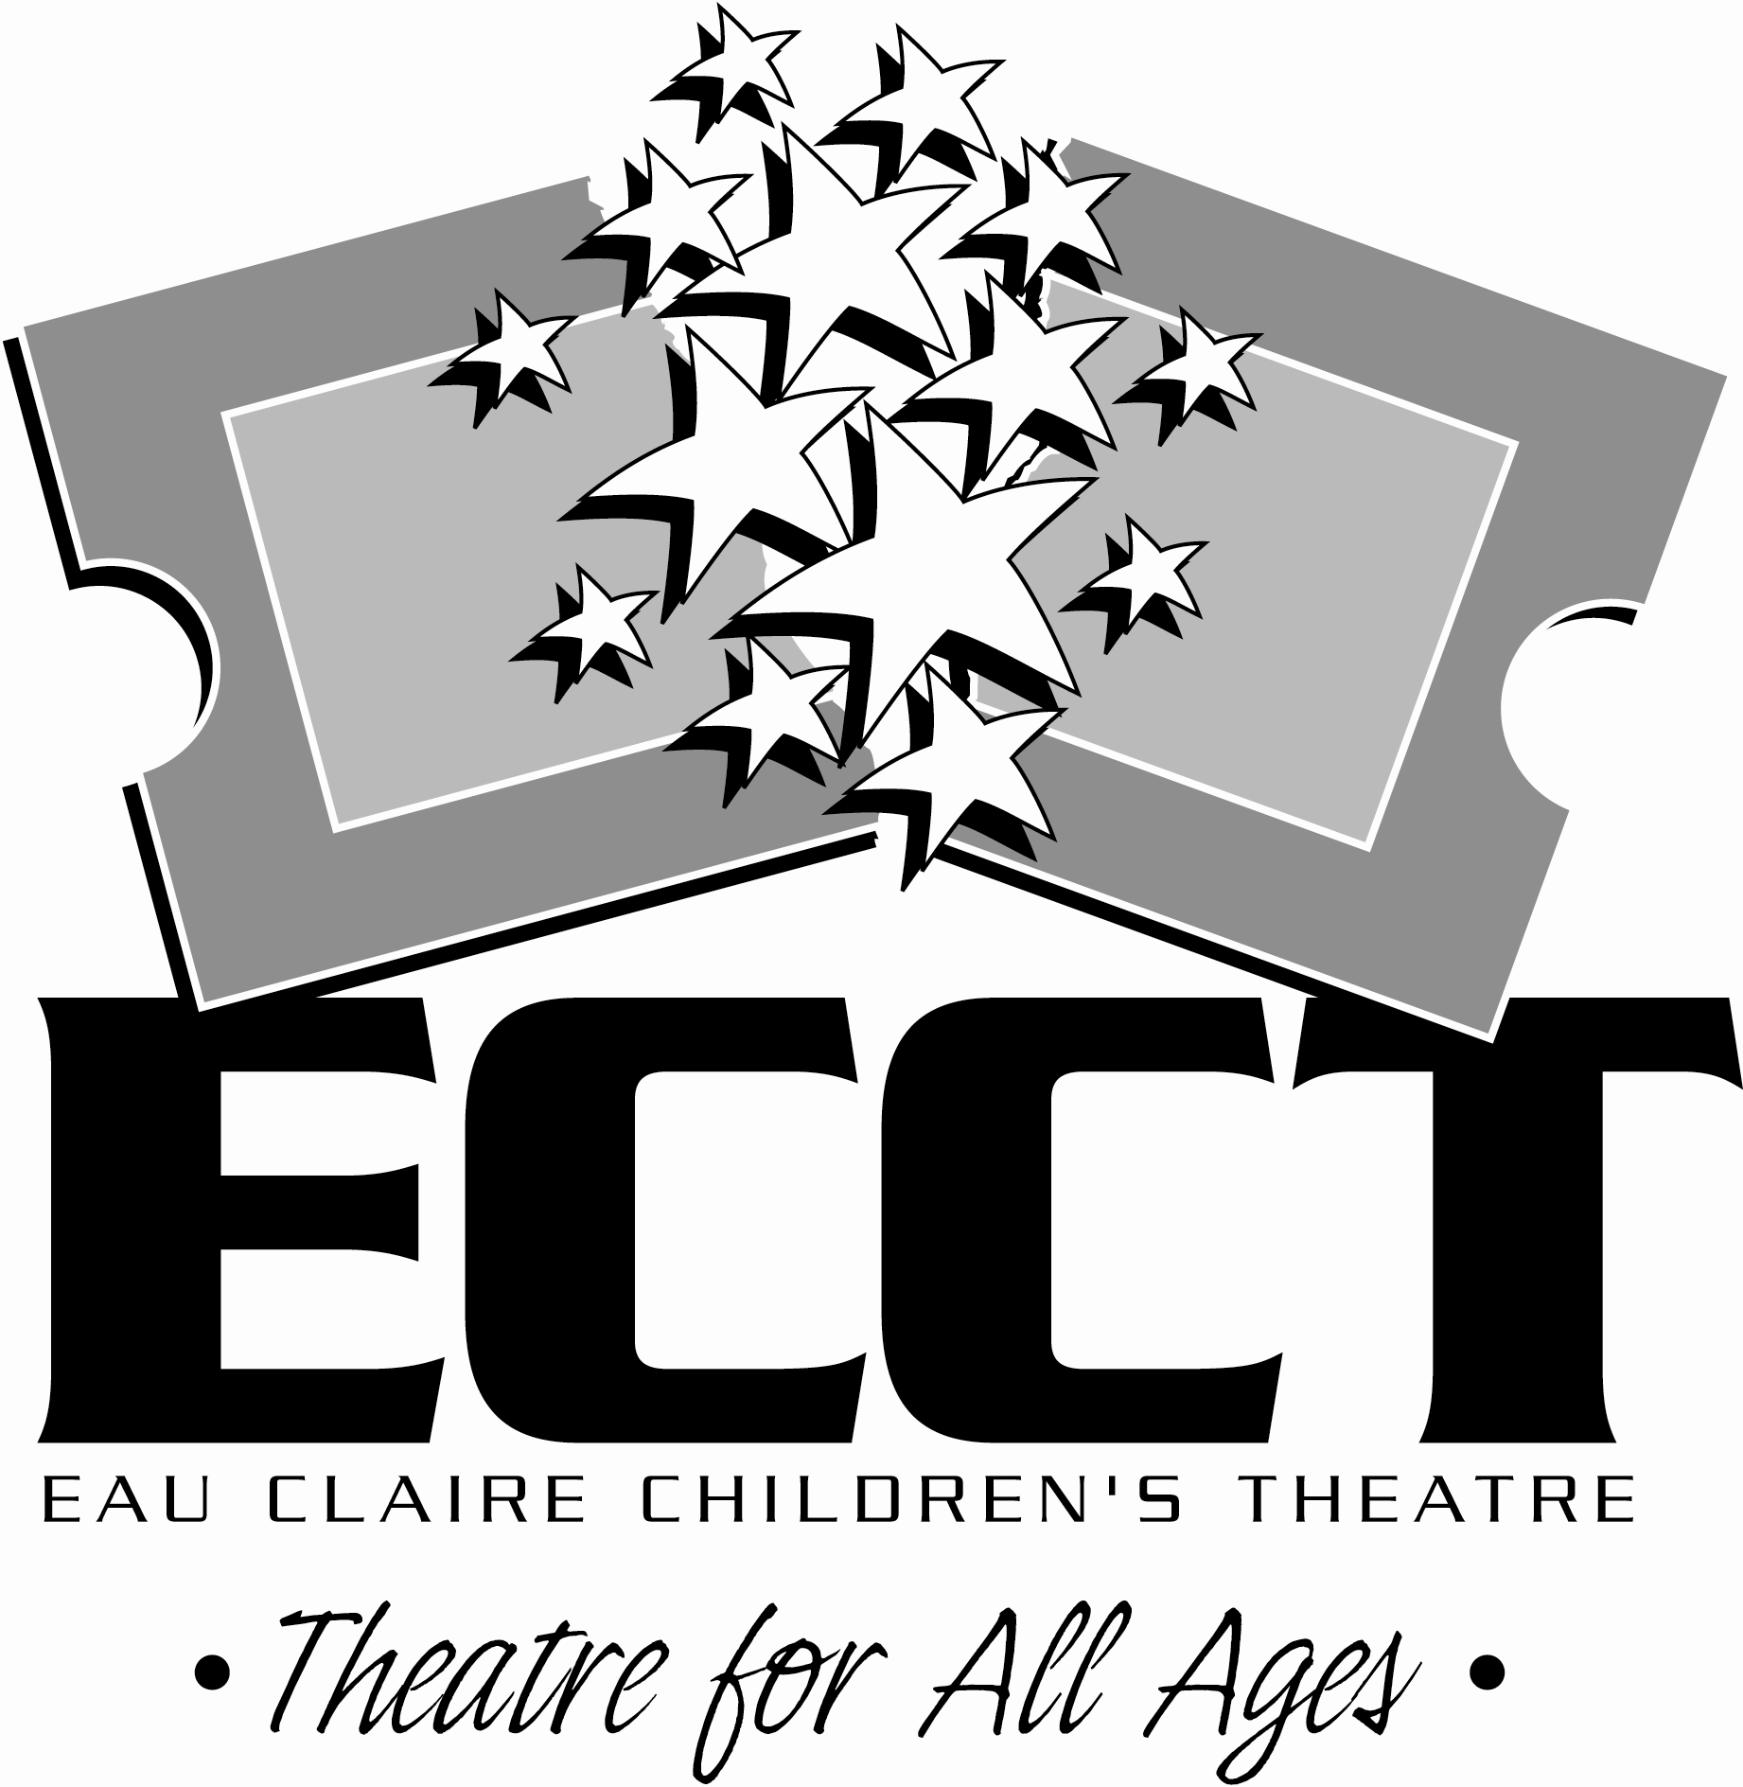
- All fees must accompany registration form. We accept cash, checks, Mastercard and Visa.
- Refunds for class fees are ONLY made in the event a class is cancelled due to low enrollment- No Exceptions.
- Registration deadline is MAY 27, 2011. After this date classes with low enrollment may be cancelled. Likewise classes which have met their minimum enrollment and are running often have openings that can be filled after the deadline- after May 27 call 715-839-8877 for class availability.

MAIL COMPLETED FORM WITH PAYMENT TO:
ECCT 1814 Oxford Ave. Eau Claire, WI 54703.

FOR OFFICE USE:

Rec’d__________ Confirmed________ Payment Type: Cash Check #___________ CC- Date processed_________

