3rd ANNUAL


SATURDAY, OCTOBER 16, 2010

Eau Claire Orchards, 6470 Balsam Road, Eau Claire
Enjoy the beautiful autumn countryside as you run the challenging course.

10K Road Race ▪ 2K Run/Walk

USATF Sanctioned
Event Schedule -
7:30 AM Registration and packet pick-up
9:00 AM 10K Road Race
10:15 AM 10K Awards
10:30 AM 2K Run/Walk
11:00 AM The Hilarious Mascot Race!
11:15 AM 2K Awards

Pre-Registration – $15. Must be received by Friday, October 1, 2010.
After Oct. 1 & Day-Of Registration – $20. Registrations end 15 minutes before each race.

Awards & Prizes - All pre-registered participants will receive a free t-shirt while supplies last. Medals will be awarded to the top two male and female finishers in each age group for each race.

Bring the Family! – Enjoy all the amenities of the Eau Claire Orchards – the corn maze, the apple slingshot, the hayrides, the store – while cheering on your favorite runners!

Questions? Contact Michael Strubel, Visit Eau Claire! Sports Sales Manager, at (715) 832-0027 or ECCT at (715) 839-8877 or info@ecct.org.
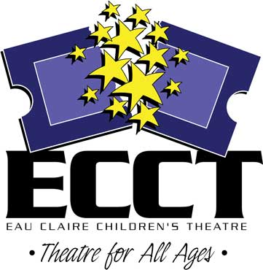
All proceeds benefit Eau Claire
Children’s Theatre.

Saturday, October 16, 2010 ▪
Eau Claire Orchards

NAME______________________________________ AGE______ SEX______

ADDRESS_______________________________________________________

CITY/ST/ZIP______________________________________________________

DAYTIME PHONE _____________________________

EMAIL _________________________________________________________
(Registration confirmation and other communication will be by email only.

RACE: □10K Road Race □2K Run/Walk
CATEGORY: □Youth (15 and Under) □Open (age 16-34) □Masters (35+)

T-SHIRT SIZE:
□Youth M □Youth L □Adult S □M □L □XL □XXL □No Shirt

ENTRY FEES (Make checks payable to ECCT):
Pre-registration by October 1 $15 $_______

Run both races (same person/1 shirt) $25 $_______

Registration after October 1 $20 $_______

Donation to support ECCT $_______

TOTAL ENCLOSED $_______

I enter this race at my own risk and waive and release any and all claims for damages I may have for any injuries suffered by me against Eau Claire Children’s Theatre, the County of Eau Claire, USATF, Eau Claire Orchards or any other sponsors, its agents or employees.

Participant’s Signature Date

If Under 18, Parent’s or Guardian’s Signature Date

MAIL TO: Eau Claire Children’s Theatre
1814 Oxford Avenue, Eau Claire, WI 54703

In the spirit of this event, no refunds will be given. Event takes place rain or shine.

