
Thursday, April 11, 2013  The Metropolis

Please return this form with your donated purse.
Completed purses due March 20, 2013

Donor Information:
Name / Company: _________________________________________________________________________________

Contact Person (if applicable): ________________________________________________________________________

Address: _________________________________________________________________________________________

City: __________________________________________________ State: ___________ Zip: ___________________

Phone: _________________________________ Email: __________________________________________________

Information about your donation:

Value of Purse: $_________________________

Value of Contents: $_________________________

Total Value: $_________________________

A clever name for my purse might be: _________________________________________________________________

The following items are in my purse: __________________________________________________________________

________________________________________________________________________________________________

________________________________________________________________________________________________

________________________________________________________________________________________________

Delivery:
□ I’ll deliver my purse donation to ECCT by Wednesday, March 20, 2013.
A Benefit for ECCT

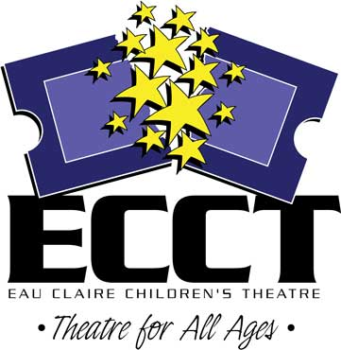
□ Please call me to make arrangements for ECCT to pick up my donation.

Questions? Contact:
Eau Claire Children’s Theatre Wayne Marek, Executive Director
1814 Oxford Avenue Email: info@ecct.org
Eau Claire, WI 54703
Phone: 715-839-8877 Shelly Grokowsky, Promotions
Email: shellygrokowsky@gmail.com

