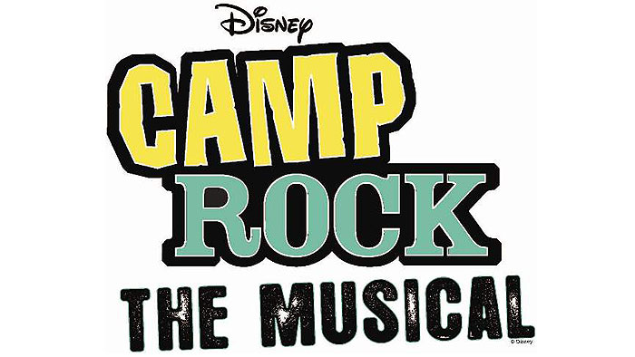

THANK YOU TO EVERYONE THAT AUDITIONED!
HERE’S THE CAST LIST!

CAMP ROCK
Mitchie Torres Haley Ashlin
Shane Gray Alex King
Nate Gray Joseph Sletner
Jason Gray Mark Quamme
Caitlyn Geller Emily Ashlin
Tess Tyler Rachel McIlquham
Ella Pador Meagan Seubert
Peggy Dupree Rachel Wrobel
Rosie Day Emma Cruciani
Barron James Johnny Lee
Sander Loya Austin Long
Andy Hosten Nate Maskevich
Brown Cesario John Leonauskas
Camp Rockers
Conor Jones Nick Ohren Mitchell Randall Nathan Shellenberger
Kendra Stahl Mariah Karis Rhiannon Larrabee Rita Kawak
Emma McIlquham Jordyn Leonauskas Berit Breed Devan Finn
Hannah Jones Heidi Nelson Marie Kruger Kiana Veal
Emily Surges Signe Thorpe

CAMP STAR
Dana Turner Alivia Rae Fredrickson
Luke Williams Pascal Pastrana
Axel Turner Dan Ekblad
Georgina Farlow Cassie Cherney
Star Campers
Adam Accola Taylor Price Jenny Grokowsky Hannah Olson
Signe Thorpe Berit Breed Kiana Veal Austin Long

- The first rehearsal for the entire cast will be held on Monday, June 6 from
5pm-7pm at ECCT. Bring your calendars to complete paperwork for the summer.
- The first parade of the season is the Eleva Broiler Fest on Sun. June 5. We will be carpooling from ECCT at 12:30pm and heading to Eleva to march in the parade to promote the show. We will return to ECCT around 3:30pm. Show T-shirts are supposed to be in by Sunday to wear in the parade and can be purchased for $12 before we leave. (As a backup please wear a colorful shirt or a shirt from a past ECCT show.) Please contact us at info@ecct.org if you have any questions before Sunday.

