
Thursday, April 7, 2011  Eau Claire Golf & Country Club

Fill This Form Out Now

Donor Commitment Form
Due February 25, 2011

For your convenience, this form is also available at www.ecct.org.

□ Yes, I’ll donate a purse filled with a minimum of $50 worth of goods/services.

Name / Company: _________________________________________________________________________________

Contact Person (if applicable): ________________________________________________________________________

Address: _________________________________________________________________________________________

City: __________________________________________________ State: ___________ Zip: ___________________

Phone: _________________________________ Email: __________________________________________________

Completed purses are due March 24, 2011.

A Benefit for ECCT

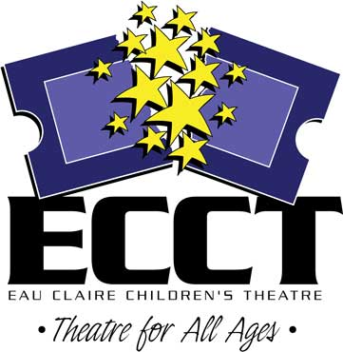
Questions? Contact:
Shelly Grokowsky, Promotions Phone: 715-839-8877
Eau Claire Children’s Theatre Email: shelly@ecct.org
1814 Oxford Avenue Website: www.ecct.org
Eau Claire, WI 54703

