6th ANNUAL

SATURDAY, OCTOBER 19, 2013

Ferguson Orchards, 6470 Balsam Road, Eau Claire
(formerly Eau Claire Orchards)

Half Marathon ▪ 10K Road Race ▪

2K Fun Run

USATF Half Marathon Course Certified

All Races USATF Sanctioned

Chip Timing- Half Marathon & 10K Road Race

Event Schedule - Course Maps-
7:00 AM Registration and packet pick-up Half Marathon
8:00 AM Half Marathon/10K Begins http://tinyurl.com/cfyet7w
8:30 AM 2K Fun Run Begins 10K Road Race
9:30 AM The Hilarious Mascot Race! http://tinyurl.com/c58yvwl
10:00 AM Awards Ceremony 2K Fun Run
12:00 PM Half Marathon Course Closes http://tinyurl.com/dxnvc3s

Pre-Registration – Online at http://goo.gl/GpZFH; via email at info@ecct.org; by mail or in person- address on form. $40/Half Marathon; $15/10K; $10/2K. Must be received by Friday, Oct. 4, 2013 to guarantee T-Shirt and Chip Timing.
After Oct. 4 & Day-Of Registration – $45/Half Marathon; $20/10K; $15/2K. Registration ends 15 minutes before each race. T-Shirt and Chip Timing not guaranteed after Oct. 4.

Awards & Prizes - All pre-registered participants will receive a free t-shirt while supplies last. Medals will be awarded to the top two male and female finishers in each age group for each race.

Bring the Family! – Enjoy all the amenities of the ALL PROCEEDS BENEFIT
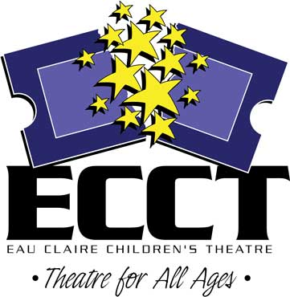
Ferguson Orchards while cheering on your favorite runners! Don’t miss the Mascot Race at 9:30am!

Questions? Contact Michael Strubel, Visit Eau Claire! Director of Sales & Events, at (715) 559-9377or ECCT at (715) 839-8877 or info@ecct.org.

Saturday, October 19, 2013 ▪
Ferguson Orchards

NAME______________________________________ AGE______ SEX______

ADDRESS_______________________________________________________

CITY/ST/ZIP______________________________________________________

DAYTIME PHONE _____________________________

EMAIL _________________________________________________________
(Registration confirmation and other communication will be by email only.

RACE: □Half Marathon □10K Road Race □2K Run/Walk
CATEGORY: □Youth (15 and Under) □Open (age 16-34) □Masters (35+)
T-SHIRT SIZE: □Youth M □Youth L □Adult S □M □L □XL □XXL

ENTRY FEES (Make checks payable to ECCT):
HALF 10K 2K
Pre-registration by Oct. 4 $40 $15 $10 $_______

Registration after Oct. 4 $45 $20 $15 $_______

Donation to support ECCT $_______

TOTAL ENCLOSED $_______

Charge My: □Visa □MC Account #__________________________________

Exp. Date_________ 3 Digit Code on Back__________ Amount $_________

I enter this race at my own risk and waive and release any and all claims for damages I may have for any injuries suffered by me against Eau Claire Children’s Theatre, the County of Eau Claire, USATF, Ferguson Orchards or any other sponsors, its agents or employees.

Participant’s Signature Date

If Under 18, Parent’s or Guardian’s Signature Date

MAIL TO: Eau Claire Children’s Theatre
1814 Oxford Avenue, Eau Claire, WI 54703

In the spirit of this event, no refunds will be given. Event takes place rain or shine.

