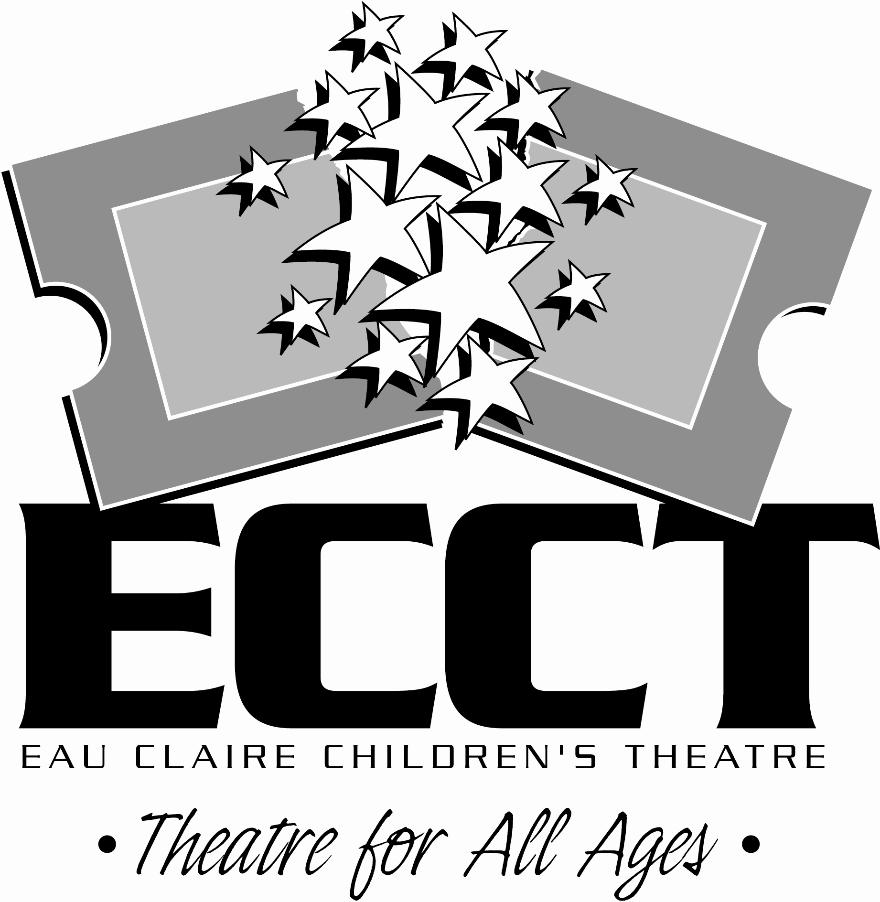

2016-2017 BOARD
OF DIRECTORS

SANDY BOWE
Instructor, CESA #10 (Ret.)

KARI CHERMACK
Community Volunteer

LAURA GOSS
Billing Representative, United Health Group

ANDREW FELIX
Promotions & Creative Services Director, WEAU 13 News

JULIE HAYES
Co-Director and Lead Teacher, Kiddie Patch Early Learning Center

KAY HESTEKIN
Executive Director
EC County Housing Authority

JESSICA JONES
Restaurant Manager, Olive Garden

TESS MORGAN
Radio Personality, iHeart Media

JAMI RIGGS
Clinical Lab Specialist, MCHS

NATHAN SHELLENBERGER
Server, Hu Hot

JENNA SIVERLING
Lead Teacher, Beautiful Minds Child Care & Apartment Housing Specialist, PPMC

STEVE TUREK
Elementary Teacher, Elk Mound Elem. (Ret.)

MEMBER
- Eau Claire Area Chamber of Commerce
- Downtown Eau Claire, Inc.
- Wisconsin Association of
Community Theatres
- American Association of
Community Theatres

1814 Oxford Ave.
Eau Claire, WI 54703
715-839-8877
info@ecct.org
www.ecct.org

Dear Arts Supporter,

This holiday season the Eau Claire Children’s Theatre will be producing the Broadway Disney musical “THE LITTLE MERMAID.” Based on the award-winning animated classic, we’re excited to bring this show back to the State Theatre after a number of sold out performances this spring. The show will be presented at the State Theatre November 18-20, 2016. It’s a perfect way for Chippewa Valley residents to kick off their holiday season.

To help our patrons begin their holiday shopping and to start raising the $15,000 needed to replace the decades old portion of our parking lot, the ECCT Board of Directors is organizing the 13th annual Holiday Silent Auction to be held in the lobby of the State Theatre during the performances of “THE LITTLE MERMAID.” Our goal for this year’s auction is $5,000. Funds raised will go toward replacing the oldest portion of our parking lot next spring and making it more handicapped accessible. The majority of our parking lot was put in in 2009 when The Oxford was built- the original parking lot dates back to the 1950’s and needs to be replaced.

We ask your assistance as we begin gathering donations for this event. The sky’s the limit when it comes to the number, type and size of your tax-deductible donation. Items like gift certificates, tickets and such can be mailed to: ECCT, 1814 Oxford Avenue, Eau Claire, WI 54703. Just give us a call at 715-839-8877 if you have an item that you need us to pick up.

If your donation has a market value of $75 or more you’ll also receive 2 complimentary vouchers to a performance of “THE LITTLE MERMAID” ($44 value) as an added incentive and a special thank you for your generous support.

Our deadline for securing items for publicity purposes is Friday, November 4. We hope you’ll join us for this annual holiday season fundraiser and perhaps have an opportunity to see the show- it would also make a great outing for you and your co-workers. Please give us a call at 715-839-8877 if you have any questions about the auction or the show. Thank you for your time and thoughtful consideration!

Sincerely,

ECCT Board Member

