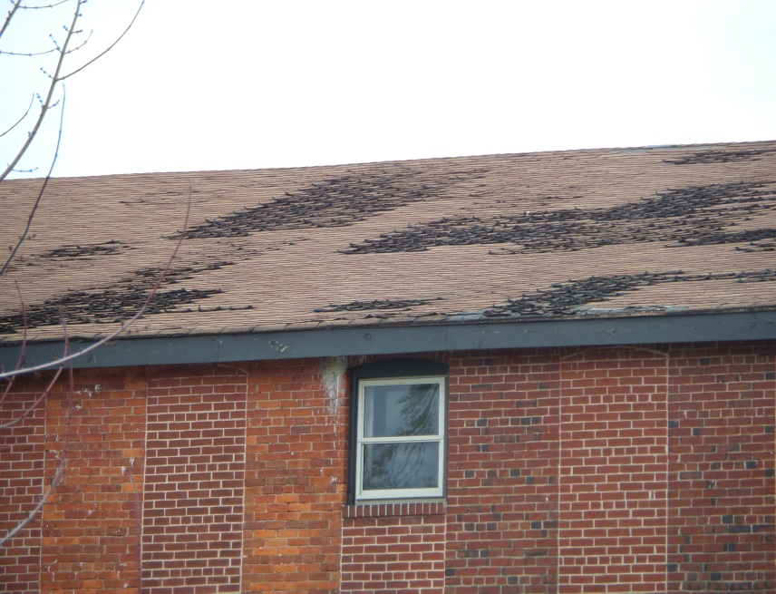**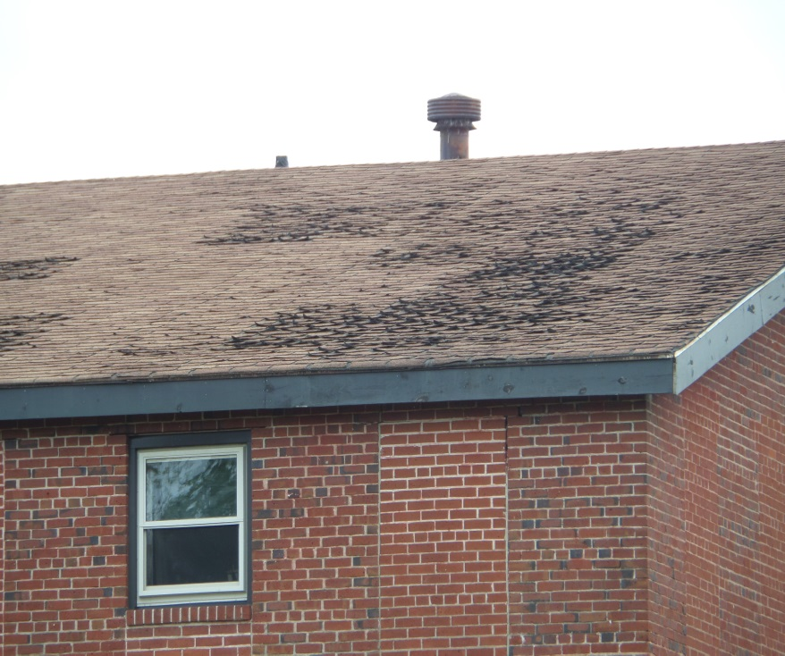HERE’S WHAT IT LOOKS LIKE!**

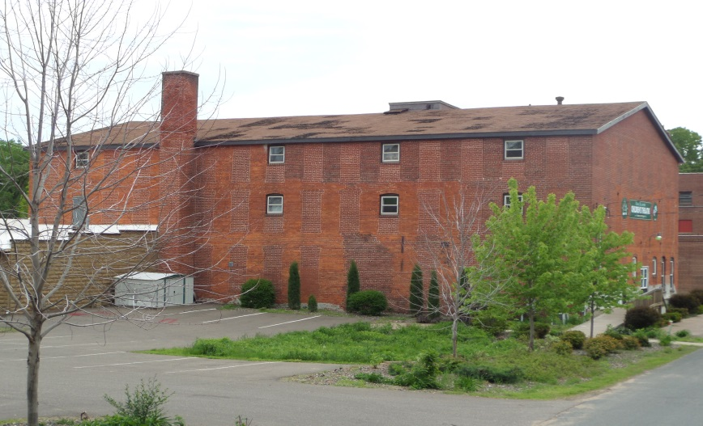

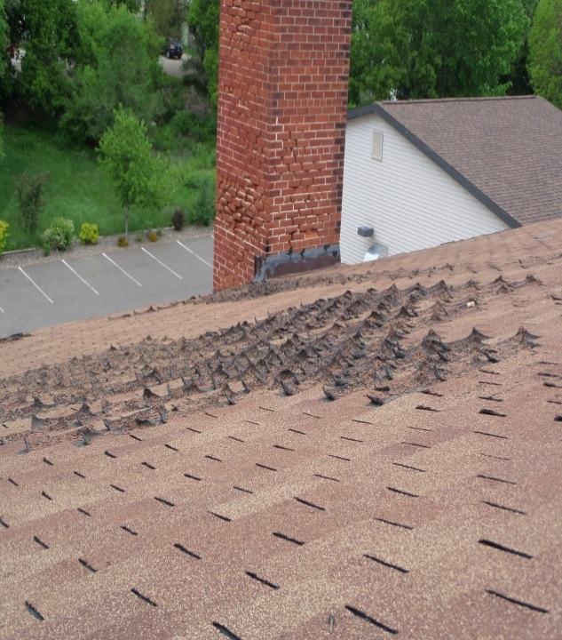

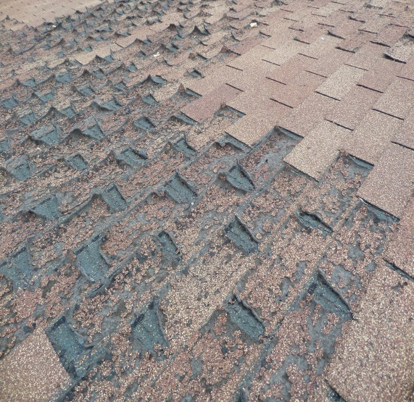

Thank you in advance for investing in the creation of quality live theatre in the Chippewa Valley!

- - - - - - - - - - - - - - - - - - - - - - - - - - - - - - - - - - - - - - - - - - - - - - - - - - - - - - - - - - - - - - - - - - - - - - - - - - - - - - - - - - - - - - - -

YES, I/we would like to give a gift in the amount of:

$________________________ NAME___________________________________________________________

Producer $10000+ (as you wish to be acknowledged)

Director $5000-$9999 ADDRESS_______________________________________________________

Legend $1000-$4999

Superstar $500-$999 CITY/STATE______________________________________________________

Leading Player $300-$499

Co-star $100-$299 ZIP_____________ PHONE_________________________________________

Actor $50-$99

□Check payable to “ECCT” EMAIL __________________________________________________________

□ Bill my: MasterCard Visa (to receive info on shows, events and special offers)

Acct. #_______________________________________ **CHECK ALL THAT APPLY:**

□Our gift is for the Roof Replacement Fund

Exp. Date__________ CVV 3 Digits_____________ □We prefer our gift go to the ECCT Endowment Fund

□Send volunteer information

Signature_____________________________________ □My employer has a matching gift program

□Call me about in-kind donations

Return this form in the enclosed envelope or drop off during regular business hours at:

ECCT 1814 Oxford Avenue, Eau Claire, WI 54703 Questions? 715-839-8877/[info@ecct.org](mailto:info@ecct.org)

***We Appreciate Your Continued Support!***