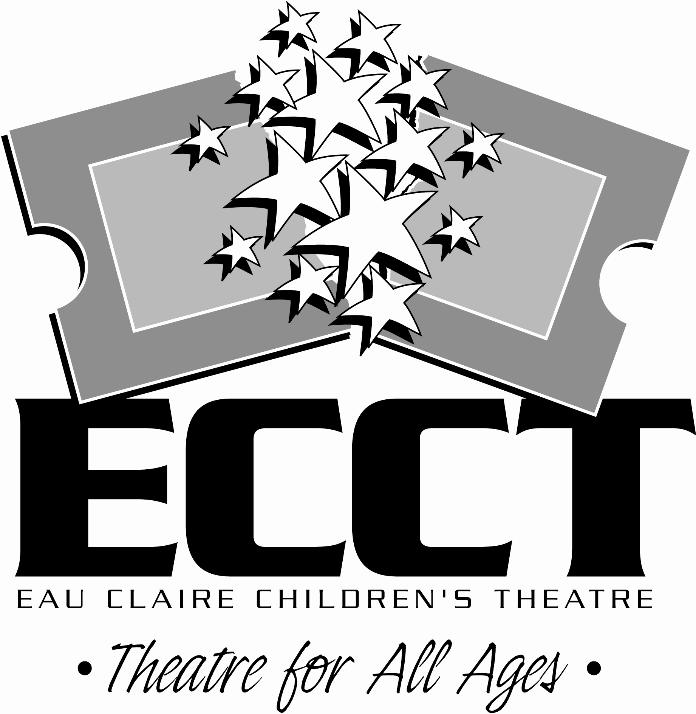

WE WANT TO HEAR
FROM YOU!

The Eau Claire Children’s Theatre will be celebrating its 25th Anniversary during the 2013-2014 Season starting in September, 2013 and we want to hear from YOU! Do you have a funny backstage story? Memories of being in a show? Thoughts on how involvement with ECCT influenced your life? The 25th Anniversary Committee is looking for these anecdotes, thoughts, experiences, funny stories and the like to include in lobby displays, newsletters and playbills throughout the next season.

Over the next 3 months committee member and performer/actress/juggler Kobi Shaw will be collecting, editing and compiling these memories to be used throughout the season. You can submit your stories and thoughts to HappyAnniversaryECCT@gmail.com. In addition to your stories, thoughts and memories, please include your full name, a contact phone number, the approximate year(s) that you were involved with ECCT and a little about what you’re up to now- people love hearing where life has taken those who have been involved. Kobi may also contact you for more info or to see if you have pictures of your ECCT involvement that you could share.

Our deadline for collecting these stories is May 15 as we may use some in the next season brochure as well. With 25 years of experiences we hope to hear from many of you over the next three months and invite you to check out all the great shows and events coming up later this year for the 25th Anniversary.

CONTACT US
Send your stories and thoughts to Kobi at HappyAnniversaryECCT@gmail.com. Send questions about the anniversary season and events to Wayne at info@ecct.org.
Check out what’s going on at ECCT at www.ecct.org.

