
Thursday, April 7, 2011  Eau Claire Golf & Country Club

Please return this form with your donated purse.
Completed purses due March 24, 2011

Donor Information:
Name / Company: _________________________________________________________________________________

Contact Person (if applicable): ________________________________________________________________________

Address: _________________________________________________________________________________________

City: __________________________________________________ State: ___________ Zip: ___________________

Phone: _________________________________ Email: __________________________________________________

Information about your donation:

Value of Purse: $_________________________

Value of Contents: $_________________________

Total Value: $_________________________

A clever name for my purse is: _______________________________________________________________________

The following items are in my purse: __________________________________________________________________

________________________________________________________________________________________________

________________________________________________________________________________________________

________________________________________________________________________________________________

Delivery:
□ I’ll deliver my purse donation to ECCT by Tuesday, March 24, 2011.
A Benefit for ECCT

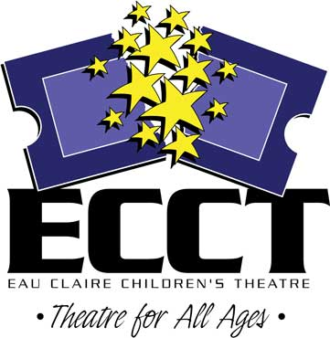
□ Please call me to make arrangements for ECCT to pick up my donation.

Questions? Contact:
Shelly Grokowsky, Promotions Phone: 715-839-8877
Eau Claire Children’s Theatre Email: shelly@ecct.org
1814 Oxford Avenue Website: www.ecct.org
Eau Claire, WI 54703

